

**Euro+Med-Checklist Notulae, 12**

Authors: Raab-Straube, Eckhard von, and Raus, Thomas

Source: Willdenowia, 50(2) : 305-341

Published By: Botanic Garden and Botanical Museum Berlin (BGBM)

URL: https://doi.org/10.3372/wi.50.50214



BioOne Complete (complete.BioOne.org) is a full-text database of 200 subscribed and open-access titles in the biological, ecological, and environmental sciences published by nonprofit societies, associations, museums, institutions, and presses.

Your use of this PDF, the BioOne Complete website, and all posted and associated content indicates your acceptance of BioOne’s Terms of Use, available at www.bioone.org/terms-of-use.

Usage of BioOne Complete content is strictly limited to personal, educational, and non - commercial use. Commercial inquiries or rights and permissions requests should be directed to the individual publisher as copyright holder.



BioOne sees sustainable scholarly publishing as an inherently collaborative enterprise connecting authors, nonprofit publishers, academic institutions, research libraries, and research funders in the common goal of maximizing access to critical research.

Downloaded From: https://bioone.org/journals/Willdenowia on 23 Aug 2020

Terms of Use: https://bioone.org/terms-of-use

Willdenowia



Annals of the Botanic Garden and Botanical Museum Berlin

Notulae ad floram euro-mediterraneam pertinentes No. 41

ECKHARD VON RAAB-STRAUBE1* & THOMAS RAUS1 (ed.)

**Euro+Med-Checklist Notulae, 12**

Version of record first published online on 17 July 2020 ahead of inclusion in August 2020 issue.

**Abstract:** This is the twelfth of a series of miscellaneous contributions, by various authors, where hitherto un-published data relevant to both the Med-Checklist and the Euro+Med (or Sisyphus) projects are presented. This instalment deals with the families *Asparagaceae* (incl. *Hyacinthaceae*), *Boraginaceae*, *Cactaceae*, *Caryophyllaceae*, *Chenopodiaceae*, *Compositae*, *Crassulaceae*, *Euphorbiaceae*, *Gramineae*, *Haloragaceae*, *Iridaceae*, *Labiatae*, *Le­ guminosae*, *Malvaceae*, *Orchidaceae*, *Orobanchaceae*, *Plumbaginaceae*, *Polygonaceae*, *Rosaceae*, *Scrophulariace­ ae* (incl. *Buddlejaceae*), *Solanaceae* and *Umbelliferae.* It includes new country and area records and taxonomic anddistributional considerations for taxa in *Abutilon*, *Aegilops*, *Amelanchier*, *Andryala*, *Aruncus*, *Asparagus*, *Bellevalia*, *Brugmansia*, *Buglossoides*, *Bupleurum*, *Cortaderia*, *Crassula*, *Datura*, *Dysphania*, *Euphorbia*, *Fallopia*, *Iris*, *Ly­ cianthes*, *Myriophyllum*, *Nicodemia*, *Onobrychis*, *Ophrys*, *Opuntia*, *Orobanche*, *Phelipanche*, *Plumbago*, *Salvia*, *Silene*, *Stellaria* and *Wisteria*, and new combinations in *Amelanchier* and *Phelipanche*.

**Key words:** distribution, Euro+Med PlantBase, Europe, Med-Checklist, Mediterranean, new combination, newrecord, taxonomy, vascular plants

**Article history:** Contributions received 18 November 2019 to 2 June 2020; peer-review completed 14 June 2020;received in revised form 22 June 2020; accepted for publication 22 June 2020.

**Citation**

**For the whole article:**

Raab-Straube E. von & Raus Th. (ed.) 2020: Euro+Med-Checklist Notulae, 12 [Notulae ad floram euro-mediterra-

neam pertinentes No. 41]. – Willdenowia 50: 305–341. doi: <https://doi.org/10.3372/wi.50.50214>

**For a single contribution (example):**

Meyer S. & Bazos I. 2020: *Bellevalia speciosa* Woronow ex Grossh. – Pp. 307–308 in: Raab-Straube E. von & Raus Th. (ed.), Euro+Med-Checklist Notulae, 12 [Notulae ad floram euro-mediterraneam pertinentes No. 41]. – Willde-nowia 50: 305–341. doi: <https://doi.org/10.3372/wi.50.50214>

**Notice** **Contributors**

A succinct description of the Euro+Med project, with a list of recognized territories and their abbreviations, and the conventions used to indicate the status and presence of taxa, can be found in the introduction to the first instal-ment of the Euro+Med Notulae (Greuter & Raab-Straube 2005: 223–226) and on the Euro+Med PlantBase website (Euro+Med 2006+). For the previous instalment of the Euro+Med-Checklist Notulae, see Raab-Straube & Raus (2019).

Z. Baumwol, Birmont Medical Group, 11/44 Kadish Luz st., Kiryat Motzkin 2640306, Israel; e-mail: [­zalmanpen1@gmail.com](mailto:zalmanpen1%40gmail.com?subject=)

I. Bazos, National and Kapodistrian University of Ath-ens, Faculty of Biology, Department of Ecology and Systematics, Panepistimiopolis, 15784 Athens, Greece; e-mail: [ibazos@biol.uoa.gr](mailto:ibazos%40biol.uoa.gr?subject=)

R. Böcker, Institut für Landschafts- und Pflanzenöko-logie der Universität Hohenheim, August-von-Hart-

1. Botanischer Garten und Botanisches Museum Berlin, Freie Universität Berlin, Königin-Luise-Str. 6–8, 14195 Berlin, Germany; *e-mail: [e.raab-straube@bgbm.org](mailto:e.raab-straube%40bgbm.org?subject=) (author for correspondence), [t.raus@bgbm.org](mailto:t.raus%40bgbm.org?subject=)

Downloaded From: https://bioone.org/journals/Willdenowia on 23 Aug 2020

Terms of Use: https://bioone.org/terms-of-use

306 Raab-Straube & Raus: Euro+Med-Checklist Notulae, 12

mann-Straße 3, 70599 Stuttgart, Germany; e-mail:

[reinhard.boecker@uni-hohenheim.de](mailto:reinhard.boecker%40uni-hohenheim.de?subject=)

S. Bogdanović, University of Zagreb, Faculty of Agri-culture, Department of Agricultural Botany, Herbar-ium ZAGR, Svetošimunska cesta 25, 10000 Zagreb, Croatia; e-mail: [sbogdanovic@agr.hr](mailto:sbogdanovic%40agr.hr?subject=)

M. Bou Dagher Kharrat, Laboratoire Biodiversité et Génomique Fonctionnelle, Faculté des Sciences, Uni-versité Saint-Joseph, Campus Sciences et Technolo-gies, Mar Roukos, Mkalles, BP: 1514 Riad el Solh, Beirut 1107 2050, Lebanon; e-mail: [magda.boudagher](mailto:magda.boudagher%40usj.edu.lb?subject=) [@usj.edu.lb](mailto:magda.boudagher%40usj.edu.lb?subject=)

M. Chasapis, Forest Office of Aridaia, Xenitidi & Er-mou str. 5, 58400 Aridaia, Greece; e-mail: [minxas1](mailto:minxas1%40gmail.com?subject=) [@gmail.com](mailto:minxas1%40gmail.com?subject=)

S. S. Cohen, Birmont Medical Group, 8 Enzo Sereni, Haifa 3297208, Israel; e-mail: [nycthantes@icloud](mailto:nycthantes%40icloud.com?subject=)

[.com](mailto:nycthantes%40icloud.com?subject=)

D. De Beer, Blancefloerlaan 15, 2050 Antwerpen, Bel-gium; e-mail: [dirk.debeer@telenet.be](mailto:dirk.debeer%40telenet.be?subject=)

G. De Bélair, Université Badji Mokhtar, BP 512, 23000 Annaba, Algeria; e-mail: [debelairg@yahoo.com](mailto:debelairg%40yahoo.com?subject=)

G. Domina, Department of Agricultural, Food and For-est Sciences, University of Palermo, Palermo, Viale delle Scienze Bldg. 4, 90128 Palermo, Italy; e-mail:

[gianniantonio­.domina@unipa.it](mailto:gianniantonio.domina%40unipa.it?subject=)

R. El Mokni, Department of Pharmaceutical Sciences “A”, Laboratory of Botany, Cryptogamy and Plant Physiology, Faculty of Pharmacy of Monastir, BP. No. 207, Avenue Avicenne, 5000 Monastir, Tunisia; e-mail: [riridah@hotmail.com](mailto:riridah%40hotmail.com?subject=)

E. Eleftheriadou, Aristotle University of Thessaloniki, Faculty of Agriculture, Forestry and Natural Environ-ment, School of Forestry and Natural Environment, Laboratory of Forest Botany/Geobotany, 54124 Thes-saloniki, Greece; e-mail: [eelefthe@for.auth.gr](mailto:eelefthe%40for.auth.gr?subject=)

A. V. Fateryga, T. I. Vyazemsky Karadag Scientific Sta-tion, Nature Reserve of the Russian Academy of Sci-ences, Branch of A. O. Kovalevsky Institute of Biol-ogy of the Southern Seas, Nauki Str. 24, Kurortnoye, Feodosiya 298188, Crimea; e-mail: [fater_84@list.ru](mailto:fater_84%40list.ru?subject=)

R. Fekete, Department of Botany, University of Debre-cen, Egyetem tér 1, 4032 Debrecen, Hungary; e-mail: [feketereka722@gmail.com](mailto:feketereka722%40gmail.com?subject=)

M. Z. Ferreira, Madeira Botany Group, University of Madeira, Campus Universitário da Penteada, 9020-105 Funchal, Madeira, Portugal; e-mail: [mzitaferreira](mailto:mzitaferreira%40sapo.pt?subject=) [@sapo.pt](mailto:mzitaferreira%40sapo.pt?subject=)

A. Fridlender, Faculté des Sciences, Département Pluri-disciplinaire, Université AMU, 3 place Victor Hugo, 13003 Marseille cedex 03, France; e-mail: [alain](mailto:alain.fridlender%40univ-amu.fr?subject=)

[.fridlender@univ-amu.fr](mailto:alain.fridlender%40univ-amu.fr?subject=)

E. Gubler, Via Johannes Badrutt 7, 7500 St. Moritz, Swit-zerland; e-mail: [ernst-gubler@bluewin.ch](mailto:ernst-gubler%40bluewin.ch?subject=)

M. Harásek, Department of Botany and Zoology of Ma-saryk University, Kotlářská 2, 611 37 Brno, Czech Republic; e-mail: [harasek1993@gmail.com](mailto:harasek1993%40gmail.com?subject=)

P. Hein, Botanischer Garten und Botanisches Museum Berlin, Freie Universität Berlin, Königin-Luise-Str. 6 – 8, 14195 Berlin, Germany; e-mail: [p.hein@bgbm](mailto:p.hein%40bgbm.org?subject=)

[.org](mailto:p.hein%40bgbm.org?subject=)

D. Iamonico, Department of Biology, Botany Unit, Uni-versity of Pisa, Via Luca Ghini 13, 56126 Pisa, Italy; e-mail: [d.iamonico@yahoo.it](mailto:d.iamonico%40yahoo.it?subject=)

N. Jogan, Department of Biology, Biotechnical Faculty, University of Ljubljana, Večna pot 111, 1000 Ljublja-na, Slovenia; e-mail: [nejc.jogan@bf.uni-lj.sl](mailto:nejc.jogan%40bf.uni-lj.sl?subject=)

V. Kalníková, Department of Botany and Zoology of Masaryk University, Kotlářská 2, 611 37 Brno, Czech Republic & Beskydy Protected Landscape Area Administration, Nádražní 36, 756 61, Rožnov pod Radhoštěm, Czech Republic; e-mail: [v.kalnikova](mailto:v.kalnikova%40seznam.cz?subject=) [@seznam.cz](mailto:v.kalnikova%40seznam.cz?subject=)

N. Korotkova, Botanischer Garten und Botanisches Museum Berlin, Freie Universität Berlin, Königin-Luise-Str. 6 – 8, 14195 Berlin, Germany; e-mail: [n.korotkova@bgbm.org](mailto:n.korotkova%40bgbm.org?subject=)

V. Kummer, Universität Potsdam, Institut für Biochemie und Biologie, Biodiverstätsforschung/Spezielle Bo-tanik, Maulbeerallee 1, 14469 Potsdam, Germany; e­-mail: [kummer@uni-potsdam.de](mailto:kummer%40uni-potsdam.de?subject=)

N. Kuzmanović, Institute of Botany and Botanical Garden, Faculty of Biology, University of Belgrade, 11000 Bel-grade, Serbia; e-mail: [nkuzmanovic@bio.bg.ac.rs](mailto:nkuzmanovic%40bio.bg.ac.rs?subject=)

V. Löki, Wetland Ecology Research Group, Depart-ment of Tisza Research, MTA Centre for Ecological Research, Bem tér 18/C, 4026 Debrecen, Hungary; e­-mail: [lokvi89@gmail.com](mailto:lokvi89%40gmail.com?subject=)

S. Maslo, Primary School, Lundåkerskola, Gislaved, Sweden; e-mail: [semmas@edu.gislaved.se](mailto:semmas%40edu.gislaved.se?subject=)

V. Matevski, Faculty of Natural Sciences and Mathe­ matics, Ss. Cyril and Methodius University of

Skopje,­ Arhimedova 5, 1000 Skopje, North Macedo-nia; e­-mail: [vlado.matevski@manu.edu.mk](mailto:vlado.matevski%40manu.edu.mk?subject=)

S. Meyer, Georg-August Universität Göttingen, Alb-recht-von-Haller Institut für Pflanzenwissenschaften, Ökologie und Ökologieforschung, Untere Karspü-le 2, 37075 Göttingen, Germany; e-mail: [smeyer1](mailto:smeyer1%40gwdg.de?subject=) [@gwdg.de](mailto:smeyer1%40gwdg.de?subject=)

A. Molnár V., Department of Botany, University of Debre-cen, Egyetem tér 1, 4032 Debrecen, Hungary; e­-mail: [mva@science.unideb.hu](mailto:mva%40science.unideb.hu?subject=)

R. A. Murtazaliev, Mountain Botanical Garden of the Dagestan Federal Research Center of the RAS, M. Gadjiev str. 45, Makhachkala 367000, Russia; e-mail: [murtazaliev.ra@yandex.ru](mailto:murtazaliev.ra%40yandex.ru?subject=)

M. Niketić, Natural History Museum Belgrade, Nje­ goševa 51, 11000 Beograd, Serbia; e-mail: [mniketic](mailto:mniketic%40nhmbeo.rs?subject=) [@nhmbeo.rs](mailto:mniketic%40nhmbeo.rs?subject=)

P. Novák, Department of Botany and Zoology of Masa-ryk University, Kotlářská 2, 611 37 Brno, Czech Re-public; e-mail: [pavenow@seznam.cz](mailto:pavenow%40seznam.cz?subject=)

G. Parolly, Botanischer Garten und Botanisches Muse-um Berlin, Freie Universität Berlin, Königin-Luise-

Downloaded From: https://bioone.org/journals/Willdenowia on 23 Aug 2020

Terms of Use: https://bioone.org/terms-of-use

|  |  |
| --- | --- |
| Willdenowia 50 – 2020 | 307 |
|  |  |

Str. 6 – 8, 14195 Berlin, Germany; e-mail: [g.parolly](mailto:g.parolly%40bgbm.org?subject=) [@bgbm.org](mailto:g.parolly%40bgbm.org?subject=)

A. V. Popovich, Environmental Commission, Krasnodar Regional Branch of the Russian Geographical So­ ciety, Lenina Str. 103/64, Krasnodar 350033, Russia; e-mail: [popovitch.antonio220386@yandex.ru](mailto:popovitch.antonio220386%40yandex.ru?subject=)

E. von Raab-Straube, Botanischer Garten und Botani-sches Museum Berlin, Freie Universität Berlin, Kö-nigin-Luise-Str. 6 – 8, 14195 Berlin, Germany; e­-mail: [e.raab-straube@bgbm.org](mailto:e.raab-straube%40bgbm.org?subject=)

S. Rätzel, Georg-Friedrich-Händel-Straße 13, 15234 Frankfurt an der Oder, Germany; e-mail: [stefan.raetzel](mailto:stefan.raetzel%40googlemail.com?subject=) [@googlemail.com](mailto:stefan.raetzel%40googlemail.com?subject=)

Th. Raus, Botanischer Garten und Botanisches Museum Berlin, Freie Universität Berlin, Königin-Luise-Str. 6 – 8, 14195 Berlin, Germany; e-mail: [t.raus@bgbm](mailto:t.raus%40bgbm.org?subject=)

[.org](mailto:t.raus%40bgbm.org?subject=)

M. Ristow, University of Potsdam, Plant Ecology and Nature Conservation, Am Mühlenberg 3, 14476 Pots-dam, Germany; e-mail: [ristow@uni-potsdam.de](mailto:ristow%40uni-potsdam.de?subject=)

L. E. Ryff, Flora and Vegetation Laboratory, Nikitsky Botanical Garden – National Scientific Centre, Yalta, Crimea; e-mail: [ryffljub@ukr.net](mailto:ryffljub%40ukr.net?subject=)

A. Saci, Conservation of the forests of the wilaya of Skikda, Bouabaz City-Skikda, 21000 Skikda, Alge-ria; e-mail: [amarsaci21@gmail.com](mailto:amarsaci21%40gmail.com?subject=)

D. A. Samaras, Department of Forestry, Wood Science and Design, University of Thessaly, V. Griva 11, 43100 Karditsa, Greece; e-mail: [dsamar@uth.gr](mailto:dsamar%40uth.gr?subject=)

M. Sequeira, Madeira Botany Group, University of

Madeira,­ Campus Universitário da Penteada, 9020-

105 Funchal, Madeira, Portugal; e-mail: [sequeira](mailto:sequeira%40uma.pt?subject=) [@uma.pt](mailto:sequeira%40uma.pt?subject=)

1. Shilnikov, Komarov Botanical Institute, Russian Academy of Sciences, Eco-botanical station Pyati­ gorsk, Russia; e-mail: [demons2002@yandex.ru](mailto:demons2002%40yandex.ru?subject=)

J. Stephan, Lebanese University, Faculty of Sciences II, Fanar, Lebanon; e-mail: [dr.jeanstephan@gmail](mailto:dr.jeanstephan%40gmail.com?subject=)

[.com](mailto:dr.jeanstephan%40gmail.com?subject=)

D. Stešević, Faculty of Natural Sciences and Mathemat-ics, University of Montenegro, Džordža Vašingtona bb, Podgorica 81 000, Montenegro; e-mail: [danijela](mailto:danijela.stesevic%40ucg.ac.me?subject=)

[.stesevic@ucg.ac.me](mailto:danijela.stesevic%40ucg.ac.me?subject=)

A. Stinca, Department of Environmental Biological and Pharmaceutical Sciences and Technologies, University of Campania Luigi Vanvitelli, via Vivaldi 43, 81100, Caserta, Italy; e-mail: [adriano.stinca@unina.it](mailto:adriano.stinca%40unina.it?subject=)

S. Stoyanov, Department of Plant and Fungal Diversity and Resources, Institute of Biodiversity and Ecosys-tem Research, Bulgarian Academy of Sciences, Acad. G. Bonchev Str., bl. 23, 1113 Sofia, Bulgaria; e-mail: [tjankata@abv.bg](mailto:tjankata%40abv.bg?subject=)

A. Strid, Bakkevej 6, 5853 Ørbæk, Denmark; e-mail:

[arne.strid@youmail.dk](mailto:arne.strid%40youmail.dk?subject=)

S. A. Svirin, City Development Institute, Sevastopol State University, Universitetskaya str. 33, Sevastopol 299053, Crimea; e-mail: [sapsan7@mail.ru](mailto:sapsan7%40mail.ru?subject=)

A. A. Taleb, Faculty of Agronomy, Lebanese University, P.O. Box 6573/14 Badaro, Museum, Beirut, Lebanon; e-mail: [ali.talebakkar@gmail.com](mailto:ali.talebakkar%40gmail.com?subject=)

K. A. Taleb, Akkar Trail group, main road, 1st floor, Meshmesh Akkar, Lebanon; e-mail: [akkartrail@gmail](mailto:akkartrail%40gmail.com?subject=)

[.com](mailto:akkartrail%40gmail.com?subject=)

K. Theodoropoulos, Aristotle University of Thessaloniki, Faculty of Agriculture, Forestry and Natural Environ-ment, School of Forestry and Natural Environment, Laboratory of Forest Botany/Geobotany, 54124 Thes-saloniki, Greece; e-mail: [ktheodor@for.auth.gr](mailto:ktheodor%40for.auth.gr?subject=)

H. Uhlich, Gartenstraße 19, 56357 Welterod, Germany; e-mail: [uhlich.holger@googlemail.com](mailto:uhlich.holger%40googlemail.com?subject=)

Y. Ur, 106 Moshav Amnoon, 1293500, Israel; e-mail:

yairur@013.net

F. Verloove, Meise Botanic Garden, Nieuwelaan 38, 1860 Meise, Belgium; e-mail: [filip.verloove@botanic](mailto:filip.verloove%40botanicgardenmeise.be?subject=) [gardenmeise.be](mailto:filip.verloove%40botanicgardenmeise.be?subject=)

B. Wallnöfer, Naturhistorisches Museum, Botanische Abteilung, Burgring 7, 1010 Wien, Austria; e-mail: [bruno.wallnoefer@nhm-wien.ac.at](mailto:bruno.wallnoefer%40nhm-wien.ac.at?subject=)

E. Zippel, Botanischer Garten und Botanisches Muse-um Berlin, Freie Universität Berlin, Königin-Luise-Str. 6 – 8, 14195 Berlin, Germany; e-mail: [e.zippel](mailto:e.zippel%40bgbm.org?subject=) [@bgbm.org](mailto:e.zippel%40bgbm.org?subject=)

D. Zukal, Department of Botany and Zoology of Masa-ryk University, Kotlářská 2, 611 37 Brno, Czech Re-public; e-mail: [dominikzukal@gmail.com](mailto:dominikzukal%40gmail.com?subject=)

*Asparagaceae* (incl. *Hyacinthaceae*)

***Asparagus aethiopicus*** L. (≡*Asparagopsis aethiopica*(L.) Kunth = *Asparagus sprengeri* Regel)

**A Ga(F):** France: Marseille, along Rue Caisserie,43°17'49.82"N, 05°22'6.12"E, 14 m, between cracks, 25 Jul 2017, *Stinca* (PORUN-herb. Stinca). – *Asparagus aethiopicus* is a perennial herb or shrub native to South Africa that is fre-quently grown as outdoor ornamental plant in the Mediterranean region. In this area it some-times escapes from gardens by seed dispersal. In the Euro+Med area it has been recorded from Mallorca (Sáez & al. 2016), Sardinia, Sicily and Italy (Galasso & al. 2018), often as an epiphytic plant (Stinca & al. 2013). Some individuals were observed in a ruderal environ-ment in the urbanized area of Marseille, near

the port. A. Stinca

***Bellevalia speciosa*** Woronow ex Grossh*.*– Fig. 1.

* **AE(G):** Greece: East Aegean Islands, Nomos ofLesvos, Eparchia of Mitilini, Lesvos island, above Vrisa in locality called Agia Anna, 39°02'43"N, 26°13'32"E, 250 m, clearings in *Pinus brutia* Ten. forest, olive groves and uncultivated land, 16 Apr 1995, *Bazos* *2218* (ATHU); ibid., between Agios Pavlos

Downloaded From: https://bioone.org/journals/Willdenowia on 23 Aug 2020

Terms of Use: https://bioone.org/terms-of-use

*mum arvense* subsp. *gasparinii* (Guss.) Laínzfrom Albania (Qosja & Paparisto 1996: 85; Vangjeli 2015: 327; Pils 2016: 52, sub *Buglos­* *soides incrassata* subsp. *sibthorpiana* nom.nud.) might potentially refer to *B*. *incrassata* subsp. *splitgerberi*, but they remain uniden-tifiable and therefore cannot be evaluated for mapping purposes.

**+ Ar:** Armenia: Talin district, 1620 m, 21 Jun 2002,*Fayvush & al.* (WU 2005-11451); ibid., Loriprovince, 1390 m, 29 Jun 2003, *Fayvush & al.* (WU); ibid., Sjunik province, 1900 – 2300 m, 22 Jun 2004, *Fayvush & al*. *04-1194* (WU 2004-01200); ibid., Sjunik province, 2539 m, 23 June 2004, *Fayvush & al. 04-1417* (WU 2006-05733); ibid., Vayots Dzor province, 1630 m, 16 May 2006, *Fayvush & al. 06-0200* (WU 2006-08951); ibid., Gegharkinik prov-

Fig. 1. *Bellevalia speciosa*, flowering plant in habitat. – Greece: Lesvos island, between Agios Pavlos and Skamioudi, 22 Apr 2019, photograph by S. Meyer.

Raab-Straube & Raus: Euro+Med-Checklist Notulae, 12

308

and Skamioudi, 39°07'44"N, 26°13'23"E, 8 m, two individu-als in a barley field with deep soil together with *Echinophora* *tenuifolia­* L., *Leontice leonto­ petalum* L. and *Muscari como­ sum* (L.) Mill., 22 Apr 2019, *Meyer* (ATHU). – This is a newrecord for the East Aegean Is-lands and Greece as a whole. The currently known distribution of the species includes Trans­ caucasia and N Iran, the Pontic region (Romania, Ukraine, S Russia) and Turkey (Wendelbo 1984). The occurrence of the species on Lesvos is presum-ably an outpost of populations in the NW part of Turkey (Çanak-kale, Istanbul, Izmir; Wendelbo 1984; Özhatay & al. 1991). The species was already found on Lesvos and reported with uncertainty under its younger synonym *Bellevalia sarmatica* (Pall.) Miscz. (Bazos 2005), but, because of the uncertainty, was not taken into account by ­Dimopoulos & al. (2013, 2016) and Strid (2016a, 2016b). An old record of *B. ciliata* (Cirillo) T. Nees by Candargy (1898) probably refers to *B. speciosa* as well, because, according to Wendelbo (1984: 270), the name *B. ciliata* has been misappliedto plants of *B. sarmatica* from NW Turkey. The two localities of *B*. *speciosa* recorded on Les-

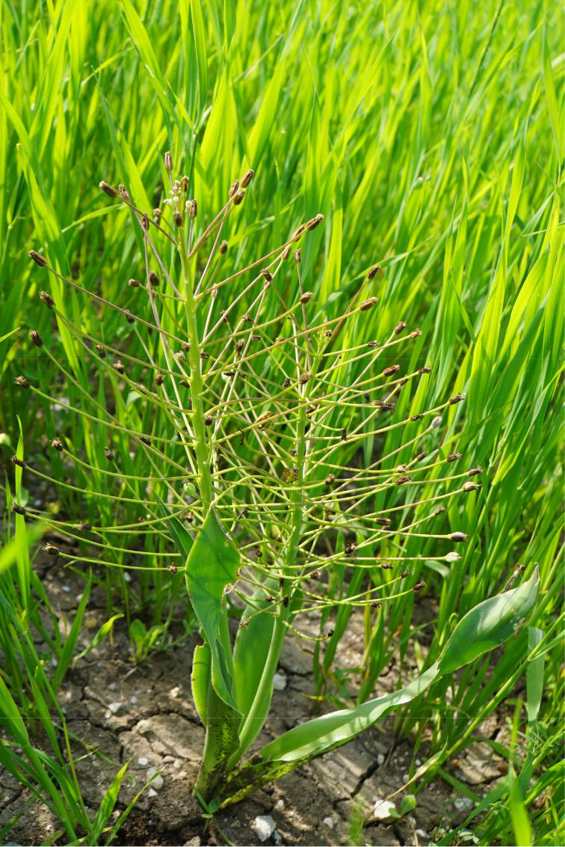

vos are approximately 10 km apart. *Bellevalia* *edirnensis* Özhatay & B. Mathew, which wasdescribed from the Edirne area in European Turkey (Özhatay & al. 1991; Dayhan & al. 2013) and has subsequently been found also on the Greek side of the border (Bareka & al. 2008), is somewhat similar but has much shorter fruiting pedicels.

S. Meyer & I. Bazos

*Boraginaceae*

***Buglossoides incrassata*** subsp. ***splitgerberi*** (Guss.) E.Zippel & Selvi

* **Al:** Albania: Nord-Albanien, Luma, buschige Hängeder Skoza-Schlucht bei Dzuri, 500 m, 29 May 1918, *Dörfler 548* (WU). – The taxon has not so far been reported with certainty from Alba-nia. Previous literature records of *Lithosper­*

Downloaded From: https://bioone.org/journals/Willdenowia on 23 Aug 2020

Terms of Use: https://bioone.org/terms-of-use

|  |  |
| --- | --- |
| Willdenowia 50 – 2020 | 309 |
|  |  |

ince, NE of lake Sevan, N of Tchambarak, road from Ttujur to Berd, between Ttujur and Miapor pass, 1890 m, 28 May 2006, *Vitek 06-0524* (WU 2010-09869); ibid., Tavush prov-ince, 820 m, 31 May 2006, *Oganesian & al*. *06-0939* (WU 2010-09291); ibid., Aragatsotnprovince, area N of Aparan, beside road Me-likyugh, 2090 m, 4 Jun 2006, *Vitek 06-1117* (WU); ibid., Aragatsotn province, area N of Aparan, valley c. 2.5 km E of Melikyugh, 2240 m, 4 Jun 2006, *Vitek 06-1109* (WU 2010-09494); ibid., Kotayk province, 1970 m, 6 Jun 2006, *Vitek 06-1238* (WU 2010-09438); ibid., E of Yerevan, in Geghard village, 1920 m, 18 Jun 2007, *Tamanyan, Oganesian & Vitek 07-0784* (WU). – These are the first records of thetaxon for Armenia.

* **Bu:** Bulgaria: bei Radomir, 23 Mar 1905,*Urumoff*(WU3879); ibid., Slavjanka mt., Paril, Goce Delcev, dry meadow, 6 Jun 1980, *Kuzmanov BK-80474* (B); ibid., Bulharsko, Sozopol, Akutino, 3 m, in arenosis supra mare, 9 May 1993, *Grulich* *& al.* (BRNU 534257); ibid., ad Parlovo, 10May 1912, *Urimov* (BRNU 147740). – The taxon has not previously been reported from Bulgaria.
* **Ct:** Croatia: Spalato, nächst dem Fort Grippi, aufeiner Weinbergsbrache, 25 Jun 1927, *Korb* (WU); ibid., Draganički, Goljak, 26 Apr 1951, *Serjan* (ZA); ibid., Zrmanja, Getreidefeld, 5Apr 1890, *Rossi 6052* (ZA); ibid., Istrien, Ge-biet des Monte Maggiore, 130 m, Äcker und Brachen, 28 May 1909, *Ginzberger* (WU). – The taxon has not previously been reported from Croatia.
* **Fe:** Finland: Prov. Tavastia australis, Pohjois-Pirkka-la, ratapenger [railway bank], 2 Jul 1933, *Rydman* (TMP); ibid., Kulovesi, radan varsi[railway side], 8 Jul 1935, *Haapanen* (TMP D673); ibid., Tampere, Lielahti, kuiva rinne [dry slope], 27 May 1937, *Setälä* (TMP); ibid., Åland, Sund, Kastelholm, linnan takana vallilla [behind castle on rampart], 24 May 1952, *Saransaari* (TMP D1054); ibid., Nokia, Haavisto, rautatien varsi [railway side], 12 Jun 1952, *Helin* (TMP); ibid., Nokia, SOK:n myllyalue [area of SOK company’s mill], 23 Jul 1966, *Kääntönen* (TMP D670); ibid., Tampere, Lielahden asema, ratapenger [Lie-lahti railway station, railway bank], 4 Aug 1968, *Kääntönen* (TMP); ibid., Prov. Alandia, Maarianhamina, Espholm, pellon reuna [field margin], 5 Jul 1967, *Lyly* (TMP); ibid., Salt-vik, Ödkarby, Haga Kungsgårdin SW, puolel-la vehnäpellon laidalla, runsaasti [margin of wheat field, abundant], una cum [with] *Al­* *lium oleraceum* L., *Centaurea cyanus* L. [and]

­*Veronica arvensis* L., 25 Jul 1990, *Lahtonen*

* 1. (TMP D963). – The taxon has not pre-viously been reported with certainty from Finland. Literature records of *Lithospermum* *arvense* subsp. *coerulecens­* DC., mapped byMossberg & Stenberg (2018: 688) for Scan-dinavia including Finland, may refer to *B*. *incrassata* subsp. *splitgerberi*, but remainquestionable unless substantiated by revised herbarium material.
* **Gg(G):** Georgia: Transcaucasia, Tiflis, in faucibusfl. Dabachanka, 18 Apr 1924, *Grossheim* (BRNU 94800). – First record of the taxon

from Georgia­.

* **He:** Switzerland: Basel, zwischen Bottningen undBatterie, 7 May 1942, *Tschopp* (BASBG); ibid., Graubünden, Puschlav, Resena, Mauer­ kronen, 1080 m, 27 Jun 1972, *Eckardt* *2469* (B); ibid., Wallis, Mattertal, Grächen,1400 – 1600, Wegrand,­ 4 Jul 2001, *Ristow* *262/01* (herb. Ristow); ibid., Wallis, Visper-timen, Acker, 4 Aug 2001, *Zippel & Waldis* *01-209.1* (BSB); ibid., 4 Aug 2001, *Zippel & Waldis 01-209.2* (BSB). – The taxon has notpreviously been published for Switzerland. An old literature record of *Lithospermum ar­* *vense* subsp. *coerulecens* DC. from Wallis/Valais (Schmid & Gams 1927: 2159) refers possibly to *B*. *incrassata* subsp. *splitgerberi*, but remains questionable unless substantiated by revised herbarium material.
* **Ho:** Netherlands: Siebengewald, 26 May 1997,*Reijerse*­

*97063* (BSB). – The taxon has not previouslybeen reported from the Netherlands.

* **Hs(S):** Spain: Sierra Nevada, 24 km N Granada,1720 m, Weizen, 28 May 1936, *Huber-Morat* *3335* (BASB); ibid., Huesca, Puntón de Guara,Gottesacker, 1980 m, 11 Jul 1974, *Montserrat* *3884/74* (BASBG); ibid., zwischen Motrilund Granada nördlich der Abzweigung nach Lanjaron, 23 May 1981, *Hübl & Holzner* (W).

– The taxon has not previously been reported with certainty from Spain. Pastor (2012: 381), although commenting on *Buglossoides incras­* *sata* subsp. *splitgerberi*, does not authenticateverified populations in the *Flora iberica* area; the pertinent drawing, captioned *B. incrassata* subsp. *incrassata* (Pastor 2012: 380), depicts in fact *B. arvensis*.

* **Hu:** Hungary: Csepelinsel bei Budapest, 12 May 1906,*Janchen* (WU); ibid., Comit[atus]. Pest, Òkutivölgy supra oppidum Szentendre, c. 200 m, in agris vallis, 29 Apr 1952, *Kárpáti & Baráth* (WHB 188633); ibid., Umgebung von Bu-dapest, Blockberg-Csepelinsel, May 1888, *Wettstein* (WU). – The taxon has not previouslybeen reported from Hungary.

Downloaded From: https://bioone.org/journals/Willdenowia on 23 Aug 2020

Terms of Use: https://bioone.org/terms-of-use

310 Raab-Straube & Raus: Euro+Med-Checklist Notulae, 12

* **Mk:** North Macedonia: Galicitza, Jul 1908,*Dimonie*(WHB 2007-02384). – This is the first record of the taxon from North Macedonia.
* **Po:** Poland: Silesia, Biała Prudnicka, field, 30 Jun1961, *Stojanowska* (B); ibid., Grünberg (Zielo-na Góra), bei Nittritz, 16 May 1892, *Schroeder*

(B). – No previous published records of the taxon are known from Poland.

* **Rm:** Romania: Geoagin, Hunedoava, 9 May 1964,*Slanovschi* (IASI); ibid., Adjud, Vrancea, po-sune, 13 May 1965, *Popanikai* (IASI); ibid., Lebatiste Codresti (V Vasheretalui), 1 Jun 1968, *Zinasj* (IASI 80546); ibid., Tg Oena, 27 May 1969, *Chifu & Stefan* (IASI 94358); ibid., Vasliu, Ackerbrache, 16 May 1973, *Dobrescu* (IASI). – These are the first verified records of the taxon from Romania.
* **Se:** Serbia: Pirot, mte Graiste, 21 May 1888,*Born­**müller* (B); ibid., in arvis ad Vranja, May 1895, *Aderc* (WHB). – These are the first verifiedrecords of the taxon from Serbia.
* **Sk:** Slovakia: Slovakia merid[ionalis]., distr. Štúrovo,in declivibus­ silvatico-stepposis Skály dictis supra station[em] viae ferrat[ae]. Kamenica nad Hronom, 250 m, 19 May 1962, *Smejkal* (BRNU 410725); ibid., distr. Lučenec, in declivib[us]. septentr[ionalis]. collis Hyalos (cota 317) prope pagum Fil’akovske Kl’ačany, 260 m, in pascuis, 1 Jun 1965, *Smejkal*­ (BRNU 421038); ibid., Devinsaka, Kobyla, Devín, ruderal, 11 May 1994, *Ferráková* (B); ibid., Senica, Moravský Ján, Borové, ostrůvek vátých písků v nivenĕ Moravy 5 km jz obce, 15 May 1994, *Grulich* (BRNU 534983). – The taxon has not previously been reported from Slovakia.
* **Su:** Sweden: Uppland, Danmark, 22 Jun 1905,*Svens­**son* (BSB); ibid., Halland, Akrav, 5 Jun 1921,Acker, *Svenson* (BASBG); ibid., Öland, Runsten, 24 May 1897, *Arescog* (B); ibid., Falun, Upland, Vigelsbo, 5 Jul 1893, *Fröman* (WU). – The taxon has not previously been re-ported with certainty from Sweden. Literature records of *Lithospermum arvense* subsp. *coe­* *rulecens* DC. from Scandinavia (e.g. Hylander1945: 261), later mapped by Mossberg &

Stenberg­ (2018: 688) for the Nordic countries of Denmark, Norway, Sweden and Finland, might refer to *B*. *incrassata* subsp. *splitgerberi*, but remain questionable unless substantiated by revised herbarium material.

* **Tu(A), Tu(E):** Anatolia: Burdur, macchie, 17 Apr1985, *Nydegger 40250* (BASBG); ibid., An-talya, Campus University Akdeniz, ruderal, 7 Apr 1998, *Even 50.3* (B). – Turkey-in-Europe: Umgebung von Konstantinopel, San Stefano, 6 Apr 1895, *Nemetz* (WU 2001-12328). – No

previous published records of the taxon are known from Turkey.

* **Uk:** Ukraine: Prov. Ternopil, Tornopolis, field, 9 May1993, *Kagalo & Sytschak 04707* (B); ibid., Prov. Kiew, in agris pr. urb. Uman, 30 May 1900, *Jenko-Darowsky* (WU); ibid., Galizien, Umge-bung von Lemberg, c. 1860, *collector unknown* (WU 2001-13501). – These are the first verified records of the taxon from Ukraine.

The distribution of this taxonomically and floristically largely neglected taxon, chiefly growing in seminatural xerothermous mead-ows and similar habitats as well as in grain fields like *Buglossoides arvensis* (L.) I. M. Johnst. (Zippel & Wilhalm 2003), is only very fragmentarily documented in the Euro+Med PlantBase, with area records merely for Ger-many, Italy, Sicily and Corsica (Valdés 2011+a). There are, however, published records of

*Buglossoides incrassata* subsp. *splitgerberi*,partly under various synonyms, from addi-tional parts of Europe and the Mediterranean such as continental France (Tison & de Four-cault 2014: 546), Austria (Fischer & al. 2008: 691, as *B. incrassata* subsp. *leithneri* (Heldr.) E. Zippel & A. Clermont, nom. inval.), the Czech Republic (Danihelka & al. 2012: 682; Kaplan 2019: 808), continental Greece (Wil-ling & Willing 2012: 69, Willing 2020: 67), and Cyprus (Hand & al. 2011+). Although its *locus classicus* is situated in Sicily (Alcamo,province of Trapani, according to Selvi & Cec-chi 2009: 624), the taxon is neither endemic to Italy (as incorrectly stated by Bartolucci & al. 2018: 249) nor confined to the Euro+Med area (as actually indicated by Valdés 2011+a). Ver-ified specimens of *B. incrassata* subsp. *split­* *gerberi* have been seen from Iran (Urumiakad rivi Scher Tschai ripas, 2 Jul 1884, *Knapp*, WU), Kazakhstan (Semipalatinsk, 28 Mar 1905, *Kossinsky 352*, BRNU 95137), Pakistan­ (Islamabad, 28 Feb 1992, *Tahir*, WU) and

Turkmenistan (Aschabad, in montibus supra pagum Nephon, 13 Apr 1900, *Sintenis 104*, WU). Further records, even though with un-clear status, are from Japan (Matsushima, 30 Jul 1897, *Faurie 680*, WU) and as a neophyte from the U.S.A. (Illinois, 29 Apr 1978, *Müh­* *lenbach & Boufford*, B). All specimens citedhave been revised and determined by E. Zip-

pel (Berlin). E. Zippel & Th. Raus

*Cactaceae*

***Opuntia dejecta*** Salm-Dyck (≡*Nopalea dejecta*(Salm-Dyck) Salm-Dyck) – Fig. 2.

**A Ag:** Algeria: Skikda, Beni Bechir, 36°4638"N,07°00'38"E, 230 m, close to a hedge of *Par­*

Downloaded From: https://bioone.org/journals/Willdenowia on 23 Aug 2020

Terms of Use: https://bioone.org/terms-of-use

|  |  |
| --- | --- |
| Willdenowia 50 – 2020 | 311 |
|  |  |

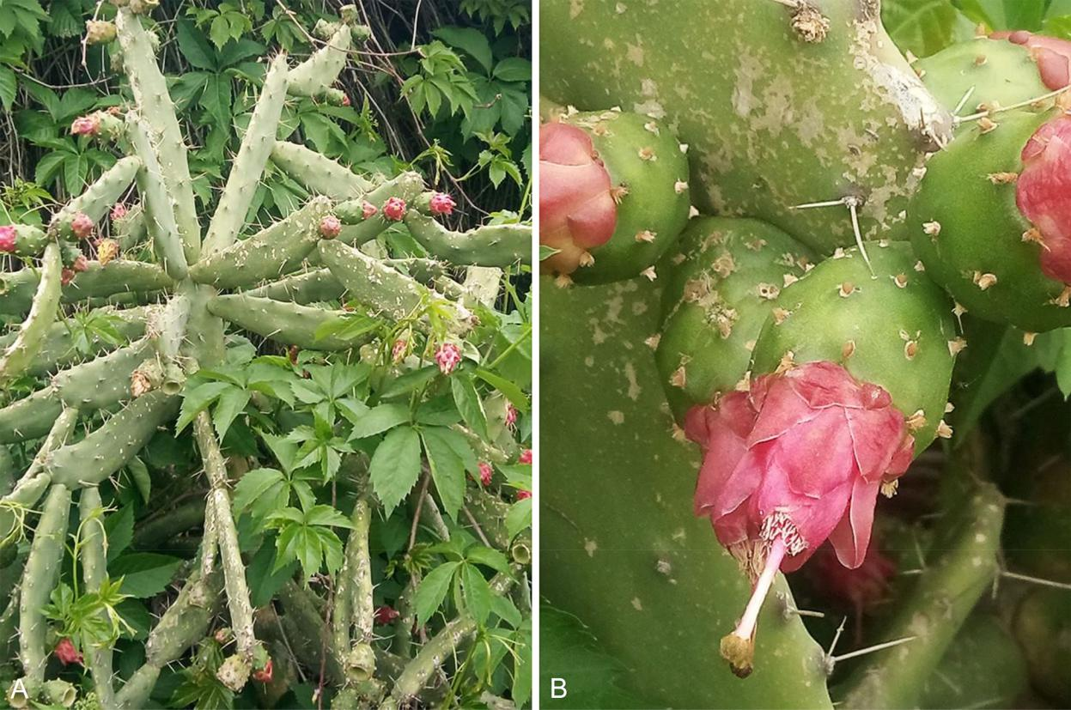

Fig. 2. *Opuntia dejecta* – A: habit of flowering plant; B: detail of flowers showing typical red tepals. – Algeria: Skikda, Beni Bechir, 26 Apr 2020, photographs by A. Saci.

*thenocissus quinquefolia* (L.) Planch., 26 Apr2020, *Saci* (*photos*). – A xenophyte probably native to Panama, *Opuntia dejecta* is very common in cultivation in tropical America (Britton & Rose 1919). The species is new to Algeria, reported for the second time for N Africa (El Mokni & al. 2020; APD 2020) and for the fourth time for the Mediterranean area, where so far it has been reported as natural-ized in Italy (Celesti-Grapow & al. 2009, as *Nopalea dejecta*) and Sicily (Korotkova &Raab-Straube 2017+) and as casual in Tuni-sia (El Mokni & al. 2020). In Algeria, *O. de­* *jecta* is obviously a recent escape and can beclassified only as casual. However, like other species within this genus, it certainly has the potential to spread to nearby regions.

R. El Mokni & A. Saci

*Caryophyllaceae*

***Silene lydia*** Boiss. (≡*Conosilene conica*subsp.*lydia*(Boiss.) Á. Löve & Kjellq. ≡ *Pleconax lydia* (Boiss.) Šourková). – According to Euro+Med PlantBase (Marhold 2011+a), *Silene lydia* (*S.* sect. *Conoimor­* *pha* Otth) would currently occur in most of the Balkancountries, in European Turkey and in SW Asia (Asia Minor, Lebanon and Syria). The alleged occurrence in

Bosnia and Herzegovina, Croatia, Montenegro, North Macedonia,­ Serbia and Slovenia was given by Greuter

* al. (1984) and Chater & al. (1993) and reported in Euro+Med PlantBase (2006+) as “Former Yugoslavia”, all based on misinterpretation of the imprecise “Ma”

(for Macedonia)­ in Hayek (1924: 260). Jalas & Suomi-nen (1988), however, correctly indicated *S. lydia* in Bul-garia, Greece, and European Turkey only. Hayek (1924: 259 – 260) recorded the species from “*Macedonia*, in-clusa Chalcidice et insula Thaso” (abbreviated as “*Ma*”; see Hayek 1927: v), thus referring to the Chalkidiki peninsula and the island of Thasos which are now part of Greece and, respectively, the administrative regions of Central Macedonia and Eastern Macedonia-Thrace. Trinajstić & Pavletić (1979), in their treatment of *Silene* for *Analitička flora Jugoslavije­*, recorded *S. lydia* only as doubtfully present for the Republic of North Mace­ donia.

As part of currently ongoing studies on *Caryophyl­* *laceae* (see, e.g., Iamonico 2018) and specifically on *Silene* sect. *Conoimorpha*, neither herbarium specimensnor published sources of *S. lydia* could be verified from the countries listed below. Therefore, *S. lydia* has to be excluded from the following Balkan countries.

D. Iamonico & E. von Raab-Straube

* **BH:** No record of*Silene lydia*was reported by Beck

(1907). D. Iamonico & S. Maslo

Downloaded From: https://bioone.org/journals/Willdenowia on 23 Aug 2020

Terms of Use: https://bioone.org/terms-of-use

312 Raab-Straube & Raus: Euro+Med-Checklist Notulae, 12

* **Cg:** No record of*Silene lydia*was reported by Rohlena

(1942) and Stešević & Caković (2013).

D. Iamonico & D. Stešević

* **Ct:** No record of*Silene lydia*was reported by Nikolić(2019) and Nikolić (2020).

D. Iamonico & S. Bogdanović

* **Mk:** *Silene lydia*was recorded in North Macedonia inBitola (Velenovský 1911) and Prilep-Dobrush-evo (Stojanoff 1928). According to Micevski (1993), as well as from recent field investiga-tions, these data have not been confirmed, and we think that this species has probably been confused with *S. conica* L.

V. Matevski, D. Iamonico & E. von Raab-Straube

* **Sl:** No record of*Silene lydia*was reported by Mayer(1952), Martinčič & Sušnik (1969), Martinčič
  + al. (1999) and Jogan & al. (2001).

D. Iamonico & N. Jogan

* **Sr:** No record of*Silene lydia*was reported by Slavnić(1970) and Niketić (2012).

D. Iamonico, M. Niketić & N. Kuzmanović

***Stellaria ruderalis*** M. Lepší & al.

* **AE(G), Cr:** Greece, East Aegean Islands: Nomos ofLesvos, Eparchia of Mitilini, Lesvos island, Agia Marina village, along road to north, 39°04'N, 26°35'E, 100 – 200 m, olive grove and stone fences, 28 Mar 1994, *Nielsen &*

*Skovgaard­ 9230* (B, under *Stellaria media*;det. A. Strid); ibid., Nomos of Dodekanisos, Eparchia of Rodos, Rodos island, Stegna, 36°12'39.3"N, 28°08'27.6"E, 3 m, ruderal floodplain c. 200 m distant from the harbour, 18 Mar 2010, *Peter & Ristow RH3-26* (B, as

*S*. *media*; det. A. Strid). Cretan area: Kriti is-land, Nomos of Chania, Eparchia of Kissamos, between Kambos and Keramoti, 35°23'01"N, 23°33'56"E, 370 – 380 m, ruderal places domi-nated by *Geranium molle* L., semi-shaded by *Platanus orientalis* L., slightly condensed acidsoil on schistose substrate, 13 Mar 1998, *Böh­* *ling 7065* (B, as *S*. *media*; det. A. Strid); ibid.,Nomos of Lasithi, Eparchia of Ierapetra, Thrip-ti, 35°04'54"N, 25°51'22"E, 700 m, weedy vineyard with *Oxalis pes-caprae* L., *Poa in­* *firma* Kunth and *Urtica urens* L. on dolomiticsubstrate, 24 Mar 1998, *Böhling & Raus 7219* (B, as *S*. *media*; det. A. Strid); ibid., 700 m, abandoned, formerly irrigated vegetable field under *Platanus* trees on dolomitic substrate, 24 Mar 1998, *Böhling & Raus 7220* (B, as *S*. *media*; det. A. Strid); ibid., Eparchia of Lasi-thi, Lasithi plain SE of Kristallenia monastery, 35°10'44.6"N, 25°30'14.7"E, 840 m, fields and orchards with traditional agriculture, *Bareka &* *Turland sub Turland 1072* (B, as *S*. *media*; det.

A. Strid; duplicates, not examined, in BM, MO, UPA). – Only recently Lepši & al. (2019) un-veiled that the name *Stellaria media*, as tradi-tionally in current use at species rank (i.e. excl. *S*. *apetala* Ucria, *S*. *cupaniana* (Jord. & Fourr.)Bég. and *S*. *neglecta* Weihe), covers in fact an-other two separate species, viz. *S*. *media* (L.) Vill. (s. str.) and *S*. *ruderalis* M. Lepši & al., the latter presumably of hybridogenous origin be-tween *S. apetala* (= *S*. *pallida* (Dumort.) Crép.; see IPNI 2012+; Dimopoulos & al. 2013: 248; Buttler & al. 2018) and *S. neglecta*; for mor-phological, karyological, molecular, ecological and chorological details see Lepši & al. (loc. cit.). *Stellaria ruderalis* is probably a hitherto overlooked, widespread species, the distribu-tion of which is not yet completely known, especially in S Europe. In its *terra typica*, the Czech Republic, it is currently spreading along roads, railways and rivers. Outside this coun-try, Lepši & al. (2019: 412, 418 – 420) identi-fied herbarium material of *S. ruderalis* from Austria, Slovakia, Hungary, Slovenia, Croatia, Serbia, continental Greece (Thessaly) and Italy including Sardinia. The species also occurs in the East Aegean Islands and the Cretan area of Greece, substantiated by re-determined her-barium specimens hitherto stored at B under “*S. media*” (and mapped under that name in Strid 2016b: 330, map 1287). Only a fraction of the vast holdings of Greek specimens of the *Stellaria media* group at B have been criticallyexamined. Ripe seeds are needed for positive identification. *Stellaria ruderalis* may well turn out to be at least as common as *S. media* s. str. The Greek holdings at LD have been examined by T. Tyler, who found that *S. ruderalis* is fairly widespread on the Aegean islands.

A. Strid & Th. Raus

*Chenopodiaceae*

***Dysphania pumilio*** (R. Br.) Mosyakin & Clemants (≡*Chenopodium pumilio* R. Br.)

**A Gg(G):** Georgia: Samegrelo-Zemo Svaneti, Matkhoji,42°23'21.2"N, 42°26'35.54"E, c. 200 m, tram-pled site around church below Matkhoji nun-nery, c. 100 plants, 23 Jul 2019, *Novák* (*pho­* *to*); ibid., Mestia, 43°02'38"N, 42°43'30.1"E,1400 m, gaps between pavement stones of side-walk around central town square, c. 20 plants, 19 Jul 2016, *Novák* (*photo*); ibid., trampled site with annual vegetation next to road close to Mulkhura bridge, 43°02'30.7"N, 42°43'40.7"E, c. 1390 m, dense monospecific patch cover-ing c. 10 m2, 19 Jul 2019, *Novák* (*photo*); ibid., Racha-Lechkhumi and Kvemo Svaneti,

Downloaded From: https://bioone.org/journals/Willdenowia on 23 Aug 2020

Terms of Use: https://bioone.org/terms-of-use

|  |  |
| --- | --- |
| Willdenowia 50 – 2020 | 313 |
|  |  |

Achara,­ 42°33'34.5"N, 42°51'22.1"E, c. 490 m, c. 50 plants in trampled site with annual veg-etation next to main road in centre of village, 8 Jul 2017, *Novák* (BRNU). – *Dysphania pumi­* *lio* is an annual or short-lived perennial plant.It usually inhabits various open annual vegeta-tion, including sidewalks, road edges, etc. It originates from Australia and was introduced mainly with wool shipments across New Zea-land, New Caledonia, North and South Ameri-ca and Europe (Lhotská & Hejný 1979). In the Euro+Med PlantBase (Uotila 2011+), it is re-ported mostly from W, C and S Europe, includ-ing the Balkan Peninsula. Nevertheless, it has not been recorded in Transcaucasia although it was reported from N Iran as well (Rahiminejad

* al. 2004). Currently, it is spreading across Europe mainly by hemerochory. Epichory me-diated by sheep or humans was also described (Lhotská & Hejný 1979). The finding of the large population in Mestia may indicate its fu-ture spreading across Transcaucasia. In Mes-tia, it was observed in a therophyte-rich tram-pled vegetation (*Polygono-Poetea annuae*). In Matkhoji, it occurred in an open vegetation dominated by a species of *Digitaria*, an annual C4 grass (*Digitario sanguinalis-Eragrostietea* *minoris*). In Achara, it grew in a species-richannual vegetation (*Sisymbrietea*) dominated by tall herbs (*Sisymbrium officinale* (L.) Scop. and *Xanthium spinosum* L.).

P. Novák & V. Kalníková

*Compositae* (*Asteraceae*)

***Andryala dentata*** Sm. (≡*A. rothia*subsp.*dentata*(Sm.)

Pignatti ≡ *A. sinuata* subsp. *dentata* (Sm.) Arcang.)

**A Sy:** Northern Golan Heights: c. 3 km E of Merom Go-lan, 33°07'56.2"N, 35°48'44.4"E, 945 m, on grumusol (formed from weathering of lime-stone and volcanic tuff) mixed with alloch-thonous substrate from the construction of a reservoir and its surrounding dike, population of more than 70 individuals, 19 Apr 2018, *Ur* (HUJ, deposited on 20 Aug 2018). – *Andryala* *dentata* is a C & NE Mediterranean species,occurring in S Italy (comprising Sicily and Pantelleria), S & E Greece (including islands), W Turkey and Lebanon (Greuter 2006+). It is an annual herb; stems 8 – 28 cm; cauline leaves sessile, margin dentate; inflorescence corymbi-form; capitula 8 – 14 mm in diam.; involucre slightly stellate tomentose with glandular tri-chomes, external involucral bracts involute, enfolding a floret, purplish at apex; receptacle with short setae 0.4 – 2 mm long; ligules pale yellow, external ones often reddish on outer

face, slightly exceeding involucral bracts. Ar-cangeli (1882: 447) recognized *A. dentata* Sm. as a subspecies of *A. sinuata* L. (i.e. *A. integri­* *folia* L.). Several other authors (e.g. Matthews1975; Sell 1976; Mouterde 1983) have treated *A. dentata* as a plain synonym of the widespread *A. integrifolia*. However, recent taxonomic andphylogenetic studies supported the separation of these two taxa as distinct species (Ferreira & al. 2015). *Andryala dentata* is here reported for the first time from the Golan area with the status of a casual alien, possibly introduced through allochthonous soil material. The species has been known to occur in Lebanon and Syria since the late 19th century (Boissier 1875: 880; Post 1896: 484; followed by Mouterde 1983: 544; Tohmé & Tohmé 2007: 49, as *A*. *integri­* *folia*). Nonetheless, it is considered doubtfullynative in that area (Greuter 2008: 19).

M. Z. Ferreira, M. Sequeira, Y. Ur, S. S. Cohen & Z. Baumwol

*Crassulaceae*

***Crassula alata*** (Viv.) A. Berger

**N Bl(M):** Spain, Balearic Islands, Mallorca: Santanyi,Mondragó Parque Natural, bank of Torrent de ses Coves del Rei near the mouth, 39°21'17.39"N, 03°11'18.72"E, 17 m, salt marsh area on brackish sand, 19 Apr 2017, *De Beer* (BR 0000027274743V). – *Crassula alata* is a poor-ly known species that was initially described from Egypt and was subsequently also found from the Middle East to India. In Europe it was discovered relatively recently, first from the Greek islands of Kriti and the Kyklades (Webb

* Akeroyd 1993). In the Euro+Med area it has been reported so far from Egypt, Libya and Morocco, Israel-Jordan and Lebanon-Syria, Greece (incl. islands) and Cyprus (Marhold 2011+b). In the last two decades, however, it was reported from several additional regions in the Mediterranean region: Sicilia-Pantelleria (Bartolo & al. 2004), Corse (Gallo 2008), Tu-nisia (Lambinon 2000) and, since 2006, also from the Spanish mainland (Martínez Fort & Donat Torres 2006). Recently, it turned out that this species had been overlooked in the Balear-ic island of Menorca, as a result of confusion with *C. tillaea* Lest.-Garl. (Fraga-Arguimbau
* al. 2018). In addition, it is also found as an introduced weed in Australia and New Zealand (Toelken 1981; Sykes 2005).

*Crassula alata* is a rather diminutive spe-cies that is easily overlooked or confused with similar species such as *C. tillaea*. It is easily separated from the latter based on its petals be-

Downloaded From: https://bioone.org/journals/Willdenowia on 23 Aug 2020

Terms of Use: https://bioone.org/terms-of-use

314 Raab-Straube & Raus: Euro+Med-Checklist Notulae, 12

ing only half as long as the sepals, the shortly pedicellate flowers, the mucronate leaf and se-pal tips and the more or less winged stem (after desiccation).

It is here reported for the first time from the island of Mallorca. It occurs in a massive stand on the banks of a rivulet close to the sea, in a salt marsh area on brackish sand. It was ac-companied by *Polypogon maritimus* Willd. and other species typical for that type of habitat.

It is sometimes thought that *Crassula alata* has been widely confused in the Mediterrane-an area and that it has been present for quite a long time. However, the recent record from Mallorca rather seems to point to a recent ex-pansion; the species was certainly absent from that locality about 15 years ago (Ll. Sáez, pers. comm; also Sáez 2003).

D. De Beer & F. Verloove

*Euphorbiaceae*

grass *Eragrostis minor* Host (*Digitario san­* *guinalis-Eragrostietea minoris*).

P. Novák, V. Kalníková & D. Zukal

*Gramineae* (*Poaceae*)

***Aegilops peregrina*** (Hack.) Maire & Weiller (≡*Triticum**peregrinum* Hack.≡ *Aegilemma peregrina* (Hack.) Á.Löve ≡ *Aegilops variabilis* var. *peregrina* (Hack.) Eig & Feinbrun; = *Aegilops variabilis* Eig ≡ *Triticum variabile* (Eig) Markgr.; = *T. ovatum* subsp. *violaceum* Braun-Blanq. & Wilczek ≡ *Aegilops ovata* var. *violacea* (Braun-Blanq. & Wilczek) Maire) – Fig. 3, 4.

**D Cm:** Crimea: Sevastopol region, Balaclava vicin-ity, Vitmerova balka (Vitmer’s ravine), 44°29'55.64"N, 33°37'45.45"E, 260 m, con-glomerate hill, dry grasslands on the edge of woodlands of *Juniperus excelsa* M. Bieb. and *Quercus pubescens* Willd., 16 May 2017, *Ryff* (YALT); ibid., 10 Jun 2019, *Ryff* (YALT); ibid., Varnautskaya valley, Goncharnoye vicinity,

***Euphorbia davidii*** Subils

**A Gg(G):** Georgia: Tbilisi, road and pathmargins around petrol station next to Kakheti Highway S5, 1.3 km NE from Airport Settlement train station, 41°41'33.9"N, 44°57'39.3"E, c. 550 m, c. 50 plants, 17 Jul 2017, *Novák &* *Zukal* (BRNU). – *Euphorbia davidii* is an annual species na-tive to North America, ranging between the central U.S.A. and NW Mexico. As an alien spe-cies it has been reported from Australia, South America and Europe (Barina & al. 2013). In the Euro+Med PlantBase (Euro+Med 2006+) it is reported from Bulgaria only. However, Barina & al. (2013) summa-rized its European distribution and reported the species from 13 countries, including the N Cau-casian foothills in Russia, but not in Transcaucasia. In Europe, it has mostly been found along railways and less frequently road surroundings and arable lands. The source of its seeds in the Georgian site was probably traffic, because it is situated next to the highway, and a railway is also nearby. In this new site it occurred in a sparse vegeta-tion dominated by the annual C4

Fig. 3. *Aegilops peregrina*, habit of plant in habitat. – Crimea: Sevastopol ­region, Balaclava vicinity, Vitmerova balka, 10 Jun 2019, photograph by L. E. Ryff.

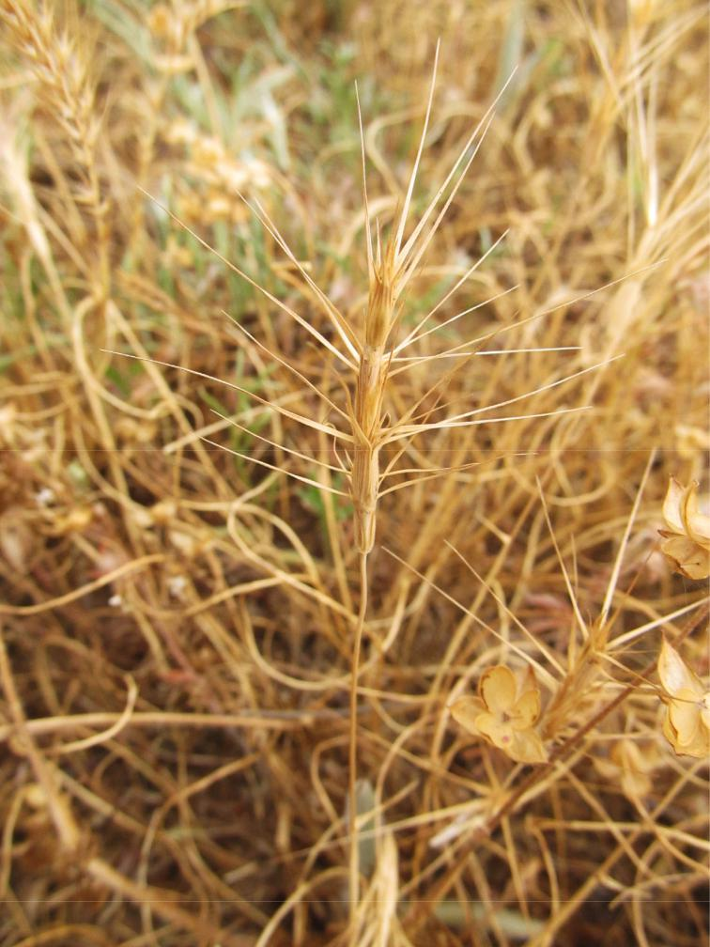

Downloaded From: https://bioone.org/journals/Willdenowia on 23 Aug 2020

Terms of Use: https://bioone.org/terms-of-use

|  |  |
| --- | --- |
| Willdenowia 50 – 2020 | 315 |
|  |  |

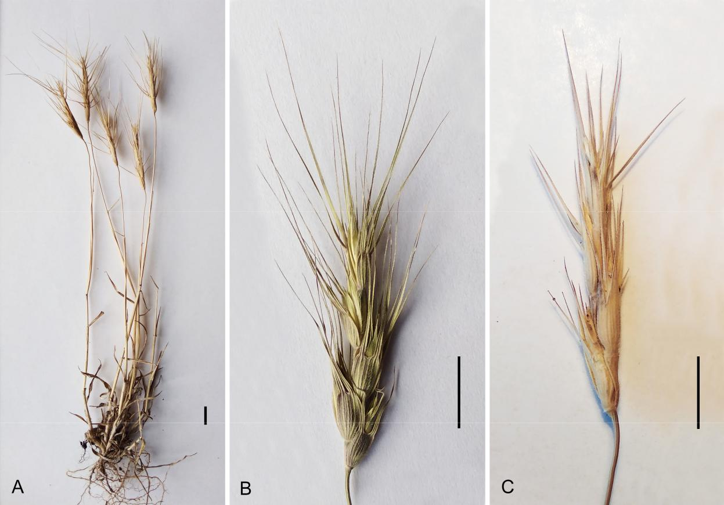

Fig. 4. *Aegilops peregrina*, dried specimens. – A: whole plant; B, C: panicles. – Scale bars: A – C = 1 cm. – Source of material: Crimea, Sevastopol region, Balaclava vicinity, Vitmerova balka, 10 Jun 2019 (A, C), 16 May 2017 (B), *Ryff* (YALT). – Photographs by L. E. Ryff.

44°28'13"N, 33°42'08"E, 270 m, dry grassland on abandoned farmland, 26 May 2017, *Svirin* (YALT). – *Aegilops peregrina* differs from the widespread *A. triuncialis* L. by having glumes with veins equal in width, more or less paral-lel, protruding from the surface and equally spaced; it differs from the closely related *A.* *kotschyi* Boiss. (which has not yet been foundin Crimea) by having a stout spike with an “ir-regular” appearance caused by wide variation in glume and lemma awn development, and by the glumes of the lowest fertile spikelets hav-ing 2 or 3 awns or teeth, non equally wide at the base (Slageren 1994).

This is the first record of *Aegilops pere­* *grina* for E Europe. Its native range is the S

* E Mediterranean and W Asia from Tunisia and Greece to Transcaucasia, Iran and Turk-menistan. In Cyprus this species has a doubt-ful status, but in Morocco, Algeria and Italy it is alien (Valdés & al. 2009+; WCSP 2020). As an adventive plant it is also given for Scotland (Slageren 1994). Despite the fact that plants of *A. peregrina* are found only in natural and semi-natural habitats in Crimea, we assume that this species is also alien there. It was prob-

ably accidentally or deliberately introduced by the Albanian-speaking emigrants from Greece (“Arnauts”) who resettled Crimea from the Aegean Islands in the late 18th century. Bala-clava and the Varnautskaya valley were exactly the areas of their compact residence. Isolation from the main range, limited distribution and small population size, in our opinion, testify in favour of the alien status of *A. peregrina*, but new findings could refute this.

L. E. Ryff & S. A. Svirin

***Cortaderia selloana*** (Schult. & Schult. f.) Asch. &Graebn. (≡ *Arundo selloana* Schult. & Schult. f.)

**N Tn:** Tunisia: Tunis, Sidi Thabet, 36°54'36"N, 10°06'39"E, 23 m, *Acacia* plantations, 27 Jan 2018, *El Mokni* (herb. Univ. Monastir); ibid., Tunis city, 36°51'06"N, 10°07'27"E, 88 m, ruderal vegetation on roadsides, 3 Feb 2020, *El Mokni* (herb. Univ. Monastir); ibid., Mo-nastir, Monastir city, 35°45'57"N, 10°48'22"E, 29 m, olive plantations, 29 Nov 2019, *El* *­Mokni* (herb. Univ. Monastir). – Native totemperate South America (Argentina, Brazil, Chile and Uruguay; Zuloaga & al. 2008). In Europe, according to Başnou (2009), this spe-

Downloaded From: https://bioone.org/journals/Willdenowia on 23 Aug 2020

Terms of Use: https://bioone.org/terms-of-use

It was not reported from the Canary Islands by Hohenester & Welß (1993), Uotila (2009+), Arechavaleta & al. (2010), Muer & al. (2016), Anthos (2020), Gil González (2020) and CABI (2020). The only species of *Myriophyl­* *lum* so far known to occur there (on El Hierro,La Palma, Tenerife and Gran Canaria) is *M.*

*spicatum* L.

*B. Wallnöfer*

*Fig. 5. Myriophyllum aquaticum, flowering plant. – Spain: Canary Islands, La Palma, “Área Recreativa y Acampada” SE of Barlovento, 31 May 2019, photo-graph by B. Wallnöfer.*

*Raab-Straube & Raus: Euro+Med-Checklist Notulae, 12*

316

cies is mainly present in Ireland, Britain, France, Portugal, Spain and Italy. It also occurs in South Africa, Australia, New Zealand, many Micronesian islands, the Hawaiian Islands and the Pacific coast of the U.S.A. For N Africa this species is currently listed as merely “cultivated” in the Ca-nary Islands, Morocco and Al-geria, although this status needs to be updated in at least some of these regions. In Tenerife in the Canary Islands, for instance, it has become an invasive species in a short period of time (Rodrí-guez Navarro & Fariña Trujillo 2019). In Tunisia and Libya it was considered to be “intro-duced” (alien with unknown sta-tus; Valdés & al. 2009+). How-ever, for Tunisia it has not yet been cited or given as natural-ized, neither by Le Floc’h & al. (2010), Dobignard & Chatelain

(2010) nor in the continuously updated APD (2020). The actual alien status of *C. selloana* in Tu-nisia is here defined.

R. El Mokni & F. Verloove

*Haloragaceae*

***Myriophyllum aquaticum*** (Vell.) Verdc. –Fig. 5.

**A Ca(P):** Spain, Canary Islands, La Pal-ma: SE of Barlovento, channel NE-ENE of pond in Área Recre-

ativa y Acampada (area designated for recrea-tion and camping) near Laguna de Barlovento (large artificial basin for storage of drinking water), 28°48'32.1"N, 17°48'7.8"W, 735 m,

1. May 2019, *Wallnöfer* (*photo*). – A very large population of this plant grows at the bot-tom of the channel, which was very muddy and wet but without superficial water at the time of the observation. This species is native to South America and has been reported as an invasive neophyte from all continents except Antarctica (see map in CABI 2020). Accord-ing to CABI (2020), it is now regarded as a major international aquatic weed, having been introduced to much of the warm-temperate to subtropical regions of the world. Cirujano (1997) reported it also from the Spanish main-land and from Portugal, and Hansen & Sund-ing (1993) from the nearby island of Madeira.

*Iridaceae*

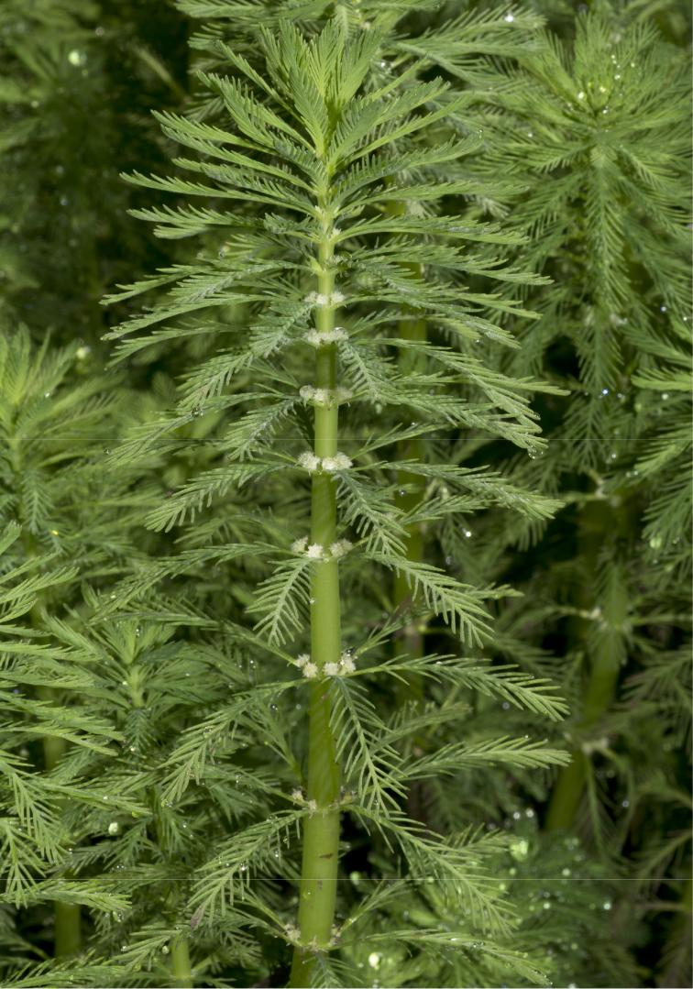

***Iris basaltica*** Dinsm. – Fig. 6, 7.

* **Le:** Lebanon: Michmich, 34°26'49"N, 36°12'38"E,c. 1650 m, 20 May 2020, *Taleb* (*photos*). – Hundreds of *Oncocyclus* irises flowering on basaltic ground in an open landscape along with *Acer hyrcanum* subsp. *tauricola* (Boiss. & Balansa) Yalt., *Astragalus gummifer* Labill., *Berberis libanotica* Ehrenb. and *Juniperus ex­ celsa* M. Bieb. were observed during a visit to

Downloaded From: https://bioone.org/journals/Willdenowia on 23 Aug 2020

Terms of Use: https://bioone.org/terms-of-use

|  |  |
| --- | --- |
| Willdenowia 50 – 2020 | 317 |
|  |  |

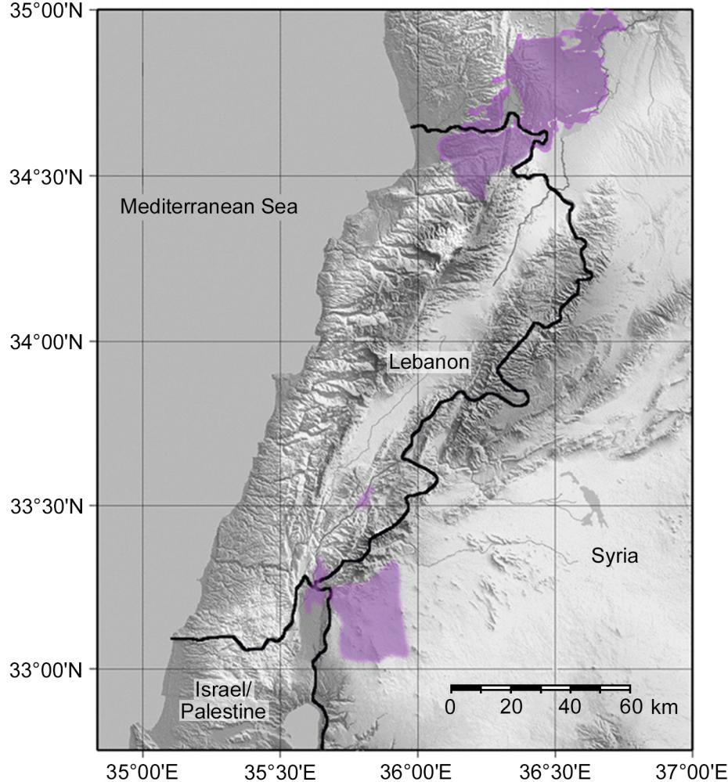

Fig. 6. Map showing areas of basaltic substratum in Syria, Lebanon and Israel/Palestine (purple shading), after Dubertret (1955) and Walley (1998).

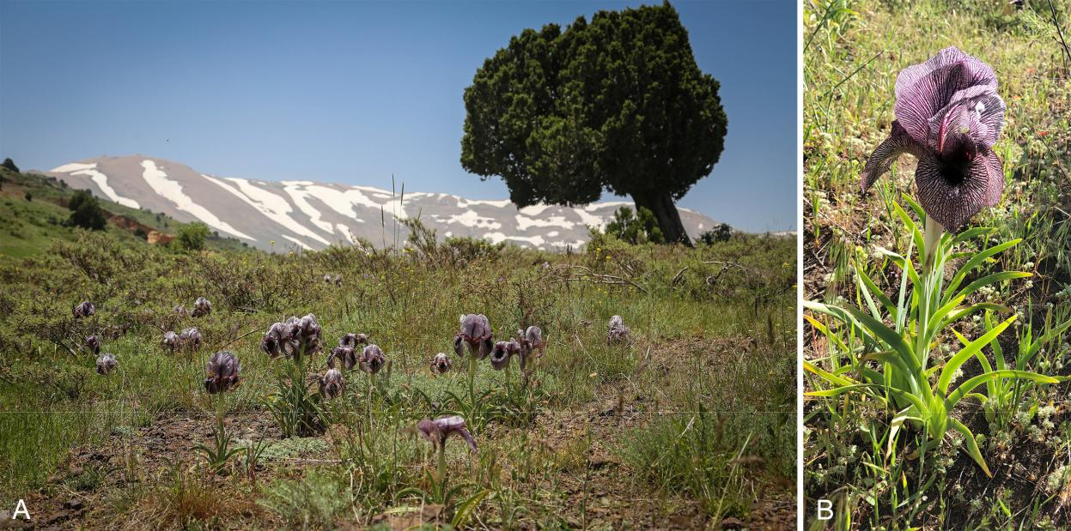

Fig. 7. *Iris basaltica* – A: basaltic landscape showing clumps of flowering *Iris basaltica* in foreground and tree of *Juniperus excelsa*

in background; B: flowering plant. – Lebanon: Michmich, c. 1650 m, 20 May 2020, photographs by K. Taleb.

Downloaded From: https://bioone.org/journals/Willdenowia on 23 Aug 2020

Terms of Use: https://bioone.org/terms-of-use

318 Raab-Straube & Raus: Euro+Med-Checklist Notulae, 12

Michmich. The irises were found in five sites with basaltic outcrop soil located a few kilome-tres apart from one another.

*Iris basaltica* grows only on basalt (Fig.6; Post 1933; West 1963). It was given by Mouterde (1966) as endemic to the S part of the coastal mountains of Talkalakh and Qala’at-el-Hosn basalt desert and hillsides in W Syria, in close proximity to the Lebanese border (Al-Abdul Wahab & al. 2004). Herbarium speci-mens are preserved in Paris (P). *Iris basaltica* is a perennial with short, knobby rhizomes, a long stem, many long, falcate leaves, a single spherical flower, sepals with a prominent sig-nal spot that is distal to a relatively sparse and non-linear beard that does not extend to the midpoint of the sepal, and a conspicuous aril on the seed. Plants with different heights and different colour tones were observed. Irises of different ages highlight the very active natural regeneration at the newly discovered sites.

*Iris* sect. *Oncocyclus* (Siemssen) Dykesincludes about 65 described taxa. They are restricted to SW Asia and are mainly found in the E Mediterranean region and the Cauca-sus. These irises have remarkable flower sizes and pollination biology. Induced hybridiza-tion among various species showed that inter­ specific hybrids between taxa are fully fer-tile (Avishai & Zohary 1977). It is therefore believed that speciation in this group did not involve the build-up of internal reproductive isolation barriers. The various species of the highly specialized, insect-pollinated *Oncocy­* *clus* irises are isolated from one another bygeographic, ecological, and temporal mecha-nisms and by preferences of their pollinators (Sapir & Shmida 2002; Saad & al. 2009). They are also likely adapted to an environmental aridity gradient, which is indicative of ongo-ing species formation.

In Lebanon, seven *Oncocyclus* iris taxa exist at different altitudes (Abdel Samad & al. 2016) and are isolated geographically from one an-other: *Iris antilibanotica* Dinsm., *I. bismarcki­* *ana* Damman & Sprenger, *I. cedreti* Dinsm.ex Chaudhary, *I. lortetii* Barbey ex Boiss., *I.* *sofarana* f. *kasruwana* (Dinsm.) Mouterde, *I. sofarana* f. *westii* (Dinsm.) Mouterde and *I. so­ farana* Foster s.str.

*Iris basaltica* is considered as Data Defi-cient according to IUCN standards (Lansdown 2016). There is no information on population trends in this species. This *Iris* was thought to be extinct until a few individuals were found in 2008 near Homs (Houlani 2008). Fortunately, its area of occupancy in Lebanon is relatively

large. While the newly discovered *I. basaltica* populations in Lebanon are healthy and abun-dant, they happen to be all present on private lands, hence their entire habitats are threat-ened. Conservation measures should be taken promptly to preserve them.

K. A. Taleb, A. A. Taleb &

M. Bou Dagher Kharrat

***Iris variegata*** L. – Fig. 8.

* **Gr:** Greece: C Makedonia, Nomos of Pella, Eparchiaof Almopia, Mt Tzena, 41.158144°N, 22.257800°E, 1510 m, grassland, parent rock mixed gneiss and marble, 19 May 2013, *Cha­* *sapis 2243* (TAUF); ibid., 14 Jun 2019, *Cha­ sapis 2467* (TAUF). – This is a C & SE Eu-ropean species with a wide distribution from SC Germany and W Ukraine to Bulgaria and North Macedonia (Barker & Govaerts 2019; Tutin & al. 1980). Not mentioned for Greece by Dimopoulos & al. (2013, 2016), its occur-rence in that country was first substantiated by herbarium material in 2013. A few individuals (c. 10) were found on a steep, stony and grassy slope of Mt Tzena at an altitude of 1510 m, just below the treeline formed by beech (*Fagus syl­* *vatica* L.). In 2019, a larger population of c.100 individuals was found in the same locality.

M. Chasapis, D. A. Samaras, K. Theodoropoulos & E. Eleftheriadou

*Labiatae* (*Lamiaceae*)

***Salvia reflexa*** Hornem.

**A Gg(G):** Georgia: Racha-Lekhumi and Kvemo Sva­neti, Achara, 42°33'34.5"N, 42°51'22.1"E, c. 490 m, c. 50 plants in ruderal site in vil-lage, next to main road, 8 Jul 2017, *Novák* (BRNU); ibid., Mstskheta-Tianeti, Ananuri, 42°10'22.7"N, 44°41'38.3"E, c. 840 m, four plants in open grassland in front of house be-low Georgian Military Highway, 10 Aug 2018, *Novák & Harásek* (*photo*). – *Salvia reflexa* isan annual herb of North American origin (cen-tral U.S.A. and Mexico). In both its native and non-native ranges, it occurs on trampled sites and as a weed of crops (Lovett & Lynch 1979; Shao & al. 2019). It is occasionally cultivated as an ornamental plant in the warmer parts of the world, including S Europe. As it has pro-lific seed production, it is spreading by escap-ing from cultivation and by seeds contained in foodstuffs (grain and bird seed). In newly reached regions, it can rapidly colonize suitable habitats and affect the vegetation, where it can be a dangerous weed in crop fields because it contains substances toxic to cattle (Shao & al.

Downloaded From: https://bioone.org/journals/Willdenowia on 23 Aug 2020

Terms of Use: https://bioone.org/terms-of-use

|  |  |  |  |
| --- | --- | --- | --- |
| Willdenowia 50 – 2020 |  | 319 |  |
|  |  | |  |
|  | 6 Jul 1947, *Chilikina* (LENUD); ibid., W | |  |
|  | slope of Ainurbalakat site near Urkarah | |  |
|  | villages, 42°09'N, 47°34'E, 21 Jul 1947, | |  |
|  | *Chilikina* (LENUD); ibid., Buinaksky dis- | |  |
|  | trict, above Karamakhi village, NE slope, | |  |
|  | 42°36'42.6"N, 47°13'50.3"E, 1280 m, 26 | |  |
|  | Aug 2016, *Murtazaliev* (DAG). – *Onobry­* | |  |
|  | *chis altissima* grows in Transcaucasia, as | |  |
|  | well as in Turkey and Iran (Yakovlev & al. | |  |
|  | 1996; Menitsky 2001). The species is re- | |  |
|  | corded here for the first time for the Rus- | |  |
|  | sian part of the Caucasus. It was recently | |  |
|  | collected by us in Dagestan, and several | |  |
|  | sheets were found in the herbarium of the | |  |
|  | Dagestan University (LENUD), collected | |  |
|  | in the mid-20th century and correctly iden- | |  |
|  | tified by L. Chilikina. *Onobrychis altissima* | |  |
|  | is closest to *O. inermis* Steven, from which | |  |
|  | it differs in the larger size of the plant, in- | |  |
|  | cluding larger fruits and flowers. *Onobry­* | |  |
|  | *chis altissima* grows in dry meadows in the | |  |
|  | middle mountain belt, whereas *O. inermis* | |  |
|  | grows on steppe slopes in the lowlands and | |  |
|  | in the lower mountain zone. |  |  |
|  | R. A. Murtazaliev | |  |
|  | ***Wisteria sinensis*** (Sims) Sweet | |  |
|  | **A Tn:** Tunisia: Bizerte, Bizerta city, Bab- | |  |
|  | Mateur, 37°16'12"N, 09°52'01"E, 10 m, | |  |
|  | roadsides, 23 Feb 2011, *El Mokni* (herb. | |  |
|  | El Mokni); ibid., Jendouba, Tabarka, El | |  |
|  | Houemdeya, 36°55'33"N, | 08°47'22"E, |  |
| Fig. 8. *Iris variegata*, flowering plant in habitat. – Greece: Central Makedonia, 30 m, abandoned field, 4 | | Mar 2015, *El* |  |
| Mt Tzena, 19 May 2013, photograph by M. Chasapis. | *Mokni­* (herb. El Mokni); ibid., Aïn Draham, | |  |
|  | 36°46'54"N, 08°41'12"E, 720 m, pedestrian | |  |
| 2019). In the Euro+Med PlantBase (Euro+Med | paths, roadsides, 11 May 2016, *El Mokni* (herb. | |  |
| 2006+), it has so far been reported only in | El Mokni). |  |  |
| Ukraine, although it was also mentioned as | **C Ag:** Algeria: Annaba, Annaba city, quartier Gas- | |  |
| a casual alien in the United Kingdom (Clem- | siot, 36°55'06"N, 07°45'21"E, 70 m, private | |  |
| ent & Foster 1994). In Achara, it inhabited | gardens, 23 Mar 2020, *De Bélair* (herb. De | |  |
| species-rich annual vegetation (*Sisymbrietea*) | Bélair). |  |  |
| dominated by tall herbs (*Sisymbrium officinale* | *Wisteria sinensis* is a perennial, woody | |  |
| (L.) Scop. and *Xanthium spinosum* L.). In Ana- | species native to China, where it is widespread | |  |
| nuri, the trampled grassland (*Molinio-Arrhena­* | (Wei & Pedley 2010). This species is cultivat- | |  |
| *theretea*) was dominated by *Cichorium intybus* | ed in temperate regions of Europe, Asia, Af- | |  |
| L. and *Trifolium repens* L. | rica, Australasia and North and South Ame­ | |  |
| P. Novák, V. Kalníková & M. Harásek | rica (Wei & Pedley 2010; GBIF 2013; Kartesz | |  |
|  | 2015; ILDIS 2020). In the U.S.A., it is listed | |  |
| *Leguminosae* (*Fabaceae*) | as naturalized from Vermont and Massachu- | |  |
| setts south to Florida and west into Illinois | |  |
|  |  |
| ***Onobrychis altissima*** Grossh. | and Texas (Kartesz 2015); it is also noted as | |  |
| **+ Rf(CS):** Russia: Dagestan, Dakhadaevsky district, | occurring in Hawaii (PIER 2018). Other coun- | |  |
| NE slope in area of N Kaba, N of Urkarakh | tries list occasional, naturalized populations of | |  |
| villages, 42°11'N, 47°37'E, c. 1700 m, grass | *W. sinensis*, including New Zealand (Webb & | |  |
| meadow, 5 Jul 1947, *Chilikina* (LENUD); | al. 1988) and Argentina (Hurrell & al. 2011). | |  |
| ibid., terrace at Shchirbachi site near Urka- | In Europe, the taxon is reported as alien with | |  |
| rakh villages, 42°07'N, 47°37'E, grassy slope, | “status unknown” in France (see, e.g., Hey- | |  |

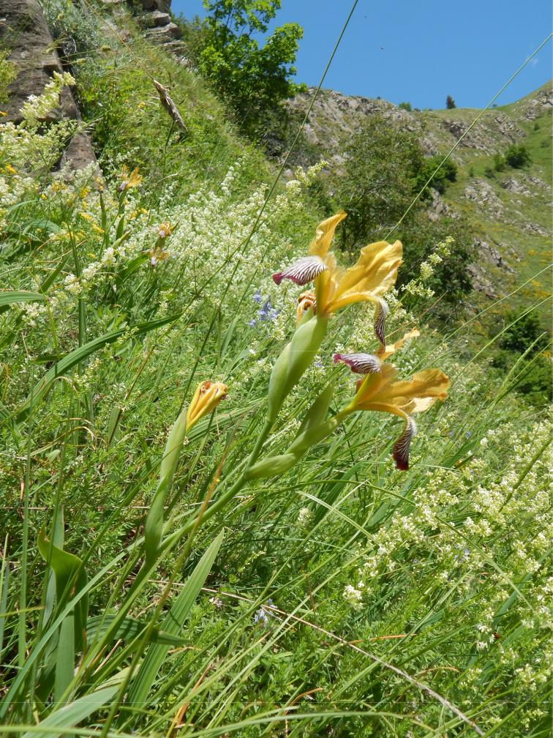

Downloaded From: https://bioone.org/journals/Willdenowia on 23 Aug 2020

Terms of Use: https://bioone.org/terms-of-use

320 Raab-Straube & Raus: Euro+Med-Checklist Notulae, 12

wood & Ball 1968; Greuter & al. 1989; ILDIS 2020), as occasionally naturalized in Spain (Campos & Herrera 2008) and as naturalized in Italy (Galasso & al. 2018). For N Africa, the status needs to be defined (see Dobignard

* Chatelain 2012; CABI 2020), even though the species was reported from Algeria in 1913 as an introduced and well-acclimatized taxon (Gubb 1913). Here we assign to *W. sinensis* the status of “alien” in Tunisia and “cultivated in large scale” in Algeria.

R. El Mokni & G. De Bélair

*Malvaceae*

***Abutilon grandifolium*** (Willd.) Sweet

**N Tn:** Tunisia: Nabeul, Bir Bouragba, 36°25'41"N,10°34'12"E, 20 m, roadsides, 25 Jun 2017, *El Mokni* (herb. Univ. Monastir); ibid., Mo-nastir, Jemmel toward Bir Taeib, 35°37'45"N, 10°44'39"E, 20 m, 23 Sep 2018, *El Mokni* (herb. Univ. Monastir). – *Abutilon grandifo­* *lium*, a shrubby tree 1 – 3 m tall originating fromSouth America, is a naturalized weed in tropi-cal Africa, South Africa (mainly in KwaZulu-Natal and Eastern Cape provinces), Australia, New Zealand and the Pacific Islands (see, e.g., Hutchinson & Dalziel 1958; Burkill 1997; Bredenkamp & Leistner 2003; Jaca & al. 2015; Von Staden 2016; Badry & al. 2018). In the Mediterranean region, this species has not yet been recorded according to Valdés (2011+b). However, more recently it was reported from Portugal and Spain (Domingues de Almeida & Freitas 2012; GBIF 2015a; CABI 2020; Ver-loove & al. 2020). For N Africa, the species is cited as alien with unknown status only in the Canary Islands. In fact, *A. grandifolium* is considered invasive there (Acebes Ginovés & al. 2010). The African Plant Database (APD 2020) listed the occurrence of the species as present with “naturalised-introduced” status for the Canary Islands, Morocco and Egypt. *A.* *grandifolium* is reported here for the first timefrom Tunisia. Sporadic subpopulations of a few perennial individuals have been observed growing mainly in the Cap Bono region since 2018; therefore, the species can be considered as locally naturalized in Tunisia.

R. El Mokni & F. Verloove

*Orchidaceae*

***Ophrys helenae*** Renz (≡*O. sphegodes*subsp.*helenae*(Renz) Soó) − Fig. 9.

**D AE(G):** Greece, East Aegean Islands: Nomos of Les-vos, Island of Lesvos, near Eresos, 39.15388°N,

25.95917°E, 120 m, on verge of road between Kalloni and Eresos, two flowering individu-als, 9 Apr 2018, *Löki & al.* (*photo*). – The new record is located on a roadside verge, and its indigenous status is doubtful. On the one hand, roadsides often host viable orchid populations (Fekete & al. 2017; Rewicz & al. 2017), and these habitats can serve as ecological corri-dors for plant dispersal, linking distant habitat patches (Tikka & al. 2001). Therefore, the nat-ural long-distance spread of the species is easi-ly conceivable. Moreover, in the genus *Ophrys*, a significant long-distance dispersal event is also known (Molnár V. & al. 2011). However, the dispersal of small seeds can be facilitated by the air-turbulence of cars (Ross 1986) or by mud attached to vehicles, which often contains large numbers of various seeds (Clifford 1959). Therefore, the human-induced colonization of the plant cannot be excluded.

*Ophrys helenae* was described from theisland of Kerkira (Corfu) based on a single specimen observed in two consecutive years (Renz 1928: 251). The species is distributed in Greece from Kerkira and Kefalonia east to Thessalia, south to the Gulf of Korinthos and north to Kastoria (Delforge 2006); fur-thermore, it also occurs in S Albania (Barina 2017). Its centre of distribution is in Ipiros (Delforge 2006), but only a single location (Ilia) is known in Peloponnisos (Papadopou-los & al. 2011). Occurrence of the species on the Aegean islands was previously unknown. The new record of *O. helenae* is located 450 km distant from the closest known popu-lation. The plant grows in full light to partial shade in xerotherm or mesophilous habi-tats on alkaline substrates, scrublands, open woodlands and dry grasslands, up to 1000 m above sea level (Delforge 2006). *Ophrys* *helenae* is a morphologically very stable anddistinct species within the genus. Its most re-markable characteristic is the entire, orbicular to broadly oboval, cherry-red to red-wine-coloured lip without a speculum (Renz 1928; Delforge 2006).

V. Löki, R. Fekete & A. Molnár V.

*Orobanchaceae*

***Orobanche baumanniorum*** Greuter – Fig. 10.

* **It:** Italy: Apulia, Gargano, region Mattinata, 10 May2006, *Gubler* (*photos*, host unclear, det./rev. Uhlich & Rätzel 21 Jan 2020). – New for Italy and the C Mediterranean (cf. Pignatti 2018). *Orobanche baumanniorum* was described fromGreece (Greuter 1987: 448; holotype: Sterea

Downloaded From: https://bioone.org/journals/Willdenowia on 23 Aug 2020

Terms of Use: https://bioone.org/terms-of-use

|  |  |
| --- | --- |
| Willdenowia 50 – 2020 | 321 |
|  |  |

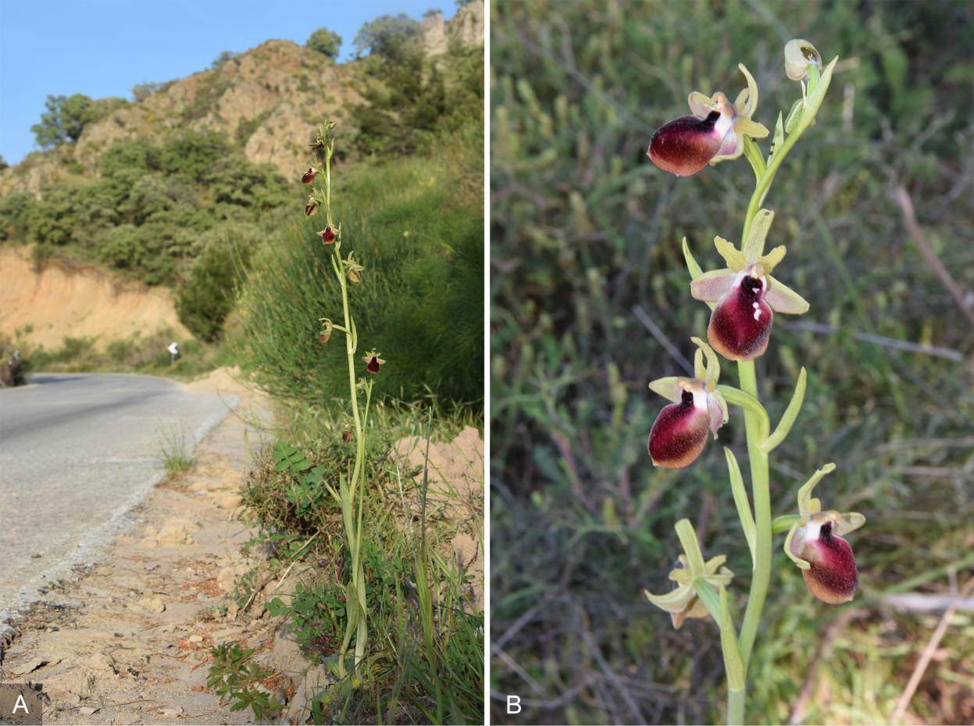

Fig. 9. *Ophrys helenae* – A: flowering plant in habitat; B: inflorescence. – Greece: Lesvos, near Eresos, 9 Apr 2018, photographs by A. Molnár V.

Ellas, Attika, Mt Parnis, May 1974, *Baumann*

* *Baumann*, herb. Greuter; isotype: [B 10](https://herbarium.bgbm.org/object/B100294598) [0294598!,](https://herbarium.bgbm.org/object/B100294598) host *Pterocephalus perennis* Coult.) and has a restricted distribution in the E Medi-terranean. In Greece, the species is given for the regions Ionian Islands, North East, North Central, East Central, Sterea Ellas and Pelopon-nisos (Dimopoulos & al. 2013). It has also been recorded from the Taurus mountains of Turkey, as follows: *Flora of Turkey* grid square C3: An-talya, 2019, *Gül* (*photo*, [https://turkiyebitkileri](https://turkiyebitkileri.com/en/photo-gallery/view-album/4521.html)

[.com/en/photo-gallery/view-album/4521.html,](https://turkiyebitkileri.com/en/photo-gallery/view-album/4521.html) accessed 22 Feb 2020); Kemer, Kesme boğazı (Zare & al. 2017); Manavgat, Oymapınar-dam (Zare & al. 2017); C4: Gündoğmuş, 2018, *Gül* (*photo*, [https://turkiyebitkileri.com/en/photo](https://turkiyebitkileri.com/en/photo-gallery/view-album/4521.html) [-gallery/view-album/4521.html,](https://turkiyebitkileri.com/en/photo-gallery/view-album/4521.html) accessed 22 Feb 2020); Gündoğmuş, Alıkbazı (Zare & al. 2017); Basyayla NW of Ermenek (Hahn

* al. pers. comm. 2001); Gazipaşa, Sugözü (Zare & al. 2017); Demirtaş, between Beydibi/ Beldibi and Çiğdem Daği, Inhisar (Zare & al. 2017); C5: between Işıktepe/Sedichig and Çukurkeşlik, Efrenk valley/Güzeldere (Zare & al. 2017).

*Orobanche baumanniorum* shows a charac-teristic habit and is morphologically relatively isolated from all other *Orobanche* species in the Eurasian area except *O. cypria* Reut., probably endemic to Cyprus. Its position in *O.* ­subsect. *Glandulosae* (Beck) Teryokhin by Teryokhin& al. (1993) is provisional.

All verified host plants belong to *Caprifo­* *liaceae*, mostly *Pterocephalus perennis*, rarelyvarious species from *Cephalaria*, *Lonicera* and *Scabiosa* (see also Rätzel & al. 2018b)*.*

H. Uhlich, E. Gubler & S. Rätzel

***Orobanche lucorum*** A. Braun ex F. W. Schultz (=*O.*

*rubi* Duby, nom. utique rej. prop.) – Fig. 11.

* **Rf(CS):** Russia: North Caucasus, Kabardino-Balkari-ya, El’brusskiy rayon, Adyr-Su valley (S tribu-tary of Baksan river), above vehicle lift c. 1 km S of Verkhniy Baksan, 43°18'N, 42°45'31"E, 1655 m, pine forest, grazed, presumably on

*Berberis*, 19 Jul 2019, *Parolly & al. 15740* [(B](https://herbarium.bgbm.org/object/B101118201)[10 1118201,](https://herbarium.bgbm.org/object/B101118201) MW, W; det. Rätzel & Uhlich Mar 2020). – New for Russia and the first verified record for the entire Caucasus region. *Orobanche lucorum*, described from Germany

Downloaded From: https://bioone.org/journals/Willdenowia on 23 Aug 2020

Terms of Use: https://bioone.org/terms-of-use

322 Raab-Straube & Raus: Euro+Med-Checklist Notulae, 12

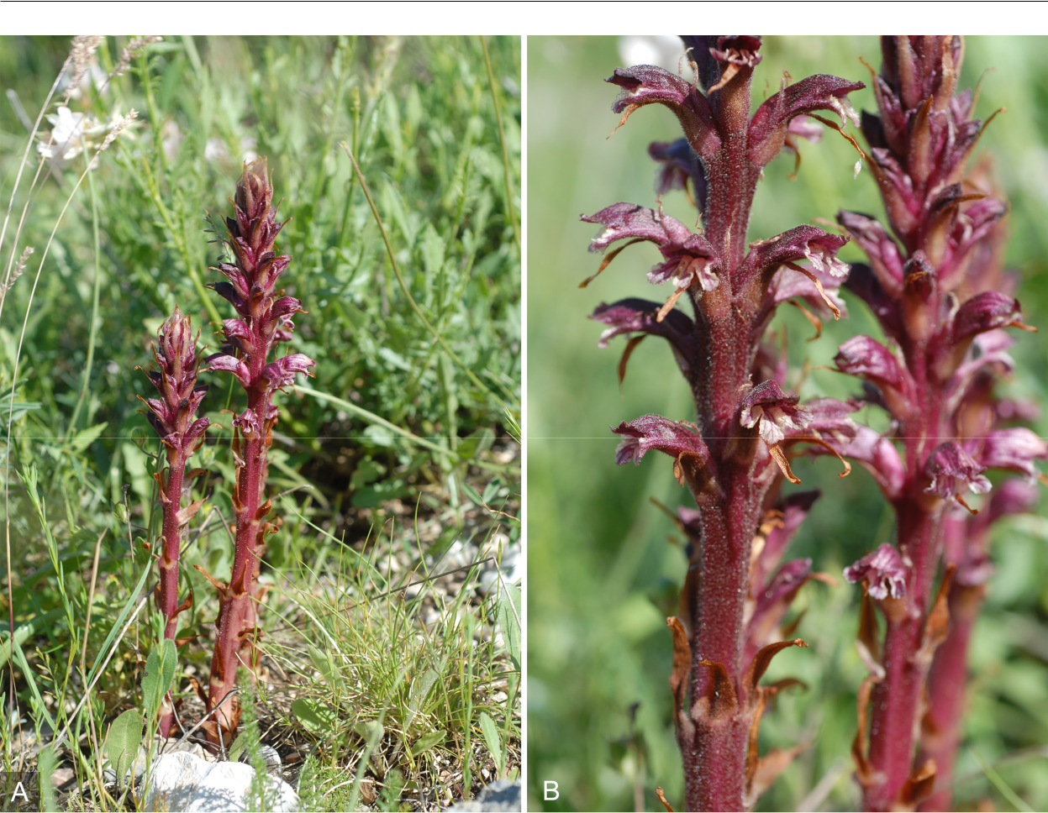

Fig. 10. *Orobanche baumanniorum* – A: habit of flowering plant; B: detail of inflorescences. – Italy: Apulia, Gargano, region ­Matinata, 10 May 2006, photographs by E. Gubler.

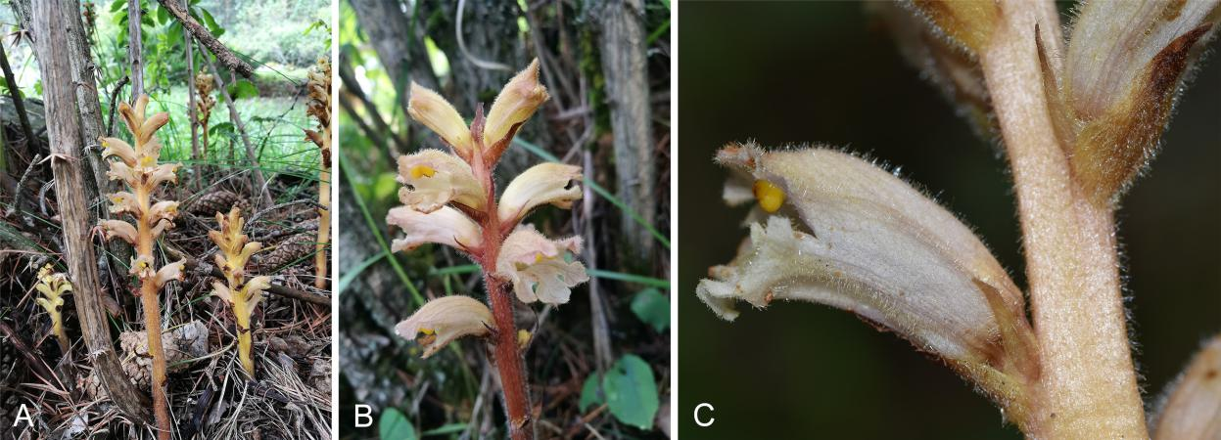

Fig. 11. *Orobanche lucorum* – A, B: habit of flowering plants with probable host *Berberis*; C: detail of flower. – Russia: Greater Caucasus, Kabardino-Balkaria, Adyr-Su (Baksan river) valley, 19 Jul 2019, photographs by E. von Raab-Straube (A, B) and G. Parolly (C).

(lectotype designated by Fleischmann & al. 2019: 599) was believed to have a restricted distribution in the European Alps. Its hosts include deciduous *Berberis* species, in nature especially *B. vulgaris* L. Native populations of the plant were so far known from Germany, Switzerland, Liechtenstein Austria and Italy

(Beck 1890: 187, Karte I; Beck 1930: 264;

Kreutz 1995: 112; Uhlich & al. 1995: 149, 232,

map 13; Aeschimann & al. 2004: 294; Pusch

2009: 87; Sánchez Pedraja & al. 2016+). Some older records of this taxon from

France (as *Orobanche rubi*), Slovenia, Croatia and Romania could not be confirmed (Grecescu

Downloaded From: https://bioone.org/journals/Willdenowia on 23 Aug 2020

Terms of Use: https://bioone.org/terms-of-use

|  |  |
| --- | --- |
| Willdenowia 50 – 2020 | 323 |
|  |  |

1898: 450; Beck 1930: 264f; Buia 1961: 70;

Gilli 1975: 501; Kreutz 1995: 112; Uhlich & al. 1995: 149; Sánchez Pedraja & al. 2016+). Indi-cations concerning the occurrence in Slovenia by Pusch (2009: 87) are doubtful, and Wraber

& Skoberne (1989) did not list the species for that country. *Orobanche lucorum* has some-times been confused with *O. lycoctoni* Rhiner, mainly in the Balkan Peninsula, but also in the Alps (Sánchez Pedraja & al. 2016+; unpub-lished records from herbaria). Records from Croatia (Sánchez Pedraja & al. 2016+, citing Kreutz 2001: 431) are due to confusion with *O. minor* Sm. Records from Spain are errone-ous and refer to other taxa (e.g. Foley 2001a: 60; Foley 2001b: 228; Sánchez Pedraja & al. 2016+). However, adventive occurrences are known from many European countries, which mostly originate from botanical institutions and gardens and can apparently be persistent for a long time (cf. Beck 1930: 265; Uhlich & al. 1995: 149; Sánchez Pedraja & al. 2016+).

The only previous indication for the Cauca-sus (Koch 1849: 667, “wächst nur auf holzigen Wurzeln verschiedener Sträucher … im süd-lichen Dagestan sehr häufig, 500 – 800' hoch”; record not mentioned by Beck 1930) is un-certain and could well refer to other species, especially to the widely distributed *Orobanche*

*laxissima­* Uhlich & Rätzel (Rätzel & Uhlich2004: 194). *Orobanche lucorum* is not men-tioned in floristic literature for Russia or the Caucasus region (e.g. Novopokrovsky & Tzve­ lev 1958; Tzvelev 2015), and no specimens have been found in comprehensive herbarium revisions, mainly in LE, during the last two decades by the second author. The present population was found in a pastured clearing in *Pinus sylvestris* var. *hamata* Steven forest supporting scattered shrubs of *Berberis* cf. *vul­* *garis*. Associated herbaceous species include *Alchemilla* spp., *Campanula collina* Sims, *C. grossheimii* Charadze, *Gentianella caucasea* (Sims) Holub, *Scabiosa ochroleuca* L., *Trifo­* *lium canescens* Willd*.* and *T. repens* L.

*Orobanche lucorum* belongs to the group of *O. flava* F. W. Schultz and differs from relatedspecies by it erect, barely reflexed upper calyx lobes, and from some of the related taxa (e.g. *O.* *flava* and *O. salviae* W. D. J. Koch) by deeplyinserted (2 – 3 mm) filaments. It is further char-acterized by the usually very lax inflorescence, at least in the basal part, and by very tender and relatively short calyx parts barely reaching

* of the corolla length. In all those characters, the material from the Elbrus region is similar to plants from the Alps and to the type speci-

men. *Orobanche inulae* Novopokr. & Abramov from the same group, locally frequent in the W part of the Great Caucasus, differs in ecol-ogy (hosts: *Inula* sp.), colour (whole plant yel-lowish to whitish without red or brown tinge), habit (inflorescence remaining compact) and morphology (e.g. much denser, eglandular pi-lose indumentum on filaments, almost reaching anthers).

The gathering from the Elbrus area, how-ever, stands out by having flowers significantly larger than the size given in the literature for *Orobanche lucorum* from the Alps (17 – 25 mmvs 12 – 20[– 21] mm; cf. Beck 1930: 263; Gilli 1975: 500; Kreutz 1995: 112; Uhlich & al. 1995: 148; Pusch 2009: 86). The original descriptions (Schultz 1830: 504; Braun in Koch 1833: 456) do not indicate the flower size. However, further examination of specimens of *O. lucorum* in B by the first author revealed that material from the European Alps can also have larger flow-ers up to 25 mm long, e.g.: Austria, Innsbruck, 1 Aug 1894, *Bornmüller* [(B 10 1113779);](https://herbarium.bgbm.org/object/B101113779) Italy, Bozen [Bolzano], in alpibus Rosengarten, pr. Welschnofen, *Berberidi* parasitica, 27 Jul 1903, *Bornmüller* [(B 10 1113778);](https://herbarium.bgbm.org/object/B101113778) *Italy,* Südalpen,Vintschgau, 15 Jul 1966, *Poelt* [(B 10 1113780,](https://herbarium.bgbm.org/object/B101113780) as *O.* cf. *lucorum*). Therefore, indication of flower size has to be emended, i.e. enlarged, for the species throughout its distribution range, and the larger flower size does not constitute a spe-cial trait for the apparently disjunct population in the Elbrus region.

S. Rätzel, H. Uhlich, D. Shilnikov, N. Korotkova, G. Parolly & E. von Raab-Straube

***Orobanche lutea*** Baumg.

* **By:** Belarus: [label translated into English] Vitebskregion and district, railway territory, sta-tion Lëtsy c. 2 km toward Vitebsk, right side, c. 300 m from bridge over Uzhniza river (direc-tion Vitebsk), 140 m, steppic grassy meadow in strip separated by railway, more than 40 plants in 200 × 5 m area, 17 Jul 1999, *Dschus* [*Dzhus*] *1174* (LE, with fragments of presumed host *Medicago falcata* L., conf. Uhlich Feb 2020).

– New for Belarus. Not mentioned in Uhlich & al. (1995), Tretyakov & Dzhus (1999), Domina & Raab-Straube (2010+) and Sánchez Pedraja

& al. (2016+). H. Uhlich & S. Rätzel

***Phelipanche gussoneana*** (Lojac.) Domina & al. (≡*Phe­**lypaea gussoneana* Lojac.; = *Phelipanche schultzioides* M. J. Y. Foley ≡ *Orobanche schultzioides* (M. J. Y. Fo-ley) Domina; – *O. ramosa* var. *brevispicata* sensu Meikle 1985, non (Ledeb.) R. A. Graham) – Fig. 12.

Downloaded From: https://bioone.org/journals/Willdenowia on 23 Aug 2020

Terms of Use: https://bioone.org/terms-of-use

324 Raab-Straube & Raus: Euro+Med-Checklist Notulae, 12

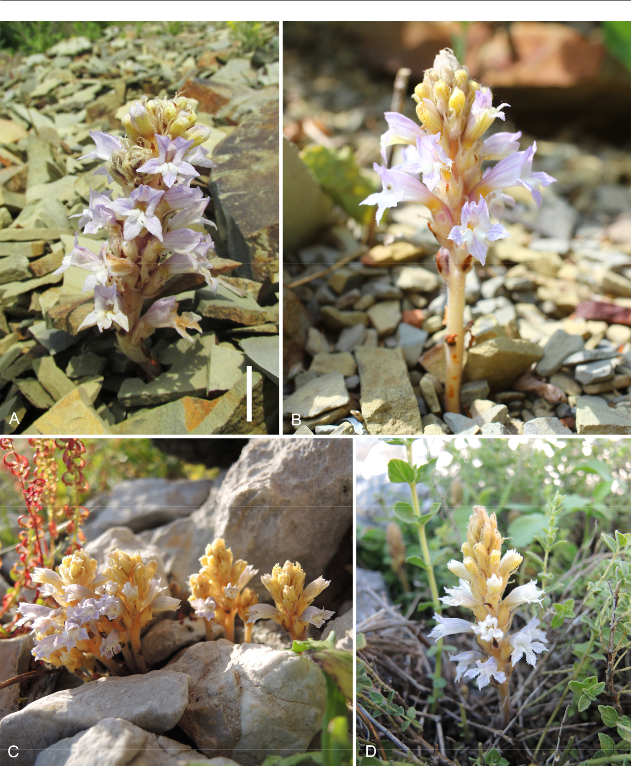

Fig. 12. *Phelipanche gussoneana* var. *zosimae* – A: habit of flowering plant parasitizing *Seseli ponticum*; B: habit of flowering plant

parasitizing *Fibigia clypeata* subsp. *eriocarpa*; C, D: habit of flowering plants parasitizing *Origanum onites*; C: left and middle

plants with form of corolla lobes transitional to var. *gussoneana*; D: plant with form of corolla lobes typical for var. *zosimae*. – A:

Russia, Krasnodar territory, Anapa district, vicinity of Bolshoy Utrish, 9 Jun 2017, photograph by A. V. Fateryga; B: ibid., 4 May

2018, photograph by A. V. Popovich; C, D: Greece, Rodos, Tsambika near Stegna, 2 Apr 2019, photographs by S. Rätzel. – Scale

bar: A = 1 cm.

* **AE(G):** Greece, East Aegean Islands: Rodos, c. 3.5 kmNNE of Stegna (near Archangelos), Tsambika, in shrubs of *Origanum onites* L. (*Lamiaceae*), 14 Mar 2018, *Kummer* (*photo*; herb. Rätzel);

ibid., Tsambika, 36°14'02.2"N, 28°09'17.9"E (WGS 84), c. 80 m, phrygana in S exposition, limestone, exclusively parasitic on *O. onites* (verified, matrix nova), at least 150 shoots, most

Downloaded From: https://bioone.org/journals/Willdenowia on 23 Aug 2020

Terms of Use: https://bioone.org/terms-of-use

|  |  |
| --- | --- |
| Willdenowia 50 – 2020 | 325 |
|  |  |

sprouting, 2 Apr 2019, *Ristow* & *Rätzel* (herb. Rätzel, var. *zosimae* (M. J. Y. Foley) Rätzel & Uhlich, Fig. 12D, and rarely transitional forms to var. *gussoneana*, Fig. 12C); ibid., Chalki, c. 2.2 km W of Imborios, Chorio/Chorio castle, 36°13'12.4"N, 27°35'08.5"E, c. 290 m, phry­ gana in N exposition, limestone, parasitic on *O. onites* (verified), small population, 31 May2014, *Rätzel* (herb. Rätzel, var. *zosimae*).

* **Cy:** Cyprus: Division 1 (sensu Meikle 1977/1985),Tala, slope opposite entrance to Agios Neofy-tos monastery, c. 400 m, macchia, 1 May 1997, *Hand 1216* (B 10 0274917, as *Orobanche ramosa* var. *brevispicata* (Ledeb.) R. A. Gra-ham, rev. Rätzel 24 Jul 2019, *Phelipanche* *gussoneana* var. *gussoneana*, left-hand, largeplant in mixed collection with *P. mutelii* (F. W. Schultz) Pomel); ibid., Division 2 (sensu Meik-le 1977/1985), Pano Panagia, Vrysia valley c. 5 km NNE, c. 750 m, “on *Compositae*?”, 26 Apr 1998, *Hand 2325* (B 10 0274915, as *O. ra­* *mosa* var. *brevispicata*, rev. Rätzel 24 Jul 2019, *P. gussoneana* var. *gussoneana*); ibid., Cyprus,Agia, station forestière (Paphos), 600 m, milieu anthropisé, humide, sous-bois de platane, sur *Smyrnium*, 23 Apr 1991, *Alziar & al.*, No. Rec.It. 1288 (B without number, as *O. aegyptiaca* Pers., rev. Rätzel 24 Jul 2019, *P. gussoneana* var. *gussoneana*)*.*
* **Le:** Lebanon: Wadi Ramayah bei Nabay, 17 Apr2003, *Böcker*, Nr. LIBA 4 (B 10 0626295, as *Orobanche ramosa* L., rev. Rätzel 24 Jul 2019, *Phelipanche gussoneana* var. *gussoneana*).

In addition to Foley (2008) and Rätzel & al. (2017a, 2017b, 2018a), we can add the oc-currence of this obviously widespread species to several regions. It has a wide spectrum of host species. In comparison, *Phelipanche ae­* *gyptiaca* (Pers.) Pomel (see record from Agia,Cyprus) is characterized by a lax spike with relatively few flowers, short, rather blunt bracts and a large corolla with an inflated throat. The calyx, with short teeth, is strikingly very delicate compared to the corolla. *Phelipanche* *aegyptiaca* is mostly a species of agriculturalfields. Good pictures of this historically often misunderstood species were provided in Hand & al. (2011+). For pictures and photographs of *P. gussoneana*, see Foley (2008) and Rätzel &al. (2017a, 2017b, 2018a), the last-cited pub-lication has photographs from the *locus clas­* *sicus* of *P. gussoneana* in Sicily.

In this context, we have to mention *Oro­* *banche hirtiflora* subsp. *zosimae* M. J. Y. Foley,described from Cyprus. We believe it to be con-specific with *Phelipanche gussoneana*, under which we recombine it at varietal rank.

***Phelipanche gussoneana*** var. ***zosimae*** (M. J. Y. Foley)Rätzel & Uhlich, **comb. & stat. nov.** ≡ *Orobanche hirtiflo­* *ra* subsp. *zosimae* M. J. Y. Foley in Candollea 58: 94. 2003[‘*zosimii*’] ≡ *Phelipanche zosimae* (M. J. Y. Foley) M. J. Y. Foley in Edinburgh J. Bot. 64: 210. 2007 [‘*zosimii*’] ≡ *Orobanche zosimae* (M. J. Y. Foley) Domina in Inform.Bot. Ital. 42: 383. 2010 [‘*zosimi*’]. [Editors’ note: In the protologue by Foley (2003), no indication was given as to the etymology of the epithet “*zosimii*”. Following a hint by Luis Carlón, we assume that Foley intended to name the new taxon after its host plant, *Zosima absinthiifolia* (Vent.) Link, not to an unidentifiable person named Zosim, Zosimius or Zosimus. The genus *Zosima* Hoffm. (1814) was dedicated to three brothers Zosimas. It is not convinc-ing to assume that Foley wished to dedicate the new taxon to one or more of those brothers.]

This taxon was known only from the *locus classicus* in Cyprus (2 km S of Trimiklini, just E of road, phrygana, 16 May 1992, *Foley 162*, E00180154; Foley 2003: 94). It could not be confirmed there in recent years, prob-ably because the place was burnt some time ago (Hand pers. com. Feb 2020). The host was *Zosima absinthiifo­* *lia* (Vent.) Link (*Apiaceae*; Foley 2003). According tothe original description with photographs (Foley 2003:

1. and additional notes on the label of the holotype, the plants are pale with yellowish shoots, scales, bracts and calyces. The corollas were said to be whitish to pale blue-whitish.

The holotype also shows peculiar, apically con-torted to curled calyx lobes and rhombic to rectangular, strongly apically elongate-acuminate corolla lobes. We have seen plants of identical coloration and morphology from Chalki and Rodos (see above) and also from the Russian coast of the Black Sea at Bolshoy Utrish near Anapa in Rf(CS) (2017 & 2018, leg. & photos Fateryga & Popovich), where they are confirmed from the follow-ing hosts: *Seseli ponticum* Lipsky (Fig. 12A; *Apiaceae*), *Odontarrhena obtusifolia* (Steven ex DC.) C. A. Mey.(*Brassicaceae*) and *Fibigia clypeata* subsp. *eriocarpa* (DC.) Greuter (Fig. 12B; *Brassicaceae*). The plants from Bolshoy Utrish differ slightly from those of the East Aegean Islands by the slightly smaller extreme values of the multicellular hairs (0.1 – 0.3 mm vs 0.1 – 0.5 mm) at the margins and in the inner part of the corolla (especially of the lobes). Other differences have not been noticed, so we consider the plants to fit into the range of this variety.

Even if typical plants of *Phelipanche gussoneana* var. *zosimae* seem to be very distinct, the study of the largepopulation on Rodos showed a number of morphologi-cally transitional plants to *P. gussoneana* s. str., especial-ly in the form of the corolla lobes (Fig. 12C). This holds likewise for other characters. The point of insertion of the stamens is said to be (4 –)5 – 6 mm above the corolla base in *P. gussoneana* var. *zosimae* vs 2 – 4 mm in *P. gussone­* *ana* var. *gussoneana* (see descriptions of *P. zosimae* and *P. schultzioides* in Foley 2003, 2008). Again, the study oflarger populations shows the variability of this character:

Downloaded From: https://bioone.org/journals/Willdenowia on 23 Aug 2020

Terms of Use: https://bioone.org/terms-of-use

326 Raab-Straube & Raus: Euro+Med-Checklist Notulae, 12

(3 –)4 – 6 mm for *P. gussoneana* var. *zosimae* (plants from Chalki and Rodos) and 2 – 5 mm in *P. gussoneana* s. str. (e.g. plants from Azerbaijan and Crimea), as well as a much greater variability in a number of characters com-pared to Foley’s descriptions, including the amount of hairs and glands on the stamens, ovary and style. Finally it is worth mentioning a new finding of *Phelipanche* para-sitizing *Zosima absinthiifolia* in a new location in Cy-prus: Agios Ilarionas castle, 26 Apr 2019, *Hadjikyriakou* (*photo*, [http://www.flora-of-cyprus.eu/cdm_dataportal](http://www.flora-of-cyprus.eu/cdm_dataportal/taxon/d2f7dce2-c76a-44dd-8bf0-7351e0c21486/images) [/taxon/d2f7dce2-c76a-44dd-8bf0-7351e0c21486/images,](http://www.flora-of-cyprus.eu/cdm_dataportal/taxon/d2f7dce2-c76a-44dd-8bf0-7351e0c21486/images) accessed 12 May 2020). According to the photograph, these plants morphologically and in colour match *P. gus­* *soneana* s. str. (see Hand & al. 2011+). So it can be statedthat *Zosima* is not parasitized exclusively by *P. gusso­* *neana* var. *zosimae*.

S. Rätzel, R. Böcker, A. V. Fateryga, V. Kummer, A. V. Popovich, M. Ristow & H. Uhlich

***Phelipanche hedypnoidis*** Rätzel & al. (≡*Orobanche**hedypnoidis* (Rätzel & al.) Hand)

* **Tn:** Tunisia: Hammamet, Feldrain, May 1968,*Geißler*[(B 10 1104518,](https://herbarium.bgbm.org/object/B101104518) as *Orobanche ramosa* L.; rev.
  + det. Rätzel & Ristow 11 Mar 2020). – New for Tunisia. This is the second finding for N Africa of this recently described, mainly Mediterranean species. In N Africa it was hith-erto known only from Morocco (Rätzel & al. 2017b). The species was found restricted to a coastal strip a few kilometres distant from the sea. Hammamet as a seaside town fits well into this distributional range. For identification and chorology, see Rätzel & al. (2017b), Hand (2019) and Uhlich & Rätzel (2019).

S. Rätzel & M. Ristow

***Phelipanche olbiensis*** (Coss.) Carlón & al. (≡*Orobanche**olbiensis* (Coss.) Nyman)

* **Tu(A):** Turkey: Bolkar Daghlari, Karagöl-Kar, Hängewestlich Meydan, 37°25'N, 34°37'E, 2450 m, Zwergstrauchflur, karbonatisches Substrat, 7 Aug 1992, *Hein 89-7a* [(B 10 0666639,](https://herbarium.bgbm.org/object/B100666639) det. Parolly 1996 as *Orobanche mutelii* F. Schultz, rev. Rätzel 11 Mar 2020). – New for Turkey. Not mentioned in Gilli (1971), Gilli (1982), Pils (2006) and Güner & al. (2012). For identi-fication, more details and distribution see Car-lón & al. (2008: 79), Domina & Raab-Straube (2010+), Flora Ionica Working group (2016+), Rätzel & al. (2016) and Sánchez Pedraja & al.

(2016+). S. Rätzel, P. Hein & H. Uhlich

*Plumbaginaceae*

***Plumbago auriculata*** Lam. (=*P. capensis*Thunb.)

**A Tn:** Tunisia: Bizerta, Jarzouna, 37°15'54"N,09°53'07"E, 1 m, young individuals devel-

oped among and near parental plants not far from a public garden, 27 Jan 2020, *El Mokni* (herb. Univ. Monastir). – A casual alien species new for the flora of Tunisia. Native of South Africa, *Plumbago auriculata* is distributed in other tropical and subtropical regions (Foden

* Potter 2005). In Europe, the species seems to be introduced/cultivated as an ornamental in a large scale mainly in Italy and Portugal, whereas it is considered a casual alien in the Balearic Islands (Domina 2011+; Sáez & al. 2016). In N Africa, the species is reported only as alien with “status unknown” in the Canary Islands and as “cultivated doubtfully escaping” in Libya (Domina 2011+; APD 2020).
  1. El Mokni

*Polygonaceae*

***Fallopia baldschuanica*** (Regel) Holub (≡*Polygonum**baldschuanicum* Regel) – Fig. 13.

**A Tn:** Tunisia: Monastir, left side of road toward Kair-ouan, 35°46'04"N, 10°48'59"E, 26 m, an escape in ornamental plantations, 8 Dec 2019, *El Mokni* (herb. Univ. Monastir). – A casual alien species new for the fllora of Tunisia and N Africa (Uotila

2017+; APD 2020). *Fallopia baldschuanica­* is native to Asia (China, Kazakhstan,­ Russia, etc.) and can be found growing wild in parts of Eu-rope (see, e.g., Domingues de Almeida & Frei-tas 2006; Bazan & Castellano 2007; Brunel & al. 2010; Verloove 2020) and North and Central America as an introduced species (see, e.g., CABI 2020; Flora of North America 2020).

R. El Mokni & F. Verloove

*Rosaceae*

***Amelanchier ovalis*** Medik. subsp. ***ovalis***

* **Le:** Absent from the Levant. Previous literature recordsunder this name (Meusel & al. 1965: 210; Browicz 1971: 10; Browicz 1984: 5, 29; Scholz 1995: 395) or its syno-nym *Amelanchier rotundifolia* (Lam.) Dum.-Cours. sub-sp. *rotundifolia* (Browicz 1972: 170) from Lebanon refer to *A*. *parviflora* var. *libanotica*; see the following entry.

***Amelanchier parviflora*** var. ***libanotica*** (Browicz) Frid­lender, **comb. nov.** ≡ *Amelanchier ovalis* var. *libanotica* Browicz in Arbor. Kórnickie 16: 10. 1971; – *A*. *ovalis* sensu Mouterde (1970), Tohmé & Tohmé (2007) et Toh­ mé & Tohmé (2014), non Medik.

* **Le:** Lebanon: Governorate of Akkar, Fnaydek, Qa-laat Aarouba mountain, 34.454°N, 36.234°E, 1930 m, individuals on mountain slope with *Berberis libanotica* C. K. Schneid., *Cotoneas­ ter* sp., *Daphne oleoides* Schreb., *Juniperus excelsa* M. Bieb., *Rhamnus libanotica* Boiss.,

Downloaded From: https://bioone.org/journals/Willdenowia on 23 Aug 2020

Terms of Use: https://bioone.org/terms-of-use

|  |  |
| --- | --- |
| Willdenowia 50 – 2020 | 327 |
|  |  |

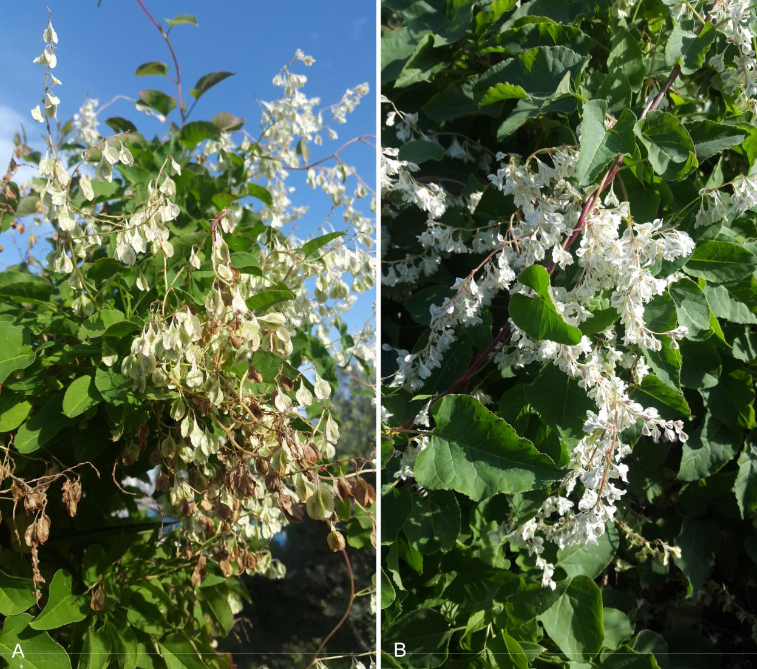

Fig. 13. *Fallopia baldschuanica* – A: detail of fruiting plant; B: detail of flowering and fruiting plant showing typical white inflo-

rescence. – Tunisia: Monastir, Monastir city, road toward Kairouan, 8 Dec 2019, photographs by R. El Mokni.

*Ribes orientale* Desf., *Rosa* cf. *spinosissima* L., *Rosa* sp., *Rubus* sp. and *Sorbus flabellifolia* (Spach) S. Schauer, 20 May 2019, *Fridlender* (*obs*.); Governorate of North-Lebanon, Ehden, escarpment above Horsh Ehden Nature Reserve, 34.295°N, 35.972°E, 1650 – 1700 m, few individ-uals at early anthesis, 27 May 2019, *Fridlender* (CLF 121192); ibid., Bcharré, road to the ce-dars, on trail to Qadisha grotto, 34.247455°N, 36.030733°E, 1700 m, a single individual, 4 Oct 2014, *Stephan* (*obs*.); ibid., Diman, on sandstone above village, c. 1400 m, Aug 2012, *Stephan* (*obs*.); ibid., Governorate of Mount-Lebanon, Mt Sannine, on escarpment near “grande coulée”, 33.954726°N, 35.846503°E, 2084 m, with individuals of *Cotoneaster num­* *mularius* Fisch. & C. A. Mey. and *Sorbus fla­ bellifolia*, 22 Aug 2019, *Stephan* (*obs*.); ibid.,Baskinta, in Wadi Aassi separating the village

from Bqaatouta, 33.965220°N, 35.785034°E, 1200 m, sandstone escarpments along a valley, several individuals mixed with *Fraxinus ornus* L., *Juniperus oxycedrus* L., *Ostrya carpinifolia* Scop., *Pinus pinea* L. and *Rhododendron pon­* *ticum* var. *brachycarpum* Boiss., 29 May 2019, *Stephan* (*obs*.). – The general aspect of youngflowering shoots from the Ehden population (leg. A. Fridlender), in particular the very hairy leaves and calyces; compact inflorescences (due to short pedicels); short petals (c. 7 mm); and relatively large fruits (c. 1 cm) of a bright col-our on short pedicels confirm that the Lebanese plants are morphologically distant from the two subspecies of *Amelanchier ovalis* Medik. from southern France and their adjacent *loci classici* (petals 14 – 19 mm; Favarger & Stearn 1983; Pignatti 2019). Anthers from the Ehden plants contain few pollen grains and some are aborted.

Downloaded From: https://bioone.org/journals/Willdenowia on 23 Aug 2020

Terms of Use: https://bioone.org/terms-of-use

328 Raab-Straube & Raus: Euro+Med-Checklist Notulae, 12

The Lebanese plants are more closely related to plants from Anatolia and rather belong to *A.* *parviflora* Boiss. (“*petalis ovato-oblongis extus tomentosis calyce duplo longioribus*”, Boissier1872: 668) than to *A. ovalis* (“*petalis oblongo-lanceolatis calyce 3 – 4plo longioribus*”, Bois-sier loc. cit.). Therefore, *A*. *ovalis* var. *libanoti­* *ca* Browicz, which was established on the basisof leaf characters (“*folia acuminata, margine* *argute serrata*”, Browicz 1971: 10), has to beconsidered a variety of *A. parviflora* (“*floribus* *eis A. vulgaris dimidio minoribus niveis, pyri­ diis pisi magnitudine*”, Boissier 1843: 9).

Given that polyploidy and apomixis produce numerous micromorphs and complicate species delimitation in the genus (Burgess & al. 2014), *Amelanchier* seems to be represented in theMediterranean area by two main groups: (1) the western group, with *A. ovalis* subsp. *ovalis* and *A. ovalis* subsp. *embergeri* Favarger & Stearn incontinental Europe and North Africa, with sev-eral local variants in isolated areas or islands: *A. ovalis* var. *balearica* Briq. in E Catalunya; *A. ovalis* subvar. *comafredensis* Bolos & Vigoin Mallorca; *A. ovalis* var. *rhamnoides* (Litard.) Briq. in Corsica; and *A. ovalis* var. *djurdjurae* Chabert in E Algeria (Chabert 1889: 22; Chabert 1906: 314; Maire 1980: 129); and (2) the eastern group, with *A. parviflora* in SW Anatolia and various related microtaxa in Lebanon and the southern Balkan peninsula (*A. parviflora* subsp. *chelmea* (Halácsy) Ziel.; *A. cretica* (Willd.) DC.s.l., see Blečić & Pulević 1983; Scholz 1995: 395). The record of *A. cretica* from Sicily seems doubtful because it is based on plants from Qua-cella that have “petali di misure maggiori rispet-to a *A. ovalis* subsp. *embergeri*” (Pignatti 2019:

1. and are therefore hardly compatible with plants of the eastern “parviflora” group.

Even the distinction between these two groups is perhaps not as clear as it seems: in Lebanon, there is obviously a significant vari-ability in the relative length of the petals and the calyx between the populations. Likewise, the leaves and calyces, hairy or even sublanate, can become completely hairless in less than two weeks when growing. In this context it is not easy to find plants of the same phenological stage for comparison. The morphological crite-ria used in the classification of the genus in the Mediterranean (Favarger & Stearn 1983; Strid 1986; Zieliński 2000) require a more in-depth study and above all a comparison with the ge-netic and cytological data.

Nevertheless, the habitat preference of all *Amelanchier* taxa is similar throughout Medi-terranean ecosystems. *Amelanchier ovalis* is

relatively abundant in the NW Mediterranean basin, where it is a pioneer shrub in rocky plac-es. Cattle (goats, donkeys, etc.) appreciate this shrub and graze all accessible branches. This is why *Amelanchier* took refuge in inaccessible escarpments. When pastoral pressure decreas-es, *A. ovalis* recolonizes mountain slopes and even underwood in the forest belt below the timberline. In the E Mediterranean basin and in southernmost European areas like Spain that are still subject to overgrazing, *Amelanchier* appears to be rare and endangered according to the IUCN red list at current national levels.

Unknown in Lebanon prior to 1930 (Bou-lomoy 1930), *Amelanchier parviflora* var. *li­* *banotica* was first reported in 1933 exclusivelyin the relatively preserved mountain range of North-Lebanon, i.e. in the vicinity of Bcharré and Ehden (Samuelsson 1935: 386, as *A. ova­* *lis*; Browicz 1971: 8); near Ehden, betweenBcharré and the cedars (Mouterde 1970: 206); and among the cedars (Zohary 1973: 374). It was not observed since then (“not found re-cently”, Tohmé & Tohmé 2007: 529), but was found again in Beqaa Kafra, not far from the cedars of Bcharré (Tohmé & Tohmé 2014). All those populations are located near 1700 m in altitude. We can now add three North-Lebanon localities to the one recently found by Tohmé & Tohmé (2014), and our two new Mount-Leba-non localities corroborate the presence of this rare taxon scattered throughout the country. The great dispersion of the few extant popula-tions shows that *Amelanchier*, which we have now observed from 1200 m up to 2200 m, is probably a constituent of a formerly more widespread woody vegetation formation. Its discovery in Qalaat Aarouba (Akkar) largely expands its known northward distribution in Lebanon, rendering possible contact with pop-ulations in Mt Amanus and Anatolia.

In all the mentioned localities, only a few individuals of *Amelanchier* could be traced. Those at higher altitudes, as in Bcharré, Eh-den, Qalaat Aarouba and Sannine, are confined to escarpments far from animals’ teeth and are associated with typical “mountain étage” shrub formations composed of *Rhamnus*, *Sorbus*, etc. In Ehden, *Amelanchier* grows with representa-tive trees and shrubs of mesophilous Mediter-ranean mountain woods (Stephan & al. 2016), such as *Arbutus andrachne* L., *Daphne oleoides*, *Ostrya carpinifolia*, *Q. cerris* L., *Quercus infec­ toria* Oliv. and *Q. kotschyana* O. Schwarz. Inthe Mount Arouba locality, mixed *Abies cilicica* (Antoine & Kotschy) Carrière and *Cedrus libani* A. Rich. are still well represented at an elevation

Downloaded From: https://bioone.org/journals/Willdenowia on 23 Aug 2020

Terms of Use: https://bioone.org/terms-of-use

|  |  |
| --- | --- |
| Willdenowia 50 – 2020 | 329 |
|  |  |

of 1700 m, whereas dense forest is completely destroyed above 1850 m and *Juniperus excelsa* is represented only by old, isolated individuals sacked by shepherds. Increasing observations of recently introduced mouflons (*Ovis* cf. *gmelini*) in Ehden (fide Bouchra Douaihy, Lebanese Uni-versity, pers. comm.) could compromise the sur-vival of these shrub communities. In Baskinta, *A*. *parviflora* var. *libanotica* is found on sand-stone, mixed with additional species such as *Pi­* *nus pinea*, *Rhododendron ponticum* L., *Fraxinus ornus* and *Juniperus oxycedrus*. Anyway, theLebanese *Amelanchier* taxon is rare and threat-ened at the southernmost distribution limit of *A*. *parviflora*, because most of the subpopulationscomprise only one to three individuals (more only in Aruba), and the genus *Amelanchier* is not known to occur in Israel (Zohary 1972; Danin 2004).

Up to now, naturalized, partly invasive, ex-otic *Amelanchier* species have been reported only from temperate European ecosystems (Schroeder 1970),

and the plants on sale have al-ways belonged to the same “Nor-dic group species” for a century (Bean 1950; Soupe 2016; Van-nucci 2016). But landscaping de-velopment around Mediterranean conurbations (i.e. most lowland parts of Lebanon!) and increasing tourism (Ehden and Bcharré hold massive tourism activities includ-ing hotel development and ski resorts) could lead to ecological and genetic disturbances through hybridization of imported woody ornamentals with native taxa (see *Pyrus calleryana* Decne., Culley

* Hardiman 2007) and probably to an inexorable expansion of the noxious phytopathogenic bacte-rium *Xylella fastidiosa* Wells & al.

A. Fridlender & J. Stephan

rock schist, 7 Jul 2019, *Chasapis 2468* (TAUF).

– A circumboreal perennial tall herb, not men-tioned for Greece in either Euro+Med (2006+) or Dimopoulos & al. (2013, 2016). Its southern distribution limit in the Balkan Peninsula was supposed to be located in N Albania (Tutin & al. 1968: 6) and North Macedonia (Micevski 1998). Its occurrence in Greece was first record-ed in 2018 on Mt Pinovo, where a population of approximately 300 individuals was found along a streambank and damp roadsides in a beech forest, at an altitude of 1250 m, on vol-canic substratum.

* + 1. Chasapis, D. A. Samaras, K. Theodoropoulos & E. Eleftheriadou

*Scrophulariaceae* (incl. *Buddlejaceae*)

***Nicodemia madagascariensis*** (Lam.) R. Parker (≡*Bud­**dleja madagascariensis* Lam.≡ *Adenoplea madagas­ cariensis* (Lam.) Eastw.) – Fig. 14.

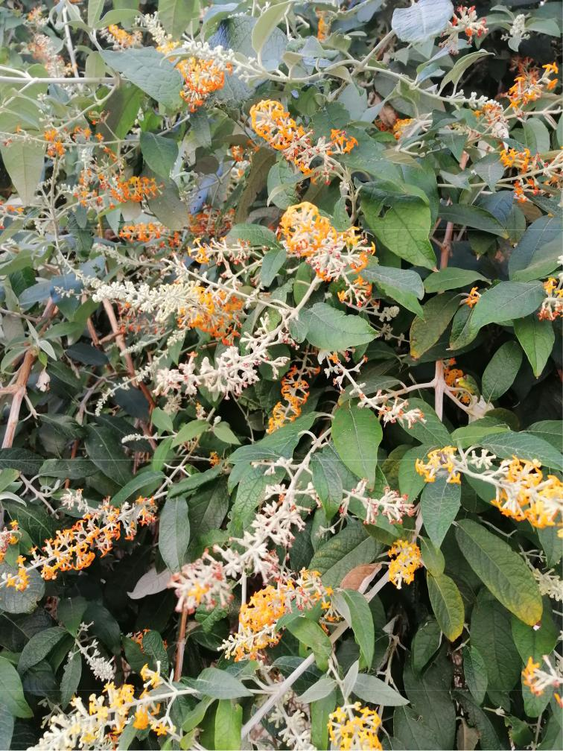

***Aruncus dioicus*** (Walter) Fernald

* **Gr:** Greece: C Makedonia, Nomos ofPella, Eparchia of Almopia, Mt Pinovo, 41°07'28.04"N, 22°04'10.74"E, 1250 m, stream bank and damp roadside in beech forest, parent rock trachyte and andesite, 3 Jul 2018, *Chasapis* *2466* (TAUF); ibid., Mt Gare-fiou Almopias, 41°03'54"N, 22°00'30.13"E, 1120 m, damp roadside in beech forest, parent

Fig. 14. *Nicodemia madagascariensis*, detail of flowering plant. – Tunisia: ­Monastir, Monastir city, near post office la Republique-Rue Hédi Khefacha, 29 Feb 2020, photograph by R. El Mokni.

Downloaded From: https://bioone.org/journals/Willdenowia on 23 Aug 2020

Terms of Use: https://bioone.org/terms-of-use

330 Raab-Straube & Raus: Euro+Med-Checklist Notulae, 12

**A Tn:** Tunisia: Bizerta, Bizerta city, 37°16'11"N,09°52'27"E, 5 m, few individuals near a pub-lic garden, 3 Mar 2015, *El Mokni* (herb. Univ. Monastir); ibid., Monastir, Monastir city, 35°46'25"N, 10°49'05"E, 22 m, very tough population in an old building, 29 Feb 2020, *El* *Mokni* (herb. Univ. Monastir); ibid., Frina, to-ward Monastir city, 35°44'25"N, 10°49'19"E, 3 m, 2 or 3 individuals near roadside, 21 Feb 2019, *El Mokni* (herb. Univ. Monastir); ibid., Menzel Nour, 35°40'31"N, 10°46'58"E, 41 m, a single vigorous individual, 21 Feb 2019, *El Mokni* (herb. Univ. Monastir). – *Nico­ demia madagascariensis*, a scandent shrubwith branches 6 – 7 m long, is a native taxon of Madagascar (Madagascar Catalogue 2016) that has been introduced as an ornamental plant and is naturalized in the U.S.A. (Flori-da), Mexico, the West Indies, South America (Argentina, Uruguay), Africa, India, Aus-tralia, New Zealand, New Caledonia, Fiji and Hawaii (Acevedo-Rodríguez & Strong 2012; Norman 2012; PROTA 2016; USDA-ARS 2016; PIER 2018). The taxon has been re-ported in the Mediterranean region as a casual alien in Sicily (Pasta & al. 2016) and Greece (Dimopoulos 2013: 151, 265; Vladimirov & al. 2019). Moreover, the species is reported as cultivated in Cyprus (Valdés 2012+a) and in Libya (El-Gadi 1987), even though the Afri-can Plant Database (APD 2020) does not re-port its occurrence in N Africa. Therefore, its citation here as a casual alien constitutes the first report of this taxon for the flora of Tuni-sia and N Africa. The easily dispersed seeds and the ability of the plant to regenerate from stem fragments facilitates its naturalization in many areas of

the world (GISD 2015).

R. El Mokni

(parts of SC Florida and further north) and Australia (GBIF 2015b; USDA-ARS 2016; USDA-NRCS 2016). In Europe, the species is considered only as naturalized in the Azores, on São Miguel, Santa Maria and Faial Islands (Valdés 2012+b; GBIF 2015b). For N Africa, it is reported only as introduced (alien with unknown status) in the Canary Islands and Morocco (Valdés 2012+b; APD 2020).

R. El Mokni & G. Domina

***Datura wrightii*** Regel – Fig. 15.

**A BH:** Bosnia-Herzegovina: Mostar, quarter Pasjak,43°21'00"N, 17°48'50"E, 76 m, rubbish tips, three individuals, two of which were large and well developed with ripening fruits, 29 Jul 2019, *Maslo* (SARA 51983).

**A Ct:** Croatia: Dalmatia, Split, Omiš, 43°26'26"N,16°39'23"E, 1 m, sandy beach along Adriatic coast, six well-developed individuals with

ripening­ fruits, 28 Jul 2013, *Maslo* (*pho­* *to*); ibid., Korčula, Vela Luka, 42°57'21"N,16°42'35"E, 19 m, ruderal sites along Gre-ben shipyard, four well-developed individu-als, 19 Jul 2019, *Maslo* (*obs.*). – *Datura* *wrightii* is a native species of the SW UnitedStates and Mexico, but is widely cultivated as an ornamental in warm-temperate regions around the world. It is much reminiscent of

*D. inoxia­* Mill., and both have been confusedfor quite a long time, especially in the Medi-terranean area (Verloove 2008). It was shown that in some areas, e.g. in France or Corsica (Lambinon 2006; Tison & Foucault 2014), only *D. wrightii* is present, whereas in other areas both are found, e.g. in Spain and Italy

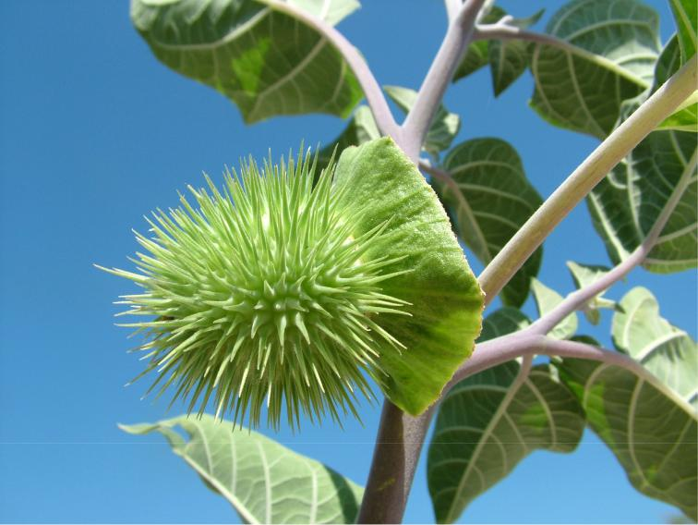

*Solanaceae*

***Brugmansia suaveolens*** (Willd.) Sweet (≡*Datura suaveolens* Willd.)

**A Tn:** Tunisia: Bizerta, Bizerta city, 37°18'03"N, 09°51'54"E, 10 m, among ornamental plants on roadsides, 21 May 2019, *El* *Mokni­* (herb. Univ. Monastir).

– A casual alien species new for the fllora of Tunisia. *Brug­* *mansia suaveolens* is a shrubbytree native to South America that has escaped cultivation to invade residential areas through-out much of South and Central America, Mexico, the U.S.A.

Fig. 15. *Datura wrightii*, detail of fruiting plant. – Croatia: Dalmatia, Split, Omiš, sandy beach along Adriatic coast, 28 Jul 2013, photograph by S. Maslo.

Downloaded From: https://bioone.org/journals/Willdenowia on 23 Aug 2020

Terms of Use: https://bioone.org/terms-of-use

|  |  |
| --- | --- |
| Willdenowia 50 – 2020 | 331 |
|  |  |

Table 1. Selected discriminating characters of *Bupleurum aequiradiatum*, *B. commutatum* and *B. gerardi*.

*B. aequiradiatum* *B. commutatum* *B. gerardi*

Umbel rays almost equal, longest to 2 cm long,

clearly divergent after anthesis

Bracts and with finely serrulate margins bracteoles

Petals limb 0.4 – 0.5 mm wide, inflexed

lobe at apex almost as wide as limb

Fruits 1 – 1.5 mm long, styles 0.3 – 0.4 mm,

equal to mericarp width, vallecular vitta 1

very unequal, longest 4 – 5 cm long, non-divergent after anthesis

with entire margins or serrulate near apex

limb 0.8 – 0.9 mm wide, inflexed lobe at apex c. ½ as wide as limb

2 – 2.5 mm long, styles 0.4 – 0.5 mm, equal to mericarp width, vallecular vitta 1

very unequal, longest 3 – 4 cm long, non-divergent after anthesis

with finely serrulate margins

limb 0.4 – 0.5 mm wide, inflexed lobe at apex c. ½ as wide as limb

2 – 2.5 mm long, styles 0.1 – 0.2 mm, shorter than mericarp width, vallecular vittae 3

(Galasso & al. 2018; Verloove & al. 2019), *D.*

*wrightii* often being the predominant species.

Conversely, in the Canary Islands only *D.*

*­inoxia* has been reliably recorded so far (pers.

obs. of first author).

*Datura inoxia* was recently reported forthe first time from the area of former Yugosla-via (Maslo & Šarić 2019). The plant depicted, however, clearly refers to *D. wrightii*. On closer examination (herbarium and photo ma-terial) it turned out that *D. wrightii* has been recorded at least three times from this area, once from Bosnia-Herzegovina and twice from Croatia. Like elsewhere in the Mediter-ranean region, it is probably locally natural-ized and increasing.

*Datura wrightii* and *D. inoxia* are easilydistinguished. The very short, incurved and eg-landular hairs of *D. wrightii* give it a downy ap-pearance, especially on new growth. Plants may even appear virtually glabrous. This contrasts with the very distinct, long, erect glandular hairs of *D. inoxia*. In addition, *D. wrightii* has mark-edly larger corollas (14 – 26 cm vs 12 – 16 cm) and, as a result, has more ornamental value than

*D. inoxia*. S. Maslo & F. Verloove

***Lycianthes rantonnei*** (Carrière) Bitter (≡*Solanum ran­**tonnei* Carrière)

1. **Tn:** Tunisia: Monastir-Sousse, 35°46'08"N,10°45'58"E, 5 m, among ornamental plants on roadsides, 26 Feb 2020, *El Mokni* (herb. Univ. Monastir). – A casual alien species new for the fllora of Tunisia and N Africa. *Lycianthes ran­* *tonnei* is native to South America (Argentina,Paraguay, Bolivia and Brazil; Gallego 2012) and is widely cultivated in many regions of the world as an ornamental shrub, mainly in warm-temperate and subtropical areas. In Eu-rope, the species is reported from Spain, as naturalized in Málaga province and Catalunya (Sáez & al. 2016; Verloove & al. 2019) and as subspontaneous in Madrid (Gallego 2012).

R. El Mokni & G. Domina

*Umbelliferae* (*Apiaceae*)

***Bupleurum aequiradiatum*** (H. Wolff) Snogerup & B.Snogerup

* **Tu(A):** Turkey: Bithyn[ia], prope Brussam, in fruti-cetis, Jul 1874, *Pichler* (BP 274226, as *Bupleu­* *rum gerardi* Jacq. [non All.]). – Wolff (1910),in the protologue of his *B. commutatum* var. *­aequiradiatum* H. Wolff, indicated that the tax-on occurs in Bithynia (NW Anatolia), ­Crimea and the Balkan Peninsula. Snogerup & Sno-gerup (2001) accepted it at species rank and indicated only the Balkan Peninsula for the distribution, because no specimens were seen from Bithynia and Crimea. Stoyanov (2019) revisited the distribution of the species and also concluded that it is a Balkan endemic. The present record is the first confirming the distri-bution of *B. aequiradiatum* in Bithynia in sup-port of Wolff’s earlier statement. *Bupleurum* *aequiradiatum* and *B. commutatum* Boiss. &Balansa are similar to some extent, in habit and in having 5 – 8 rays in the top umbels, but are quite different in a number of other characters

(Table 1). S. Stoyanov

***Bupleurum commutatum*** Boiss. & Balansa

* **Cm:** The occurrence of*Bupleurum commutatum*in theCrimean Peninsula was based on two records of A. S. Callier (Sudak, Abhänge des Sokoll, *Callier 56*; Steingeröll des Sokoll bei Sudak, *Callier 97*). Wolff (1910) assigned them to *B. commutatum* [var. *typicum*] f. *tauricum*. Sno-gerup & Snogerup (2001) accepted Callier’s records as belonging to *B. commutatum*. In the same work, they simultaneously referred *Cal­* *lier 97* to *B. gerardi* All. *Callier 97* (BP 415151,641156) was examined carefully in the herbari-um of the Hungarian Natural History Museum and it was found that two specimens belong to *B. gerardi* on account of their small pet-als, 0.4 – 0.5 mm wide (vs petals 0.8 – 0.9 mm wide in *B. commutatum*). In addition, *Callier* *56* [(JE 00022384)](https://herbarium.univie.ac.at/database/detail.php?ID=463014) *was* examined via Virtual

Downloaded From: https://bioone.org/journals/Willdenowia on 23 Aug 2020

Terms of Use: https://bioone.org/terms-of-use

332 Raab-Straube & Raus: Euro+Med-Checklist Notulae, 12

Herbaria JACQ [(https://herbarium.univie.ac.at](https://herbarium.univie.ac.at/database/) [/database/)](https://herbarium.univie.ac.at/database/). The individuals of that specimen are in the fruiting stage and it was found that the styles are only 0.1 – 0.2 mm long, shorter than the mericarp width, a character that cor-responds to *B. gerardi* (vs styles 0.4 – 0.5 mm long in *B. commutatum*). The errors in the determination can be explained by the most important diagnostic characters in *Bupleurum* being flower and fruit details, which often are less than 1 mm in size. Finally, it should be emphasized that 20 correctly determined specimens of *B. gerardi* from SE and S parts of the Crimean Peninsula were seen in the Mos-cow Digital Herbarium [(https://plant.depo.msu](https://plant.depo.msu.ru/)

[.ru/),](https://plant.depo.msu.ru/) most of which were collected in the same area of Callier’s records cited above, whereas materials of *B. commutatum* from Crimea are absent. Therefore, it is necessary to exclude *B. commutatum* from the Crimean flora, be-cause all known records in fact are referable to *B. gerardi*. *Bupleurum commutatum* and *B.*

*gerardi­* are similar in having 5 – 8 very unequalrays in the top umbels, but are quite different in a number of other characters (Table 1).

S. Stoyanov

***Bupleurum gerardi*** All.

**A Se:** Serbia: Toplac, distr. Vranja, in vinetis, July,*Ilić*(BP274073, as *Bupleurum commutatum* Boiss. & Balansa). – According to Snogerup & Snogerup (2001), all or some of the European occurrences of *B. gerardi* may represent old introductions. In fact, *B. gerardi* was first described from France in 1774, in an area where it is not native (where it had been introduced earlier from the E Mediterranean, perhaps by shipping). Its natural range comprises Crimea, Transcaucasia, Anato-lia and the Middle East. Outside that area, most-

ly in S Europe, *B. gerardi­* appears as a ruderal and casual. Recently, Stoyanov (2019) revisited its Balkan distribution and found that all records from Bulgaria are referable to *B. commutatum*. The only certain Balkan records of *B. gerardi* in the are those from the mid-19th century from the Croatian islands of Torzola and Lesina (Sno-gerup & Snogerup 2001). The present record is the first of this species for the Balkan mainland, as well as for Serbia, and most likely it is a cas-

ual alien. S. Stoyanov

**Acknowledgements**

The work of A. Molnár V. and his collaborators was supported by a grant from the Hungarian Research Fund (NKFI–OTKA K132573). R. A. Murtazaliev’s work

was supported by a grant from the Russian Foundation for Basic Research (no. 19-04-00658). S. Stoyanov’s research received support from the Synthesys+ Project [(http://www.synthesys.info/)](http://www.synthesys.info/) funded by the European Commission (Grant HU-TAF-2472). S. Rätzel and co-authors of the notula on *Orobanche lucorum* are thank-ful to Prof. P. A. Schmidt (Dresden) for information on *Berberis* in the Caucasus. N. Korotkova, G. Parolly and

1. von Raab-Straube thank the Verein der Freunde des Botanischen Gartens Berlin-Dahlem e.V. for a travel grant to the North Caucasus. S. Rätzel & M. Ristow thank R. Hand (Berlin) for information to the flora of Cyprus and Th. Raus (Berlin) for helpful literature hints. P. Uotila (Helsinki) is thanked for interpreting labels of *Buglossoides* specimens from Finland. Four anonymousreviewers are thanked for their comments on earlier ver-sions of parts of these Notulae.

**References**

Abdel Samad N., Bou Dagher-Kharrat M., Hidalgo O., El Zein R., Douaihy B. & Siljak-Yakovlev S. 2016: Unlocking the karyological and cytogenetic diversity of *Iris* from Lebanon: *Oncocylcus* section shows a distinctive profile and relative stasis during its conti-nental radiation. – [PLoS ONE **11(8):** e0160816.](https://doi.org/10.1371/journal.pone.0160816)

Acebes Ginovés J. R., León Arencibia M. C., Rodríguez Navarro M. L., Del Arco Aguilar A, Garcia Gallo P. L., Pérez de Paz O., Rodríguez Delgrado V., Martín Osorio V. E. & Wildpret de la Torre W. 2010: *Pteri­* *dophyta*, *Spermatophyta*. – Pp. 119 – 172 in: Arecha-valeta M., Rodríguez S., Zurita N. & García A. (ed.), Lista de especies silvestres de Canarias (hongos, plantas y animales terrestres), ed. 2. – La Laguna: Gobierno de Canarias.

Acevedo-Rodríguez P. & Strong M. T. 2012: Catalogue of the Seed Plants of the West Indies. [[Smithsonian](https://doi.org/10.5479/si.0081024x.98.1) [Contributions to Botany **98**](https://doi.org/10.5479/si.0081024x.98.1)]. – Washington D.C.: Smithsonian Institution. – Published at [http://botany](http://botany.si.edu/Antilles/WestIndies/catalog.htm)

[.si.edu/Antilles/WestIndies/catalog.htm](http://botany.si.edu/Antilles/WestIndies/catalog.htm) [accessed 1 Mar 2020].

Aeschimann D., Lauber K., Moser D. M. & Theurillat J.-P. 2004: Flora alpina. Ein Atlas sämtlicher 4500 Gefäßpflanzen der Alpen **2.** *Gentianaceae* – *Orchida­* *ceae*. – Bern, Stuttgart, Wien: Haupt.

Al-Abdul Wahab K., Alkadi I & Hamad I. 2004: Clas-sification of basaltic flora and isolation of *Rhizobium* strains from some wild legumes in Homs region. – Damascus Univ. J. Basic Sci. **20:** 226 – 247.

Anthos 2020: Anthos. Sistema de información sobre las plantas de España. – Published at [http://www.anthos](http://www.anthos.es/)

[.es/](http://www.anthos.es/) [accessed 8 May 2020].

APD 2020: African Plant Database (version 3.4.0). *Abu­* *tilon grandifolium* (Willd.) Sweet, *Brugmansia sua­ veolens* (Humb. & Bonpl. ex Willd.) Bercht. & C.Presl., *Buddleja madagascariensis* Lam., *Cortaderia*

Downloaded From: https://bioone.org/journals/Willdenowia on 23 Aug 2020

Terms of Use: https://bioone.org/terms-of-use

|  |  |
| --- | --- |
| Willdenowia 50 – 2020 | 333 |
|  |  |

*selloana* (Schult. & Schult. f.) Asch. & Graebn., *Fal­ lopia baldschuanica* (Regel) Holub, *Opuntia* Mill., *Plumbago auriculata* Lam. – Genève: Conservatoireet Jardin botaniques; Pretoria: South African Natio­ nal Biodiversity Institute. – Published at [http://www](http://www.ville-ge.ch/musinfo/bd/cjb/africa/index.php)

[.ville-ge.ch/musinfo/bd/cjb/africa/index.php](http://www.ville-ge.ch/musinfo/bd/cjb/africa/index.php) [accessed 1 Mar and 10 May 2020].

Arcangeli G. 1882: [Compendio della flora italiana](https://doi.org/10.5962/bhl.title.9995) ossia manuale per la determinazione delle piante che tro-vansi selvatiche od inselvatichite nell’Italia e nelle isole adiacenti. – Torino: Ermanno Loescher.

Arechavaleta M., Rodríguez S., Zurita N. & García A. (coord.) 2010: Lista de especies silvestres de Ca-narias. Hongos, plantas y animales terrestres, 2009.

– Santa Cruz de Tenerife: Gobierno de Canarias. – Published at [http://www.gobiernodecanarias.org](http://www.gobiernodecanarias.org/medioambiente/piac/descargas/Biodiversidad/Listas-Especies/Lista_Especies_Silvestres.pdf) [/medioambiente/piac/descargas/Biodiversidad/Listas](http://www.gobiernodecanarias.org/medioambiente/piac/descargas/Biodiversidad/Listas-Especies/Lista_Especies_Silvestres.pdf) [-Especies/Lista_Especies_Silvestres.pdf](http://www.gobiernodecanarias.org/medioambiente/piac/descargas/Biodiversidad/Listas-Especies/Lista_Especies_Silvestres.pdf)

Avishai M. & Zohary D. 1977: Chromosomes in the *On­*

*cocylus* Irises. – [Bot. Gaz. **138:** 502 – 511.](https://doi.org/10.1086/336956)

Badry M. O., Tate A. J. & Gabr Sheded M. 2018: A new record of *Abutilon grandifolium* (subfamily *Malvoi­* *deae*, *Malvaceae*) from Qena Governorate, Egypt. –[Phytotaxa **382:** 255 – 266.](https://doi.org/10.11646/phytotaxa.382.3.2)

Bareka P., Phitos D. & Kamari G. 2008: A karyosystematic study of the genus *Bellevalia* Lapeyr. (*Hyacinthaceae*) in Greece. – [Bot. J. Linn. Soc. **157:** 723 – 739.](https://doi.org/10.1111/j.1095-8339.2008.00817.x)

Barina Z. 2017: Distribution atlas of vascular plants in Albania. – Budapest: Hungarian Natural History Mu-seum.

Barina Z., Shevera M., Sîrbu C. & Pinke G. 2013: Cur-rent distribution and spreading of *Euphorbia davi­* *dii* (*E. dentata* agg.) in Europe. – [Open Life Sci. **8:**](https://doi.org/10.2478/s11535-012-0111-7) [87 – 95.](https://doi.org/10.2478/s11535-012-0111-7)

Barker C. & Govaerts R. 2019: World checklist of *Iri­* *daceae*. Facilitated by the Royal Botanic Gardens,Kew. – Published at <http://wcsp.science.kew.org/>[ac-cessed 25 Mar 2020].

Bartolo G., Brullo S. & Gianguzzi L. 2004: Note tas-sonomiche su *Tillaea alata* Viv. (*Crassulaceae*), nuova per la flora italiana. – Inform. Bot. Ital. **36:** 524 − 528.

Bartolucci F., Peruzzi L., Galasso G., Albano A.,

Alessandrini­ A., Ardenghi N. M. G., Astuti G., ­Bacchetta G., Ballelli S., Banfi E., Barberis G.,

Bernardo­ L., Bouvet D., Bovio M., Cecchi L., Di Pietro R., ­Domina G., Fascetti S., Fenu G., Festi F., Foggi B., Gallo L., Gottschlich G., Gubellini L.,

Iamonico­ D., Iberite M., Jiménez-Mejías P., Lattanzi­

E., ­Marchetti D., ­Martinetto E., Masin R. R., ­Medagli P., Passalacqua N. G., Peccenini S., Pennesi R., Pierini B., Poldini L., ­Prosser F., Raimondo F. M., Roma-Marzio F., Rosati L., Santangelo A., Scoppola A., Scortegagna S., Selvaggi A., Selvi F., Soldano A., Stinca A., Wagensommer R. P., Wilhalm T. & Conti F. 2018: An updated checklist of the vascular flora na-tive to Italy. – [Pl. Biosyst. **152:** 179 – 303.](https://doi.org/10.1080/11263504.2017.1419996)

Başnou C. 2009: *Cortaderia selloana* (Schult. & Schult.f.) Asch. & Graebn., pampas grass (*Poaceae*, *Magnoliophyta*). – P. 346 in: [DAISIE: handbook of](https://doi.org/10.1007/978-1-4020-8280-1) [alien species in Europe.](https://doi.org/10.1007/978-1-4020-8280-1) – Dordrecht: Springer.

Bazan G. & Castellano G. 2007: *Fallopia baldschuanica* (*Polygonaceae Magnoliophyta*) spontaneizzata in Si-cilia. – Naturalista Sicil., ser. 4a, **31:** 99 – 104.

Bazos I. 2005: Study of the flora and vegetation of Les-vos island (East Aegean, Greece). – Athens: self-pub-lished, PhD thesis, National and Capodistrian Univer-sity of Athens.

Bean W. J. 1950: Trees and shrubs hardy in the British

Isles **1.** – London: J. Murray.

Beck von Mannagetta G. 1890: Monographie der Gat-tung *Orobanche*. – Biblioth. Bot. **19.**

Beck von Mannagetta G. 1907: Flora Bosne, Hercego-vine i Novopazarskog Sandžaka, 2(4). – Glasn. Ze-maljsk. Muz. Bosni Hercegovini **19:** 16 – 29.

Beck von Mannagetta G. 1930: *Orobanchaceae.* – in: Engler A. (ed.), Das Pflanzenreich. Regni vegetabi-lis conspectus **IV. 261** (Heft **96**). – Leipzig: Wilhelm Engelmann.

Blečić V. & Pulević V. 1983: Kritički osvrt na *Amelan­* *chier ovalis* Medic. u flori Jugoslavije. – Povrem. Izd.­Muzeja Grada Šibenika **10:** 169 – 173.

Boissier E. 1843: Diagnoses plantarum novarum prae-

sertim orientalium **1(3).** – Genevae: F. Ramboz.

Boissier E. 1872: [Flora orientalis](https://bibdigital.rjb.csic.es/idurl/1/10740) sive enumeratio plantarum in oriente a Graecia et Aegypto ad Indiae fines hucusque observatarum **2.** – Genevae, Basileae & Lugduni: H. Georg.

Boissier E. 1875: [Flora orientalis](https://bibdigital.rjb.csic.es/idurl/1/10749) sive enumeratio plantarum in oriente a Graecia et Aegypto ad Indiae fines hucusque observatarum **4.** – Genevae, Basileae & Lugduni: H. Georg.

Boulomoy L. 1930: Flore du Liban et de la Syrie. Texte.

– Paris: Vigot Frères.

Bredenkamp C. L. & Leistner O. A. 2003: *Malvaceae.*

– Pp. 619 – 628 in: Germishuizen G. & Meyer N. L.

(ed.), Plants of southern Africa: an annotated check-list. – Strelitzia **14.**

Britton N. L. & Rose J. N. 1919: [The *Cactaceae*](https://doi.org/10.5962/bhl.title.45556). Descrip-tions and Illustrations of plants of the cactus family **1.**

– Washington: The Carnegie Institution.

Browicz K. 1971: Distribution of woody *Rosaceae* in W Asia 7. Genus *Amelanchier* Med. – Arbor. Kórnickie

1. 5 – 26.

Browicz K. 1972: *Amelanchier* Medik. – Pp. 168 – 172 in: Davis P. H. (ed.), Flora of Turkey and the East Aegean Islands **4.** – Edinburgh: Edinburgh Univer-sity Press.

Browicz K. 1984: Chorology of trees and shrubs in south-west Asia and adjacent regions **4.** – Warszawa-Poznań: Polish Scientific Publishers.

Brunel S., Schrader G., Brundu G. & Fried G. 2010: Emerging invasive alien plants for the Mediterranean Basin. – [OEPP/EPPO Bulletin **40:** 219 – 238.](https://doi.org/10.1111/j.1365-2338.2010.02378.x)

Downloaded From: https://bioone.org/journals/Willdenowia on 23 Aug 2020

Terms of Use: https://bioone.org/terms-of-use

334 Raab-Straube & Raus: Euro+Med-Checklist Notulae, 12

Buia A. 1961: *Orobanchaceae*. – Pp. 33 – 72 in: Săvulescu T. & Nyárády E. I. (ed.), Flora Republicii Populare Romîne **8.** – București: Editura Academiei Republicii Populare Romîne.

Burgess M. B., Cushman K. R., Doucette E. T., Talent N., Frye C. T. & Campbell C. S. 2014: Effects of apomix-is and polyploidy on diversification and geographic distribution in *Amelanchier* (*Rosaceae*). – [Amer. J.](https://doi.org/10.3732/ajb.1400113) [Bot. **101:** 1375 – 1378.](https://doi.org/10.3732/ajb.1400113)

Burkill H. M. 1997: The useful plants of West Tropical

Africa **4.** – Kew: Royal Botanic Gardens.

Buttler K. P., Thieme M. & Mitarbeiter 2018: Florenliste von Deutschland – Gefäßpflanzen. Version 10 (Au-gust 2018). – Published at [https://www.kp-buttler.de](https://www.kp-buttler.de/florenliste/) [/florenliste/](https://www.kp-buttler.de/florenliste/) [accessed 20 Mar 2020].

CABI 2020: *Abutilon grandifolium* (Willd.) Sweet, *Fal­* *lopia baldschuanica* (Regel) Holub, *Myriophyllum aquaticum* (Vell.) Verdc., *Wisteria sinensis* (Sims)Sweet. – In: Invasive Species Compendium. – Wall-ingford: CAB International. – Published at [­https://](https://www.cabi.org/isc) [www.cabi.org/isc](https://www.cabi.org/isc) [accessed 1 Mar, 12 Mar and 8 May 2020].

Campos J. A. & Herrera M. 2008: Diagnosis de la flora alóctona invasora de la CAPV [Diagnosis of the in-vasive alien flora of the Basque country]. – Bilbao: Dirección de Biodiversidad y Participación Ambien-tal, Departamento de Medio Ambiente y Ordenación del Territorio, Gobierno Vasco. – Published at [http://](http://www.invasep.eu/flora_alo_invas_capv.pdf) [www.invasep.eu/flora_alo_invas_capv.pdf](http://www.invasep.eu/flora_alo_invas_capv.pdf) [accessed 1 Apr 2020].

Candargy M. P. 1898: Flore de l’île de Lesbos. – [Bull.](https://doi.org/10.1080/00378941.1898.10830841)

[Soc. Bot. France **45:** 181 – 192.](https://doi.org/10.1080/00378941.1898.10830841)

Carlón L., Gómez Casares G., Laínz M., Moreno Moral G., Sánchez Pedraja O., Schneeweiss G. M. 2008: Más, a propósito de algunas *Phelipanche* Pomel, *Boulardia­* F. W. Schultz y *Orobanche* L. (*Oroban­ chaceae*) del oeste del Paleártico. – Doc. Jard. Bot.Atlántico **6:** 1 – 128.

Celesti-Grapow L., Alessandrini A., Arrigoni P. V.,

Banfi­ E., Bernardo L., Bovio M., Brundu G., Ca-giotti M. R., Camarda I., Carli E., Conti F., Fascetti S., Galasso G., Gubellini L., La Valva V., Lucchese F., Marchiori S., Mazzola P., Peccenini S., Poldini L., Pretto F., Prosser F., Siniscalco C., Villani M. C., Viegi L., Wilhalm T. & Blasi C. 2009: Inventory of the non-native flora of Italy. – [Pl. Biosyst. **143:**](https://doi.org/10.1080/11263500902722824) [386 – 430.](https://doi.org/10.1080/11263500902722824)

Chabert A. 1889: Note sur la flore d’Algérie. – [Bull. Soc.](https://doi.org/10.1080/00378941.1889.10830413)

[Bot. France **36:** 15 – 31.](https://doi.org/10.1080/00378941.1889.10830413)

Chabert A. 1906: Note sur quelques Pomacées. – [Bull.](https://doi.org/10.1080/00378941.1906.10831175)

[Soc. Bot. France **53:** 308 – 315.](https://doi.org/10.1080/00378941.1906.10831175)

Chater A. O., Walters S. M. & Akeroyd J. R. 1993: *Silene* L. – Pp. 191 – 218 in: Tutin T. G., Burges N. A., Chater A. O., Edmonson J. R., Heywood V. H., Moore D. M., Valentine D. H., Walters S. M. & Webb D. A. (ed.), Flora europaea, ed. 2, **1.** – Cambridge: Cambridge University Press.

Cirujano S. 1997: *Myriophyllum* L. – Pp. 3 – 7 in: Castro-viejo S. & al. (ed.), Flora iberica **8.** – Madrid: Real Jardín Botánico, CSIC.

Clement E. J. & Foster M. C. 1994: Alien plants of the British Isles. – London: Botanical Society of the Brit-ish Isles.

Clifford H. T. 1959: Seed dispersal by motor vehicles. – J.

Ecology **47:** 311 – 315.

Culley T. M. & Hardiman N. A. 2007: The beginning of a new invasive plant: a history of the ornamental Callery pear in the United States. – [BioScience **57:**](https://doi.org/10.1641/b571108) [956 – 964.](https://doi.org/10.1641/b571108)

Danihelka J., Chrtek jr. J. & Kaplan Z. 2012: Checklist of vascular plants of the Czech Republic. – Preslia

1. 647 – 811.

Danin A. 2004: Distribution atlas of plants in the Flora palaestina area. – Jerusalem: The Israel Academy of Sciences and Humanities.

Dayhan S., Güler N., Arda H., Çolak A. & Aytaç A. 2013: Conservation status and current distribution of edemic­ and extinction-prone *Bellevalia edirnensis* Özhatay & Mathew (*Asparagaceae*). – Trakya Univ. J. Nat. Sci. **14:** 87 – 91.

Delforge P. 2006: Orchids of Europe, North Africa and

the Middle East. – London: Helm.

Dimopoulos P., Raus Th., Bergmeier E., Constantinidis Th., Iatrou G., Kokkini S., Strid A. & Tzanoudakis D. 2013: Vascular Plants of Greece: an annotated check-list. – Berlin: Botanic Garden and Botanical Museum Berlin-Dahlem; Athens: Hellenic Botanical Society.

– [Englera **31.**](https://www.jstor.org/stable/i24365374)

Dimopoulos P., Raus Th., Bergmeier E., Constantinidis Th., Iatrou G., Kokkini S., Strid A. & Tzanoudakis D. 2016: Vascular Plants of Greece. An annotated check-list. Supplement. – [Willdenowia **46:** 301 – 347.](https://doi.org/10.3372/wi.46.46303)

Dobignard A. & Chatelain C. 2010: Index synonymique de la flore d’Afrique du Nord **1.** *Pteridophyta*, *Gym­* *nospermae*, *Monocotyledonae*. – Genève: Conserva-toire et Jardin botaniques de la Ville de Genève, pub-lication hors-série **11.**

Dobignard A. & Chatelain C. 2012: Index synonymique de la flore d’Afrique du Nord **4.** *Dicotyledoneae*: *Fa­* *baceae* – *Nymphaeaceae*. – Genève: Conservatoire etJardin botaniques de la Ville de Genève, publication hors-série **11c.**

Domina G. 2011+ [continuously updated]: *Plumbagi­* *naceae*. – In: Euro+Med PlantBase – the infor-mation resource for Euro-Mediterranean plant di-versity. – Published at [http://ww2.bgbm.org/Euro](http://ww2.bgbm.org/EuroPlusMed/PTaxonDetail.asp?NameId=28763&PTRefFk=7500000) [PlusMed/PTaxonDetail.asp?NameId=28763&PTRef](http://ww2.bgbm.org/EuroPlusMed/PTaxonDetail.asp?NameId=28763&PTRefFk=7500000) [Fk=7500000](http://ww2.bgbm.org/EuroPlusMed/PTaxonDetail.asp?NameId=28763&PTRefFk=7500000) [accessed 8 Mar 2020].

Domina G. & Raab-Straube E. von 2010+ [continuously updated]: *Phelipanche*. – In: Euro+Med PlantBase

– the information recource for Euro-Mediterranean plant diversity. – Published at [http://ww2.bgbm.org](http://ww2.bgbm.org/EuroPlusMed/PTaxonDetail.asp?NameId=69555&PTRefFk=7500000) [/EuroPlusMed/PTaxonDetail.asp?NameId=69555](http://ww2.bgbm.org/EuroPlusMed/PTaxonDetail.asp?NameId=69555&PTRefFk=7500000) [&PTRefFk=7500000](http://ww2.bgbm.org/EuroPlusMed/PTaxonDetail.asp?NameId=69555&PTRefFk=7500000) [accessed 13 Mar 2020].

Downloaded From: https://bioone.org/journals/Willdenowia on 23 Aug 2020

Terms of Use: https://bioone.org/terms-of-use

|  |  |
| --- | --- |
| Willdenowia 50 – 2020 | 335 |
|  |  |

Domingues de Almeida J. & Freitas H. 2006: Exotic naturalized flora of continental Portugal – a reassess-ment. – Bot. Complut. **30:** 117 – 130.

Domingues de Almeida J. & Freitas H. 2012: Exotic flora of continental Portugal – a new assessment. – Boc-conea **24:** 231 – 237.

Dubertret L. 1955: Carte géologique du Liban. – Beirut :

Lebanese Ministry of Public works.

El-Gadi A. 1987: *Buddlejaceae*. – Pp. 1 – 6 in: Jafri S. M. H. & El-Gadi A. (ed.), Flora of Libya **135.** – Tripoli: Al Faateh University.

El Mokni R., Verloove F., Guiggi A. & El Aouni M. H. 2020: New records of cacti (*Opuntioideae* & *Cac­* *toideae*, *Cactaceae*) from Tunisia. – [Bradleya **38:**](https://doi.org/10.25223/brad.n38.2020.a6) [35 – 50.](https://doi.org/10.25223/brad.n38.2020.a6)

Euro+Med 2006+ [continuously updated]: Euro+Med PlantBase – the information resource for Euro-Medi­ terranean plant diversity. – Published at [http://ww2](http://ww2.bgbm.org/EuroPlusMed/)

[.bgbm.org/EuroPlusMed/](http://ww2.bgbm.org/EuroPlusMed/) [accessed 24 Mar 2020]. Favarger C. & Stearn. P., 1983: Contribution à la cyto-

taxonomie de l’*Amelanchier ovalis* Medikus (*Rosa­* *ceae*). – [Bot. J. Linn. Soc. **87:** 85 – 103.](https://doi.org/10.1111/j.1095-8339.1983.tb00985.x)

Fekete R., Nagy T., Bódis J., Biró É., Löki V., Süveges K., Takács A., Tökölyi J. & Molnár V. A. 2017: Road-side verges as habitats for endangered lizard-orchids (*Himantoglossum* spp.): ecological traps or refuges?

– [Sci. Total Environm. **607 – 608:** 1001 – 1008.](https://doi.org/10.1016/j.scitotenv.2017.07.037) Ferreira M. Z., Zahradníček J., Kadlecová J., Menezes de

Sequeira M., Chrtek jr. J., & Fehrer J. 2015: Tracing the evolutionary history of a little-known Mediterra-nean-Macaronesian genus *Andryala* (*Asteraceae*) by multigene sequencing. – [Taxon **64:** 535 – 551.](https://doi.org/10.12705/643.10)

Fischer M., Oswald K. & Adler W. 2008: Exkursions-flora für Österreich, Liechtenstein und Südtirol, ed.

* 1. – Linz: Biologiezentrum der OÖ. Landesmuseen. Fleischmann A., Uhlich H. & Rätzel S. 2019: (2694)

Proposal to reject the name *Orobanche rubi* (*Oroban­* *chaceae*). – [Taxon **68:** 598–599.](https://doi.org/10.1002/tax.12081)

Flora Ionica Working Group 2016+ [continuously updat-ed]: Flora ionica – an inventory of ferns and flowering plants of the Ionian Islands (Greece). – Published at <https://floraionica.univie.ac.at>[accessed 22 Mar 2020].

Flora of North America 2020: *Fallopia baldschuanica* (Regel) Holub. – Published at [http://www.efloras.org](http://www.efloras.org/florataxon.aspx?flora_id=1&taxon_id=242100054) [/florataxon.aspx?flora_id=1&taxon_id=242100054](http://www.efloras.org/florataxon.aspx?flora_id=1&taxon_id=242100054) [accessed 1 Mar 2020].

Foden W. & Potter L. 2005: *Plumbago auriculata* Lam. National assessment: Red List of South African plants version 2017.1. – Published at [http://redlist.sanbi.org](http://redlist.sanbi.org/species.php?species=3567-1) [/species.php?species=3567-1](http://redlist.sanbi.org/species.php?species=3567-1) [accessed 8 Mar 2020].

Foley M. J. Y. 2001a: 2. *Orobanche* L. – Pp. 32 – 72 in: Paiva J., Sales F., Hedge I. C., Aedo C., Aldasoro J. J., Castroviejo S., Herrero A. & Velayos M. (ed.), Flora iberica **14.** – Madrid: Real Jardín Botánico, CSIC.

Foley M. J. Y. 2001b: *Orobanchaceae* in the “Flora

iberica”­ area: new taxa, excluded taxa, and typifica-

tion. – [Anales Jard. Bot. Madrid **58:** 223–233.](https://doi.org/10.3989/ajbm.2000.v58.i2.153)

Foley M. J. Y. 2003: *Orobanche hirtiflora* subsp. *zosimii* M. J. Y. Foley (*Orobanchaceae*), a new subspecies from Cyprus.  –  Candollea **58:** 83 – 95.

Foley M. J. Y. 2008: *Phelipanche schultzioides* (*Oroban­* *chaceae*), a new species from Peloponnesos, Greece.

– Bot. Chron. (Patras) **19:** 5 – 12.

Galasso G., Conti F., Peruzzi L., Ardenghi N. M. G., Banfi E., Celesti-Grapow L., Albano A., ­Alessandrini A., Bacchetta G., Ballelli S., Bandini Mazzanti M., Barberis G., Bernardo L., Blasi C., Bouvet D., Bovio M., Cecchi L., Del Guacchio E., Domina G., ­Fascetti S., Gallo L., Gubellini L., Guiggi A., Iamo-nico D., Iberite M., Jiménez-Mejías P., ­Lattanzi E., ­Marchetti D., Martinetto E., Masin R. R., Medagli­ P., ­Passalacqua N. G., Peccenini S., Pennesi R., Pierini B., Podda L., Poldini L., Prosser F., Raimondo F. M., Roma-Marzio F., Rosati L., Santangelo A., Scoppola A., ­Scortegagna A., ­Selvaggi A., Selvi F., Soldano A., Stinca A., Wagensommer R. P., Wilhalm T. & ­Bartolucci F. 2018: An updated checklist of the vas-cular flora alien to Italy. – [Pl. Biosyst. **152:** 556 – 592.](https://doi.org/10.1080/11263504.2018.1441197)

Gallego M. J. 2012: *Lycianthes* (Dunal) Hassl. – Pp.

198 – 200 in: Talavera S., Andrés C., Arista M.,

Fernández­ Piedra M. P., Gallego M. J., Ortiz P. L., Romero Zarco C., Salgueiro F. J., Silvestre S. & Quintanar A. (ed.). Flora iberica **11.** – Madrid: Real Jardín Botánico, CSIC.

Gallo L. 2008: *Tillaea alata* Viv. – P. 145 in: Jeanmonod D. & Schlüssel A. (ed.), Notes et contributions à la flore de Corse, XXII. – Candollea **63:** 145.

GBIF (Global Biodiversity Information Facility) 2013:

*Wisteria sinensis* Sweet. – Published at [https://www](https://www.gbif.org/species/2977331)

[.gbif.org/species/2977331](https://www.gbif.org/species/2977331) [accessed 1 Apr 2020].

GBIF (Global Biodiversity Information Facility) 2015a:

*Abutilon grandifolium* (Willd.) Sweet. – Published at<https://www.gbif.org/species/3152633>[accessed 12 Mar 2020].

GBIF (Global Biodiversity Information Facility) 2015b: *Brugmansia suaveolens* Bercht. & J. Presl. – Pub-lished at <https://www.gbif.org/species/5341758>[ac-cessed 1 Mar 2020].

Gil González M. L. 2020: Flora vascular de Canarias.

– Published at <http://www.floradecanarias.com/>[ac-cessed 8 May 2020].

Gilli A. 1971: Die Orobanchaceen der Türkei. – Feddes

Repert. **82:** 381 – 406.

Gilli A. 1975: 118. Familie *Orobanchaceae.* – Pp. 470 – 505 in: Hegi G. [Hartl D. & Wagenitz G. (ed.)]: Illustrierte Flora von Mittel-Europa, ed. 2, **6(1).** – München: Carl Hanser.

Gilli A. 1982: 90. *Orobanchaceae*. – Pp. 1 – 23 in: Davis P. H. (ed.), Flora of Turkey and the East Aegean Is-lands **7.** – Edinburgh: Edinburgh University Press.

GISD (Global Invasive Species Database) 2015: Species profile *Buddleja madagascariensis*. – Published at <http://www.iucngisd.org/gisd/species.php?sc=1577> [accessed 1 Mar 2020]

Downloaded From: https://bioone.org/journals/Willdenowia on 23 Aug 2020

Terms of Use: https://bioone.org/terms-of-use

336 Raab-Straube & Raus: Euro+Med-Checklist Notulae, 12

Grecescu D. 1898: Conspectul florei Romaniei. –

București: Tipografiea Dreptatea.

Greuter W. 1987: *Orobanche baumanniorum* Greuter. –

Pp. 448 – 449 in: Greuter W. & Raus Th. (ed.), Med-

Checklist Notulae, 14. – [Willdenowia **16:** 439 – 452.](https://www.jstor.org/stable/3996512)

Greuter W. 2006+ [continuously updated]: *Compositae* (pro parte majore). – In: Greuter W. & Raab-Straube E. von (ed.), *Compositae*. Euro+Med PlantBase – the information resource for Euro-Mediterranean plant diversity. – Published at [http://ww2.bgbm.org/Euro](http://ww2.bgbm.org/EuroPlusMed/PTaxonDetail.asp?NameId=14103&PTRefFk=7000000) [PlusMed/PTaxonDetail.asp?NameId=14103&PTRef](http://ww2.bgbm.org/EuroPlusMed/PTaxonDetail.asp?NameId=14103&PTRefFk=7000000) [Fk=7000000](http://ww2.bgbm.org/EuroPlusMed/PTaxonDetail.asp?NameId=14103&PTRefFk=7000000) [accessed 20 Mar 2020].

Greuter W. 2008: *Andryala* L. – Pp. 18 – 20 in: Greuter W. & Raab-Straube E. von (ed.), Med-Checklist. A critical inventory of vascular plants of the circum-mediterranean countries **2.** – Palermo: OPTIMA Sec-retariat; Genève: Med-Checklist Trust of OPTIMA; Berlin: Euro+Med PlantBase Secretariat.

Greuter W., Burdet H. M. & Long G. (ed.) 1984: Med-Checklist. A critical inventory of vascular plants of the circum-mediterranean countries **1.** – Genève: Con-servatoire et Jardin botaniques; Berlin: Botanischer Garten & Botanisches Museum Berlin-Dahlem.

Greuter W., Burdet H. M. & Long G. (ed.) 1989: Med-Checklist. A critical inventory of vascular plants of the circum-mediterranean countries **4.** Genève: Con-servatoire et Jardin botaniques, Berlin: Botanischer Garten & Botanisches Museum Berlin-Dahlem.

Greuter W. & Raab-Straube E. von (ed.) 2005: Euro+Med Notulae, 1 [Notulae ad floram euro-mediterraneam pertinentes 16]. – [Willdenowia **35:** 223 – 239.](https://doi.org/10.3372/wi.35.35201)

Gubb A. S. 1913: [La flore Algérienne. Naturelle et ac-](https://doi.org/10.5962/bhl.title.11029)

[quise.](https://doi.org/10.5962/bhl.title.11029) – Alger: A. Jourdan.

Güner A., Aslan S., Ekim T., Vural M. & Babaç M. T. 2012: Türkiye bitkileri listesi (damarlı bitkiler). Neza-hat Gökyiğit Botanik Bahçesi ve Flora Araştırmaları Derneği yayını. – İstanbul: ANG Vakfi Yayinlari.

Hand R. 2019: *Orobanche hedypnoidis* comb. nov. in Cyprus, new but not unexpected. – Cypricola **14.** – Published at <http://www.flora-of-cyprus.eu/cypricola> [accessed 20 Mar 2020].

Hand R., Hadjikyriakou G. N. & Christodoulou C. S. 2011+ [continuously updated]: Flora of Cyprus – a dynamic checklist. – Published at [http://www.flora](http://www.flora-of-cyprus.eu/) [-of-cyprus.eu/](http://www.flora-of-cyprus.eu/) [accessed 20 Mar 2020].

Hansen A. & Sunding P. 1993: Flora of Macaronesia. Checklist of vascular plants, ed. 4. – Sommerfeltia

1. 1 – 297.

Hayek A. von 1924 – 1927: Prodromus florae peninsulae balcanicae **1.** – Repert. Spec. Nov. Regni Veg. Beih. **30(1):** 1 – 352 (1924); 353 – 672 (1925); 673 – 960(1926); 961 – 1193 (1927).

Heywood V. H. & Ball P. W. 1968: *Leguminosae*. – Pp. 80 – 191 in: Tutin T. G., Heywood V. H., Burges N. A., Moore D. M., Valentine D. H., Walters S. M. & Webb D. A. (ed.), Flora europaea **2.** – Cambridge: Cambridge University Press.

Hoffmann G. F. 1814: [Genera plantarum umbelliferarum](https://books.google.de/books?id=-nkQAQAAMAAJ&pg=PR3#v=onepage&q&f=false) eorumque characteres naturales secundum numerum, figuram, situm et proportionem omnium fructificati­ onis partium. – Mosquae: sumtibus auctoris, typis N. S. Vsevolozskianis.

Hohenester A. & Welß W. 1993: [Exkursionsflora für die](https://bibdigital.rjb.csic.es/idurl/1/1526281)

[Kanarischen Inseln.](https://bibdigital.rjb.csic.es/idurl/1/1526281) – Stuttgart: Eugen Ulmer.

Houlani A. S. 2008: Irises of Syria. Report of the Minis-try of Culture. – Published at [http://www.spana-syria](http://www.spana-syria.org/download/sawsan.pdf)

[.org/download/sawsan.pdf](http://www.spana-syria.org/download/sawsan.pdf) (in Arabic) [accessed 25 May 2020].

Hurrell J. A., Cabanillas P. & Delucchi G. 2011: *Wisteria* *sinensis* (*Leguminosae*) adventicia en la Argentina.Primer registro y mecanismos de expansión [*Wiste­* *ria sinensis* (*Leguminosae*) adventitious in Argentina.First record and expansion mechanisms]. – [Revista](https://doi.org/10.22179/revmacn.13.215) [Mus. Argent. Ci. Nat., n.s., **13:** 125 – 130.](https://doi.org/10.22179/revmacn.13.215)

Hutchinson J. & Dalziel J. M. 1958: *Abutilon*. – Pp.

395 – 397 in: Keay R. W. J. (ed.), Flora of West Tropi-

cal Africa **1(2).** – London: Crown Agents.

Hylander N. 1945: Nomenklatorische und systematische Studien über nordische Gefäßpflanzen. [Uppsala Uni-versitets Årsskrift **7**]. – Uppsala: Almqvist & Wiksell, A.-B. Lundequistska; Leipzig: O. Harrassowitz.

Iamonico D. 2018: A conspectus of *Silene* sect. *Lasio­* *calycinae* (*Caryophyllaceae*). – Phyton (Horn)**57:**113 – 127.

ILDIS (International Legume Database and Information Service) 2020: *Wisteria sinensis* (Sims) Sweet. – In: ILDIS world database of legumes: draft checklist, version 10. – Published at [https://ildis.org/cgi-bin](https://ildis.org/cgi-bin/Araneus.pl?version~10.01&LegumeWeb&tno~6396&genus~Wisteria&species~chinensis) [/Araneus.pl?version~10.01&LegumeWeb&tno~6396](https://ildis.org/cgi-bin/Araneus.pl?version~10.01&LegumeWeb&tno~6396&genus~Wisteria&species~chinensis) [&genus~Wisteria&species~chinensis](https://ildis.org/cgi-bin/Araneus.pl?version~10.01&LegumeWeb&tno~6396&genus~Wisteria&species~chinensis) [accessed 1 Apr 2020].

Jaca T. P., Phephu N. & Condy G. 2015: *Abutilon gran­*

*difolium* (Willd.) Sweet. – Fl. Pl. Africa**64:**76 – 83.

Jalas J. & Suominen J. 1988: Atlas florae europaeae. Dis-tribution of vascular plants in Europe **3.** – Cambridge: Cambridge University Press.

Jogan N., Bačič T., Frajman B., Leskovar I., Naglič D., Podobnik A., Rozman B., Strgulc S., Krajšek & Trčak B. 2001: Gradivo za Atlas flore Slovenije. Ma-terials for the Atlas of flora of Slovenia. – Miklavž na Dravskem polju: Center za kartografijo favne in flore.

Kaplan Z. (ed.) 2019: Klíč ke květeně České republiky [Key to the flora of the Czech Republic], ed. 2. –

Praha:­ Academia.

Kartesz J. T. 2015: North American plant atlas. – Pub-lished at <http://bonap.net/napa>[accessed 1 Apr 2020]. Koch C. 1849: Beiträge zu einer Flora des Orients. – Lin-

naea **22:** 597–752.

Koch W. D. J. 1833: J. C. Röhlings Deutschlands Flora.

Vierter Band. – Frankfurt am Main: F. Wilmans.

Korotkova N. & Raab-Straube E. von 2017+ [continu-ously updated]: *Cactaceae*. – In: Euro+Med Plant-Base – the information resource for Euro-Mediter-

Downloaded From: https://bioone.org/journals/Willdenowia on 23 Aug 2020

Terms of Use: https://bioone.org/terms-of-use

|  |  |
| --- | --- |
| Willdenowia 50 – 2020 | 337 |
|  |  |

ranean plant diversity. – Published at [http://ww2](http://ww2.bgbm.org/EuroPlusMed/PTaxonDetail.asp?NameId=94373&PTRefFk=7500000) [.bgbm.org/EuroPlusMed/PTaxonDetail.asp?Name](http://ww2.bgbm.org/EuroPlusMed/PTaxonDetail.asp?NameId=94373&PTRefFk=7500000) [Id=94373&PTRefFk=7500000](http://ww2.bgbm.org/EuroPlusMed/PTaxonDetail.asp?NameId=94373&PTRefFk=7500000) [accessed 10 May 2020].

Kreutz C. A. J. 1995: *Orobanche.* Die Sommerwurzarten Europas/The European broomrape species, Mittel-und Nordeuropa/Central and Northern Europe. – Maastricht: Stichting Natuurpublicaties Limburg.

Kreutz C. A. J. 2001: *Orobanche*. – Pp. 431–432 in: Starmühler W. (ed.), Vorarbeiten zu einer “Flora von Istrien” Teil IV. – Carinthia II, **191:** 409–457.

Lambinon J. 2000: Additions et corrections à la liste des plantes vasculaires de l’île de Djerba (Tunisie méridi-onale). – Bull. Soc. Éch. Pl. Vasc. Eur. Bass. Médit.

1. 127 – 143.

Lambinon J. 2006: *Datura wrightii* Regel. – In: Jean-monod D. & Schlüssel A. (ed.), Notes et contributions

* la flore de Corse, XXI. – Candollea **61:** 130. Lansdown R. V. 2016: *Iris basaltica*. – In: The IUCN Red

List of threatened species 2016. – Published at [https://](https://doi.org/10.2305/iucn.uk.2016-1.rlts.t13161468a18611390.en) [doi.org/10.2305/iucn.uk.2016-1.rlts.t13161468a](https://doi.org/10.2305/iucn.uk.2016-1.rlts.t13161468a18611390.en) [18611390.en](https://doi.org/10.2305/iucn.uk.2016-1.rlts.t13161468a18611390.en) [accessed 25 May 2020].

Le Floc’h E., Boulos L. & Véla E. 2010: Catalogue syno-nymique commenté de la flore de Tunisie. – Tunis: Ministère de l’Environnement et du Développement durable.

Lepši M., Lepši P., Koutecky P., Lučanova M., Koutecka E. & Kaplan Z. 2019: *Stellaria ruderalis*, a new spe-cies in the *Stellaria media* group from central Europe.

– [Preslia **91:** 391 – 420.](https://doi.org/10.23855/preslia.2019.391)

Lhotská M. & Hejný S. 1979: *Chenopodium pumilio* in Czechoslovakia: its strategy of dispersal and domesti-cation. – [Folia Geobot. Phytotax. **14:** 367 – 375.](https://doi.org/10.1007/bf02854930)

Lovett J. V. & Lynch J. A. 1979: Studies of *Salvia reflexa* Hornem. I. Possible competive mechanism. – [Weed](https://doi.org/10.1111/j.1365-3180.1979.tb01550.x) [Res. **19:** 351 – 357.](https://doi.org/10.1111/j.1365-3180.1979.tb01550.x)

Madagascar Catalogue 2016: Catalogue of the vascular plants of Madagascar. – St. Louis & Antananarivo: Missouri Botanical Garden. – Published at [http://](http://legacy.tropicos.org/Project/Madagascar) [legacy.tropicos.org/Project/Madagascar](http://legacy.tropicos.org/Project/Madagascar) [accessed 1 Mar 2020].

Maire R. 1980: Flore de l’Afrique du Nord **15.** – Paris: Lechevalier.

Marhold K. 2011+a [continuously updated]: *Caryo­* *phyllaceae*. – In: Euro+Med PlantBase – the in-formation resource for Euro-Mediterranean plant diversity. – Published at [http://ww2.bgbm.org/Euro](http://ww2.bgbm.org/EuroPlusMed/PTaxonDetail.asp?NameId=100811&PTRefFk=7200000) [PlusMed/PTaxonDetail.asp?NameId=100811&PTRef](http://ww2.bgbm.org/EuroPlusMed/PTaxonDetail.asp?NameId=100811&PTRefFk=7200000) [Fk=7200000](http://ww2.bgbm.org/EuroPlusMed/PTaxonDetail.asp?NameId=100811&PTRefFk=7200000) [accessed 10 Apr 2020].

Marhold K. 2011+b [continuously updated]: *Crassu­* *laceae*. – In: Euro+Med PlantBase – the informa-tion resource for Euro-Mediterranean plant di-versity. – Published at [http://ww2.bgbm.org/Euro](http://ww2.bgbm.org/EuroPlusMed/PTaxonDetail.asp?NameId=18091&PTRefFk=7200000) [PlusMed/PTaxonDetail.asp?NameId=18091&PTRef](http://ww2.bgbm.org/EuroPlusMed/PTaxonDetail.asp?NameId=18091&PTRefFk=7200000) [Fk=7200000](http://ww2.bgbm.org/EuroPlusMed/PTaxonDetail.asp?NameId=18091&PTRefFk=7200000) [accessed 10 Mar 2020].

Martinčič A. & Sušnik F. 1969: Mala flora Slovenije. – Ljubljana: Cankarjeva založba.

Martinčič A., Wraber T., Jogan N., Ravnik V., Podobnik A., Turk B. & Vreš B. 1999: Mala flora Slovenije. – Ljubljana: Tehniška založba Slovenije.

Martínez Fort J. & Donat Torres P. 2006: *Crassula alata*

(Viv.) Berger subsp. *alata*: primera cita para la Penín-

sula Ibérica. – Flora Montiber. **33:** 41 – 44.

Maslo S. & Šarić Š. 2019: *Datura innoxia* Mill. (*Solanaceae*), a new alien species in the flora of Bos-nia and Herzegovina. – [Thaiszia **29:** 225 – 230.](https://doi.org/10.33542/tjb2019-2-07)

Matthews V. H. 1975: *Andryala* L. – P. 763 in: Davis P. H. (ed.), Flora of Turkey and the East Aegean Islands

1. – Edinburgh: Edinburgh University Press.

Mayer E. 1952: Seznam praprotnic in cvetnic slovenske-ga ozemlja. Dela 5. SAZU, classis IV. – Ljubljana: Slovenska akademija znanosti in umetnosti.

Meikle R. D. 1977; 1985: Flora of Cyprus **1; 2.** – Kew:

The Bentham-Moxon Trust, Royal Botanic Gardens.

Menitsky Yu. L. 2001: Synopsis of Caucasian species of

*Onobrychis* (*Fabaceae*). – Bot. Zhurn.**86(10):**75 – 88.

Meusel H., Jäger E. & Weinert E. (ed.) 1965: Vergleichende Chorologie der zentraleuropäischen Flora. Karten. – Jena: G. Fischer.

Micevski K. 1993: Flora na Republika Makedonija.

– MANU **1(2):** 153 – 391. – Skopje: Makedonska akademija na naukite i umetnostite.

Micevski K. 1998: Flora na Republika Makedonija **1(4).**

– Skopje: Makedonska akademija na naukite i umet-nostite.

Molnár V. A., Máté A. & Sramkó G. 2011: An unexpected new record of the Mediterranean orchid, *Ophrys ber­* *tolonii* (*Orchidaceae*) in Central Europe. – [Biologia­](https://doi.org/10.2478/s11756-011-0086-2)

1. [778 – 782.](https://doi.org/10.2478/s11756-011-0086-2)

Mossberg B. & Stenberg L. 2018: Nordens flora. – Stock-

holm: Bonnier Fakta.

Mouterde P. 1966: Nouvelle Flore du Liban et de la Syrie

1. Texte. – Beyrouth: Dar el-Machreq (Imprimerie Catholique).

Mouterde P. 1970: Nouvelle flore du Liban et de la Syrie

1. Texte. – Beyrouth: Dar el-Machreq (Imprimerie Catholique).

Mouterde P. 1983: Nouvelle flore du Liban et de la Syrie

1. Texte. – Beyrouth: Dar el-Machreq (Imprimerie Catholique).

Muer T., Sauerbier H. & Cabrera F. 2016: Die Farn- und Blütenpflanzen der Kanarischen Inseln. – Weikers­ heim: Margraf.

Niketić M. 2012: *Silene* L. – Pp. 372 – 587 in: Stevanović V. (ed.), Flora Srbije **2.** – Beograd: Srpska Akademija nauka i umetnosti.

Nikolić T. 2019: Flora croatica. Vaskularna flora Republike

Hvratska **4:** Ekskurzijska flora. – Zagrebu: Alfa d.d.

Nikolić T. (ed.) 2020: Flora croatica database. – Pub-lished at [https://hirc.botanic.hr/fcd/ShowResults](https://hirc.botanic.hr/fcd/ShowResults.aspx?hash=-45876170)

[.aspx?hash=-45876170](https://hirc.botanic.hr/fcd/ShowResults.aspx?hash=-45876170) [accessed 12 May 2020]. Norman E. M. 2012: *Buddlejaceae*. Flora of North Amer-

ica, provisional publication. Flora of North America Association. – Published at [http://floranorthamerica](http://floranorthamerica.org/files/Buddleja03j.CH%20for%20Prov%20Pub.pdf)

Downloaded From: https://bioone.org/journals/Willdenowia on 23 Aug 2020

Terms of Use: https://bioone.org/terms-of-use

338 Raab-Straube & Raus: Euro+Med-Checklist Notulae, 12

[.org/files/Buddleja03j.CH%20for%20Prov%20Pub](http://floranorthamerica.org/files/Buddleja03j.CH%20for%20Prov%20Pub.pdf) [.pdf](http://floranorthamerica.org/files/Buddleja03j.CH%20for%20Prov%20Pub.pdf) [accessed 1 Mar 2020].

Özhatay N., Johnson M. A. T., Mathew B. & Dalgiç G. 1991: A new hexaploid *Bellevalia* (*Hyacinthaceae*) from European Turkey. – [Bot. J. Linn. Soc. **107:** 89 – 99.](https://doi.org/10.1111/j.1095-8339.1991.tb00217.x)

Papadopoulos A. M., Fotiadis G., Pantera A., Mertzanis A., Raftoyannis Y. & Goudelis G. 2011: Roadside forest vegetation in the Ilia prefecture (W. Pelopon-nesus, Greece) after the devastating fires of 2007. – Pp. 827 – 934 in: Proceedings of the 12th International Conference on Environmental Science and Technol-ogy, Rhodes, Greece, 8 – 10 September 2011. – Pub-lished at [https://www.researchgate.net/publication](https://www.researchgate.net/publication/256648186_Roadside_forest_vegetation_in_the_Ilia_prefecture_W_Peloponnesus_Greece_after_devastating_fires_of_2007) [/256648186_Roadside_forest_vegetation_in_the](https://www.researchgate.net/publication/256648186_Roadside_forest_vegetation_in_the_Ilia_prefecture_W_Peloponnesus_Greece_after_devastating_fires_of_2007) [_Ilia_prefecture_W_Peloponnesus_Greece_after](https://www.researchgate.net/publication/256648186_Roadside_forest_vegetation_in_the_Ilia_prefecture_W_Peloponnesus_Greece_after_devastating_fires_of_2007) [_devastating_fires_of_2007](https://www.researchgate.net/publication/256648186_Roadside_forest_vegetation_in_the_Ilia_prefecture_W_Peloponnesus_Greece_after_devastating_fires_of_2007) [accessed 23 Jun 2018].

Pasta S., Badalamenti E., Sala G. & La Mantia, T. 2016: *Nicodemia madagascariensis* (Lam.) R. Parker (fam-ily *Scrophulariaceae*), a casual alien plant new to Italy. – [Webbia **71:** 155 – 162.](https://doi.org/10.1080/00837792.2016.1160662)

Pastor J. 2012: *Buglossoides* Moench. – Pp. 375 – 381 in: Castroviejo S. (ed.), Flora iberica **9.** – Madrid: Real Jardín Botánico, CSIC.

PIER 2018: US Forest Service, Pacific Island Ecosys-tems at Risk (PIER). – Published at [http://www.hear](http://www.hear.org/pier/)

[.org/pier/](http://www.hear.org/pier/) [accessed 1 Mar and 1 Apr 2020].

Pignatti S. 2018: Flora d’Italia, ed. 2, **3.** – Milano: Eda-gricole.

Pignatti S. 2019: Flora d’Italia, ed. 2, **4.** – Milano: Eda-gricole.

Pils G. 2006: Flowers of Turkey, a photo guide. – Linz:

self-published.

Pils G. 2016: Illustrated flora of Albania. – St. Stefan,

Austria: self-published.

Post G. E. 1896: [Flora of Syria, Palestine and Sinai](https://doi.org/10.5962/bhl.title.20319) from the Taurus to Ras Muhammad, and from the Mediter-ranean Sea to the Syrian desert – Beirut: Syrian Prot-estant College.

Post G. E. 1933: Flora of Syria, ed. 2, **2.** – Beirut: Ameri-can Press.

PROTA 2016: PROTA4U web database. Wageningen, Netherlands: plant resources of tropical Africa. – Published at <https://www.prota4u.org/database/>[ac-cessed 1 Mar 2020].

Pusch J. 2009: *Orobanche*. – Pp. 14–99 in: Hegi G. [Wagenitz G. (ed.)], Illustrierte Flora von Mittel-Eu-ropa, ed. 3, **6(1A).** – Jena: Weissdorn.

Qosja X. & Paparisto K. 1996: Flora e Shqipërisë **3.**

– Tiranë: Akademia e Shkencave e Republikes se Shqipërisë.

Raab-Straube E. von & Raus Th. (ed.) 2019: Euro+Med-Checklist Notulae, 11 [Notulae ad floram euro-medi­ terraneam pertinentes No. 40]. – [Willdenowia **49:**](https://doi.org/10.3372/wi.49.49312) [421 – 445.](https://doi.org/10.3372/wi.49.49312)

Rahiminejad M. R., Ghaemmaghami L. & Sahebi J. 2004: *Chenopodium pumilio* (*Chenopodiaceae*) new to the flora of Iran. – [Willdenowia **34:** 183 – 187.](https://doi.org/10.3372/wi.34.34115)

Rätzel S., Christodoulou Ch. S., Kreinsen B. & Uhlich H. 2016: *Phelipanche olbiensis* (Coss.) Carlón & al. – Pp. 432 – 433 in: Raab-Straube E. von & Raus Th. (ed.), Euro+Med-Checklist Notulae, 6 [Notulae ad floram euro-mediterraneam pertinentes No. 35]. – [Willdenowia **46:** 423 – 442.](https://doi.org/10.3372/wi.46.46310)

Rätzel S., Domina G., Raab-Straube E. von, Tatanov I.

V. & Uhlich H. 2018a: *Phelipanche gussoneana* (Lo-jac.) Domina, Raab-Straube, Rätzel & Uhlich comb. nov. – Pp. 209 – 210 in: Raab-Straube E. v. & Raus Th. (ed.), Euro+Med-Checklist Notulae, 9 [Notulae ad floram euro-mediterraneam pertinentes No. 38]. – [Willdenowia **48:** 195 – 220.](https://doi.org/10.3372/wi.48.48203)

Rätzel S., Fateryga A. V. & Uhlich H. 2017a: *Phelipanche* *schultzioides* M. J. Y. Foley. – Pp. 302 – 303 in: Raab-Straube E. v. & Raus Th. (ed.), Euro+Med-Checklist Notulae, 8 [Notulae ad floram euro-mediterraneam pertinentes No. 37]. – [Willdenowia **47:** 293 – 309.](https://doi.org/10.3372/wi.47.47311)

Rätzel S., Ristow M. & Uhlich H. 2017b: Bemerkungen zu ausgewählten Vertretern der Gattung *Phelipanche* Pomel im östlichen Mittelmeergebiet mit der Be-schreibung von *Phelipanche hedypnoidis* Rätzel, Ris-tow & Uhlich, sp. nov. – Carinthia II **127:** 643 – 684.

Rätzel S., Ristow M. & Uhlich H. 2018b: What is *Orobanche raddeana*? – A contribution to the genus *Orobanche* of the Caucasus with the description of anew species. – Haussknechtia **14:** 5 – 24.

Rätzel S. & Uhlich H. 2004: *Orobanche benkertii* sp. nova (*Orobanchaceae* Vent.) und weitere *Orobanche*-Sippen aus dem Nordwest-Kaukasus. – [Feddes](https://doi.org/10.1002/fedr.200311036)

[Repert­. **115:** 189 – 211.](https://doi.org/10.1002/fedr.200311036)

Renz J. 1928: Zur Kenntnis der griechischen Orchideen. (Mit Tafel LX – LXX.). – Repert. Spec. Nov. Regni Veg. **25:** 225 – 270.

Rewicz A., Bomanowska A., Shevera M. V., Kurowski J. K., Krasoń K. & Zielińska K. M. 2017: Cities and disturbed areas as man-made shelters for orchid com-munities. – [Notul. Bot. Horti Agrobot. Cluj-Napoca](https://doi.org/10.15835/nbha45110519) [Inst., Agron. “Dr. Petru Groza” **45:** 126 – 139.](https://doi.org/10.15835/nbha45110519)

Rodríguez Navarro M. L. & Fariña Trujillo B. 2019: The expansion of *Cortaderia selloana* (Schult. & Schult. f.) Asch. & Graebn. (*Poaceae*) on Tenerife, Canary Islands. – Vieraea **46:** 79 – 114.

Rohlena J. 1942: Conspectus florae montenegrinae. –

Preslia **20 – 21:** 1 – 506.

Ross S. M. 1986: Vegetation change on highway verges

in south-east Scotland. – [J. Biogeogr. **13:** 109 – 117.](https://doi.org/10.2307/2844986)

Saad L., Talhouk S. N. & Mahy G. 2009: Decline of en-

demic *Oncocyclus* irises (*Iridaceae*) of Lebanon: sur-

vey and conservation needs. – [Oryx **43:** 91 – 96.](https://doi.org/10.1017/s0030605308000380)

Sáez L. 2003: Briòfits del Parc Natural de Cala Mon-dragó, Mallorca (Illes Balears). – Butl. Ci. Espais Nat. Proteg. Balears **1:** 15 – 18.

Sáez L., Serapio J., Gómez-Bellver C., Ardenghi N. M. G., Guillot D. & Rita J. 2016: New records in vas-cular plants alien to the Balearic Islands. – [Orsis **30:**](https://doi.org/10.5565/rev/orsis.38) [101 – 131.](https://doi.org/10.5565/rev/orsis.38)

Downloaded From: https://bioone.org/journals/Willdenowia on 23 Aug 2020

Terms of Use: https://bioone.org/terms-of-use

|  |  |
| --- | --- |
| Willdenowia 50 – 2020 | 339 |
|  |  |

Samuelsson G. 1935: Notes on two collections of plants from Syria, Palestine, Transjordan and Irak. – Svensk Bot. Tidskr. **29:** 375 – 390.

Sánchez Pedraja Ó., Moreno Moral G., Carlón L., Pi-wowarczyk R., Laínz M. & Schneeweiss G. M. 2016+ [continuously updated]: Index of *Orobancha­* *ceae*. – Published at [http://www.farmalierganes.com](http://www.farmalierganes.com/Otrospdf/publica/Orobanchaceae%20Index.htm) [/Otrospdf/publica/Orobanchaceae%20Index.htm](http://www.farmalierganes.com/Otrospdf/publica/Orobanchaceae%20Index.htm) [ac-cessed 13 and 20 Mar 2020].

Sapir Y. & Shmida A. 2002: Species concepts and ecoge-ographical divergence of *Oncocyclus* irises. – Israel J. Pl. Sci. **50:** 119 – 127.

Schmid E. & Gams H. 1927: *Lithospermum* L. – Pp. 2153 – 2159 in: Hegi G. (ed.), Illustrierte Flora von Mitteleuropa mit besonderer Berücksichtigung von Deutschland,­ Österreich und der Schweiz zum Ge-brauche in den Schulen und zum Selbstunterricht **V(3).** *Dicotyledones*IV.*Sympetalae*. – München: J.F. Lehmann.

Scholz H. (ed.) 1995: Gustav Hegi Illustrierte Flora von

Mitteleuropa, ed. 2, **IV(2B).** *Spermatophyta*: *An­*

*giospermae*: *Dicotyledones* 2(3). *Rosaceae* Rosen-

gewächse 2. – Berlin, Wien: Blackwell.

Schroeder F. G. 1970: Exotic *Amelanchier* species natu-ralized in Europe and their occurrence in Great Brit-ain. – Watsonia **8:** 155 – 162.

Schultz F. W. 1830: IV. Monographien einzelner Gat-tungen der Phanerogamen. Beitrag zur Kenntniss der deutschen Orobanchen. – Ann. Gew. Regensb. **5:** 490 – 509.

Sell P. D. 1976: *Andryala* L. – P. 358 in: Tutin T. G., Heywood V. H., Burgess N. A., Moore D. M., Valen-tine D. H., Walters S. M. & Webb D. A. (ed.), Flora europaea **4.** – Cambridge: Cambridge University Press.

Selvi F. & Cecchi L. 2009: Typification of names of Eu-ro-Mediterranenan taxa of *Boraginaceae* described by Italian botanists. – [Taxon **58:** 621 – 626.](https://doi.org/10.1002/tax.582025)

Shao M. N., Qu B., Drew B. T., Xiang C. L., Miao Q.,

* Luo S. H. 2019: Outbreak of a new alien invasive plant *Salvia reflexa* in northeast China. – [Weed Res.](https://doi.org/10.1111/wre.12357) [**59:** 201 – 208.](https://doi.org/10.1111/wre.12357)

Slageren M. W. van 1994: Wild wheats: a monograph of *Aegilops* L. and *Amblyopyrum* (Jaub. & Spach) Eig(*Poaceae*). – Wageningen: Agricultural University; Aleppo: International Center for Agricultural Re-search in the Dry Areas.

Slavnić Ž. 1970: *Silene* L. – Pp. 204 – 240 in: Josifović M. (ed.), Flora SR Srbije **2.** – Beograd: Srpska Akadem-ija nauka i umetnosti.

Snogerup S. & Snogerup B. 2001: *Bupleurum* L. (*Um­* *belliferae*) in Europe – 1. The annuals, *B.* sect. *Bupleurum* and sect. *Aristata*. – [Willdenowia **31:**](https://doi.org/10.3372/wi.31.31201) [205 – 308.](https://doi.org/10.3372/wi.31.31201)

Soupe D. 2016: Catalogue technique des essences bota-niques. Saison 2016 – 2018. – Chatillon-sur-Chala-ronne: Pépinières Daniel Soupe.

Stephan J., Chayban L. & Vessella F. 2016: Abiotic fac-tors affecting the distribution of oaks in Lebanon. – [Turkish J. Bot. **40:** 595 – 609.](https://doi.org/10.3906/bot-1601-24)

Stešević D. & Caković D. 2013: Catalogue of vascular fllora of Montenegro **1.** – Podgorica: Montenegrian Academy of Sciences and Arts, Catalogues 8, The Section of Natural Sciences.

Stinca A., D’Auria G., Salerno G. & Motti R. 2013: Ul-teriori integrazioni alla flora vascolare aliena della Campania (Sud Italia). – Inform. Bot. Ital. **45:** 71 – 81.

Stojanoff N. 1928: Thracische und macedonische Her-barmaterialien des verstorbenen Prof. Dr. Theodor Nikoloff. – Spis. Bălg. Akad. Nauk **18:** 49–  209.

Stoyanov S. 2019: Contribution to the taxonomy and dis-tribution of *Bupleurum boissieri*, *B. aequiradiatum* and *B. gerardi* (*Apiaceae*) in the Balkans. – [Phytotaxa](https://doi.org/10.11646/phytotaxa.392.3.3)

1. [197 – 216.](https://doi.org/10.11646/phytotaxa.392.3.3)

Strid A. (ed.) 1986: Mountain flora of Greece **1.** – Cam-

bridge: Cambridge University Press.

Strid A. 2016a: Atlas of the Aegean flora. Part 1: Text & Plates. – Berlin: Botanic Garden and Botanical Muse-um Berlin, Freie Universität Berlin. – [Englera **33(1)**](https://www.jstor.org/stable/i40215597).

Strid A. 2016b: Atlas of the Aegean flora. Part 2: Maps. – Berlin: Botanic Garden and Botanical Museum Ber-lin, Freie Universität Berlin. – [Englera **33(2)**](https://www.jstor.org/stable/i40216011).

Sykes W. R. 2005: Notes on *Euphorbia* and *Crassula* with a revised key to the latter wild in New Zealand.

– New Zealand Bot. Soc. Newslett. **79:** 8 – 16. Teryokhin E. S., Shibakina G. V., Seravimovicz M. B.

& Kravtzova T. I. 1993: Opredelitel’ zarazikhovych

flory SSSR. – St. Peterburg: Nauka.

Tikka P. M., Högmander H. & Koski P. S. 2001: Road and railway verges serve as dispersal corridors for grassland plants. – [Landscape Ecol. **16:** 659 – 666.](https://doi.org/10.1023/a:1013120529382)

Tison J.-M. & Foucault B. de 2014: Flora Gallica. Flore de France. – Mèze: Biotope.

Toelken H. R. 1981: The species of *Crassula* L. in Aus-tralia. – J. Adelaide Bot. Gard. **3:** 57 – 90.

Tohmé G. & Tohmé H. 2007: Illustrated flora of Lebanon.

– Beirut: National Council for Scientific Research. Tohmé G. & Tohmé H. 2014: Illustrated flora of Leba-

non, ed. 2. – Beirut: National Council for Scientific Research.

Tretyakov D. J. & Dzhus M. A. 1999: *Orobanchaceae*

– Zarazikhovyye. – Pp. 256 – 258 in: Parfenov V. I. (ed.), Opredelitel’ vysshikh rastenii belarusi. – Minsk: Natsional’naya Akademiya Nauk Respubliki Belarusi.

Trinajstić I. & Pavletić Z. 1979: *Silene* L. – Pp. 636 – 697

in: Horvatić S. & Trinajstić I. (ed.), Analitička flora

Jugoslavije **1(5).** – Zagreb: Grafički zavod Hrvatske.

Tzvelev N. N. 2015: O rode zarazikha (*Orobanche* L. sensu lato, *Orobanchaceae*) v Rossii. On the genus *Orobanche* L. sensu lato (*Orobanchaceae*) in Rus-sia [in Russian]. – Novosti Sist. Vyssh. Rast. **46:** 189 – 215.

Uhlich H., Pusch J. & Barthel K.-J. 1995: Die Sommer-wurzarten Europas. Gattung *Orobanche*. – Die Neue

Downloaded From: https://bioone.org/journals/Willdenowia on 23 Aug 2020

Terms of Use: https://bioone.org/terms-of-use

340 Raab-Straube & Raus: Euro+Med-Checklist Notulae, 12

Brehm-Bücherei **618.** – Magdeburg: Westarp Wissen-schaften.

Uhlich H. & Rätzel S. 2019: *Phelipanche hedypnoidis* Rätzel & al. – P. 437 in: Raab-Straube E. von & Raus Th. (ed.), Euro+Med-Checklist Notulae, 11 [Notulae ad floram euro-mediterraneam pertinentes No. 40]. – [Willdenowia **49:** 421 – 445.](https://doi.org/10.3372/wi.49.49312)

Uotila P. 2009+ [continuously updated]: *Haloragaceae*.

– In: Euro+Med PlantBase – the information resource for Euro-Mediterranean plant diversity – Published at [http://ww2.bgbm.org/EuroPlusMed/PTaxonDetail.asp](http://ww2.bgbm.org/EuroPlusMed/PTaxonDetail.asp?NameCache=Haloragaceae&PTRefFk=7300000) [?NameCache=Haloragaceae&PTRefFk=7300000](http://ww2.bgbm.org/EuroPlusMed/PTaxonDetail.asp?NameCache=Haloragaceae&PTRefFk=7300000) [ac-cessed 8 May 2020].

Uotila P. 2011+ [continuously updated]: *Chenopodiace­*

*ae* (pro parte majore). – In: Euro+Med PlantBase

– the information resource for Euro-Mediterranean plant diversity – Published at [http://ww2.bgbm.org](http://ww2.bgbm.org/EuroPlusMed/PTaxonDetail.asp?NameId=17702&PTRefFk=7300000) [/EuroPlusMed/PTaxonDetail.asp?NameId=17702](http://ww2.bgbm.org/EuroPlusMed/PTaxonDetail.asp?NameId=17702&PTRefFk=7300000) [&PTRefFk=7300000](http://ww2.bgbm.org/EuroPlusMed/PTaxonDetail.asp?NameId=17702&PTRefFk=7300000) [accessed 24 Mar 2020].

Uotila P. 2017+ [continuously updated]: *Polygonaceae*. – In: Euro+Med PlantBase – the information resource for Euro-Mediterranean plant diversity. – Published at [http://ww2.bgbm.org/EuroPlusMed/PTaxonDetail](http://ww2.bgbm.org/EuroPlusMed/PTaxonDetail.asp?NameId=27790&PTRefFk=7300000)

[.asp?NameId=27790&PTRefFk=7300000](http://ww2.bgbm.org/EuroPlusMed/PTaxonDetail.asp?NameId=27790&PTRefFk=7300000) [accessed 1 Mar 2020].

USDA-ARS 2016: Germplasm Resources Information Network (GRIN). – Beltsville: National Germplasm Resources Laboratory. – Published at [https://npgsweb](https://doi.org/10.21273/hortsci.43.5.1365)

[.ars-grin.gov/gringlobal/taxon/taxonomysearch.aspx](https://doi.org/10.21273/hortsci.43.5.1365) [accessed 1 Mar 2020].

USDA-NRCS 2016: The PLANTS Database. – Baton Rouge: National Plant Data Center. – Published at <http://plants.usda.gov/>[accessed 1 Mar 2020].

Valdés B. 2011+a [continuously updated]: *Boraginaceae*.

– In: Euro+Med PlantBase – the information resource for Euro-Mediterranean plant diversity. – Published at [http://ww2.bgbm.org/EuroPlusMed/PTaxonDetail](http://ww2.bgbm.org/EuroPlusMed/PTaxonDetail.asp?NameId=109417&PTRefFk=7100000)

[.asp?NameId=109417&PTRefFk=7100000](http://ww2.bgbm.org/EuroPlusMed/PTaxonDetail.asp?NameId=109417&PTRefFk=7100000) [ac-cessed 23 Mar 2020].

Valdés B. 2011+b [continuously updated]: *Malvaceae.* – In: Euro+Med PlantBase – the information resource for Euro-Mediterranean plant diversity. – Published at [http://ww2.bgbm.org/EuroPlusMed/PTaxonDetail](http://ww2.bgbm.org/EuroPlusMed/PTaxonDetail.asp?NameId=25795&PTRefFk=7100000)

[.asp?NameId=25795&PTRefFk=7100000](http://ww2.bgbm.org/EuroPlusMed/PTaxonDetail.asp?NameId=25795&PTRefFk=7100000) [accessed 8 Mar 2020].

Valdés B. 2012+a [continuously updated]: *Nicodemia*. – In: Euro+Med PlantBase – the information resource for Eu-ro-Mediterranean plant diversity. – Published at [http://](http://ww2.bgbm.org/EuroPlusMed/PTaxonDetail.asp?NameId=9000029&PTRefFk=7100000) [ww2.bgbm.org/EuroPlusMed/PTaxonDetail.asp](http://ww2.bgbm.org/EuroPlusMed/PTaxonDetail.asp?NameId=9000029&PTRefFk=7100000) [?NameId=9000029&PTRefFk=7100000](http://ww2.bgbm.org/EuroPlusMed/PTaxonDetail.asp?NameId=9000029&PTRefFk=7100000) [accessed 1 Mar 2020].

Valdés B. 2012+b [continuously updated]: *Solanaceae* – In: Euro+Med PlantBase – the information resource for Euro-Mediterranean plant diversity. – Published at [http://ww2.bgbm.org/EuroPlusMed/PTaxonDetail](http://ww2.bgbm.org/EuroPlusMed/PTaxonDetail.asp?NameId=100493&PTRefFk=7100000)

[.asp?NameId=100493&PTRefFk=7100000](http://ww2.bgbm.org/EuroPlusMed/PTaxonDetail.asp?NameId=100493&PTRefFk=7100000) [accessed 26 Feb and 1 Mar 2020].

Valdés B. & Scholz H. with contributions from Raab-Straube E. von & Parolly G. 2009+ [continuously up-dated]: *Poaceae* (pro parte majore) – In: Euro+Med PlantBase – the information resource for Euro-Medi­ terranean plant diversity. – Published at [http://ww2](http://ww2.bgbm.org/EuroPlusMed/PTaxonDetail.asp?NameId=136237&PTRefFk=7100000)

[.bgbm.org/EuroPlusMed/PTaxonDetail.asp?NameId](http://ww2.bgbm.org/EuroPlusMed/PTaxonDetail.asp?NameId=136237&PTRefFk=7100000) [=136237&PTRefFk=7100000](http://ww2.bgbm.org/EuroPlusMed/PTaxonDetail.asp?NameId=136237&PTRefFk=7100000) [accessed 1 Mar and 30 May 2020].

Vangjeli J. 2015: Excursion flora of Albania. – König-

stein: Koeltz Scientific Books.

Vannucci V. 2016: Vannucci catalogue – 80 years. – Pis-

toia: Vannucci piante.

Velenovský J. 1911 [“1910”]: Letzte Nachträge zur Flora der Balkanländer. – Sitzungsber. Königl. Böhm. Ges. Wiss., Math.-Naturwiss. Cl. **1910(8):** 1 – 13.

Verloove F. 2008: *Datura wrightii* (*Solanaceae*), a ne-glected neophyte new to Spain. – Bouteloua **4:** 37 – 40.

Verloove F. 2020: *Fallopia baldschuanica* (Regel) Holub.

– In: Manual of the alien plants of Belgium. – Meise: Botanic Garden Meise. – Published at [http://alien](http://alienplantsbelgium.be/content/fallopia-baldschuanica) [plantsbelgium.be/content/fallopia-baldschuanica](http://alienplantsbelgium.be/content/fallopia-baldschuanica) [ac-cessed 1 Mar 2020].

Verloove F., Aymerich P., Gómez-Bellver C. & López-Pujol J. 2019: Chorological notes on the non-native flora of the province of Tarragona (Catalonia, Spain).

– Butl. Inst. Catalana Hist. Nat. **83:** 133 – 146. Verloove F., Ferrer-Gallego P. P. & Laguna E. 2020: On

the identity of *Abutilon arboreum* (*Malvaceae*) in Spain. – Flora Montiber. **76:** 37 – 38.

Vladimirov V., Aybeke M., Matevski V. & Tan K. (ed.) 2019: New floristic records in the Balkans: 38. – ­Phytol. Balcan. **25:** 97 – 120.

Von Staden L. 2016: *Abutilon grandifolium* (Willd.) Sweet. National assessment: Red List of South Af-rican plants version 2017.1. – Published at [http://](http://redlist.sanbi.org/species.php?species=2595-12) [redlist.sanbi.org/species.php?species=2595-12](http://redlist.sanbi.org/species.php?species=2595-12) [ac-cessed 12 Mar 2020].

Walley C. D. 1998: Some outstanding issues in the geo­ logy of Lebanon and their importance in the tectonic evolution of the Levantine region. – [Tectonophysics](https://doi.org/10.1016/s0040-1951(98)00177-2)

* 1. [37 – 62.](https://doi.org/10.1016/s0040-1951(98)00177-2)

WCSP 2020: World checklist of selected plant families (WCSP). Facilitated by the Royal Botanic Gardens, Kew. – Published at <http://wcsp.science.kew.org/>[ac-cessed 28 May 2020].

Webb C. J., Sykes W. R. & Garnock-Jones P. J. 1988: Flora of New Zealand **4:** naturalised pteridophytes, gymnosperms, dicotyledons. − Christchurch: New Zealand Botany Division, DSIR.

Webb D. A. & Akeroyd J. R. 1993: *Crassula* L. − Pp. 422 − 423 in: Tutin T. G., Burges N. A., Chater A. O., Edmondson J. R., Heywood V. H., Moore D. M.,

Valentine­ D. H., Walters S. M. & Webb D. A. with assist. of Akeroyd J. R. & Newton M. E. (ed.), Flora europaea, ed. 2, **1.** – Cambridge: Cambridge Univer-sity Press.

Downloaded From: https://bioone.org/journals/Willdenowia on 23 Aug 2020

Terms of Use: https://bioone.org/terms-of-use

|  |  |
| --- | --- |
| Willdenowia 50 – 2020 | 341 |
|  |  |

Wei Z. & Pedley L. 2010: [*Wisteria* Nuttall. – Pp. 188 – 189](http://www.efloras.org/florataxon.aspx?flora_id=2&taxon_id=134945)

in: Wu Z. Y., Raven P. H. & Hong D. Y. (ed.), Flora

of China **10** (*Fabaceae*). – Beijing: Science Press; St.

Louis: Missouri Botanical Garden Press.

Wendelbo P. 1984: *Bellevalia* Lapeyr. – Pp. 269 – 270 in: Davis P. H., Mill R. R. & Tan K. (ed.), Flora of Turkey and the East Aegean Islands **8.** – Edinburgh: Edin-burgh University Press.

West W. A. 1963: New *Oncocyclus* irises. – ASI Year-

book **1963:** 60 – 61.

Willing E. 2020: 41st Willing contribution to Flora Hel-lenica / Flora of Greece. Field records 2019. – Ber-lin: Botanic Garden and Botanical Museum Berlin.

* Published at [https://www.bgbm.org/sites/default](https://doi.org/10.3372/wfr2019) [/files/41st_willing_contribution_to_flora_of_greece](https://doi.org/10.3372/wfr2019) [_field_records_2019.pdf.](https://doi.org/10.3372/wfr2019)

Willing E. & Willing R. 2012: A Willing contribution to Flora Hellenica. Field records 2011. – Berlin: Bo-tanic Garden and Botanical Museum Berlin-Dahlem.

* Published at [https://www.bgbm.org/sites/default](https://doi.org/10.3372/wfr2011) [/files/documents/Willing%20Contribution_Field%20](https://doi.org/10.3372/wfr2011) [Records%202011.pdf](https://doi.org/10.3372/wfr2011)

Wolff H. 1910: *Umbelliferae* – *Apioideae*– *Bupleurum*, *Trinia* et reliquae *Ammineae* heteroclitae. – In: EnglerA. (ed.), Das Pflanzenreich. Regni vegetabilis conspec-tus **IV. 228** (Heft **43**). – Leipzig: Wilhelm Engelmann.

Wraber T. & Skoberne P. 1989: Rdeči seznam ogroženih praprotnic in semenk SR Slovenije. – Varstvo Narave **14/15:** 1 – 429.

Yakovlev G. P., Sytin A. K. & Roskov Yu. R. 1996: Leg-umes of northern Eurasia. – Kew: Royal Botanic Gar-dens.

Zare G., Doğru-Kocak A. & Dönmez A. A. 2017: *Orobanche baumanniorum*, *Orobanche kotschyi*. –Pp. 33 – 34 in: Nobis M., Erst A., Nowak A., ­Shaulo D., Olonova M., Kotukhov Y., Doğru-Koca A.,

Dönmez­ A. A., Király G., Ebel A. E., Kushunina M., ­Piwowarczyk R., Sukhorukov A. P., Nobis A.,

Verloove­ F., Zalewska-Gałosz J., Zare G., Burri J­.-F., Cakovic D., Jędrzejczak E., Jogan N., Klicowska E., Pliszko A., Popovich A. V., Steševic D., Šilc U., Tupitsyna N., Vasjukov V. M., Wang W., Werner P., Wolanin M. N., Wolanin M. M. & Xiang K.-L. 2017, Contribution to the flora of Asian and European countries: new national and regional vascular plant records, 6. – [Bot. Lett. **164:** 23 – 45.](https://doi.org/10.1080/23818107.2016.1273134)

Zieliński J. 2000: *Amelanchier parviflora* subsp. *chelmea* (Haláscsy) Ziel. comb & stat. nov. – P. 239 in: Greuter W. & Raus Th. (ed.), Med-Checklist Notulae, 19. – [Willdenowia **30:** 229 – 243.](https://doi.org/10.3372/wi.30.30202)

Zippel E. & Wilhalm Th. 2003: Nachweis und Verbrei-tung annueller *Buglossoides*-Arten (*Lithospermeae*, *Boraginaceae*) in Südtirol (Italien). – Gredleriana**3:**347 – 360.

Zohary M. 1972: Flora palaestina **2.** Text. – Jerusalem:

The Israel Academy of Sciences and Humanities.

Zohary M. 1973: Geobotanical foundations of the Mid-dle East **2.** – Stuttgart: G. Fischer; Amsterdam: Swets & Zeitlinger.

Zuloaga F. O., Morrone O. & Belgrano M. J. 2008: Catálogo de las plantas vasculares del cono sur (Ar-gentina, southern Brazil, Chile, Paraguay y Uru-guay). – Monogr. Syst. Bot. Missouri Bot. Gard. **107** (3 volumes).

Willdenowia



Open-access online edition [bioone.org/journals/willdenowia](https://bioone.org/journals/willdenowia)

Online ISSN 1868-6397 · Print ISSN 0511-9618 · 2019 Journal Impact Factor 0.887 Published by the Botanic Garden and Botanical Museum Berlin, Freie Universität Berlin © 2020 The Authors · This open-access article is distributed under the [CC BY 4.0 licence](https://creativecommons.org/licenses/by/4.0/)

Downloaded From: https://bioone.org/journals/Willdenowia on 23 Aug 2020

Terms of Use: https://bioone.org/terms-of-use